Merging of tester and test item
The following sub-chapters will deal with the problems occurred during consolidation. Right from the beginning of this thesis it was expected that this part of development will cause problems which need to be fine-tuned and/or solved. Due to the circumstance of using alternative hardware (see chapter XYZ INTRODUCTION on page ZYX), several more problems and workarounds occur during the consolidation. As far as possible it must be taken into account that the workarounds run on the alternative devices.

Analysis and solution of accrued problems

Hardware patches and workarounds
Before the designed hardware becomes usable, it must be assembled and checked. The assembly is done manually, which is mainly caused by the advantage of being able to patch wrong footprints or other, smaller errors immediately. It is usual that prototype layouts contain design errors, especially in the first revision. In addition to that, a lot of components and footprints in this paper had to be created manually, which represents another source of error. During the assembly process, some design errors were detected and patched as mentioned in the following.
The bus circuits contain two RS 485 level changer of type SN75hvd12. They consist of a plastic small outline package with eight pins. By mistake, a different package with 16 pins was chosen for these components, which leads to the impracticality of the footprint. To solve this problem, the component is soldered to small wires, which in turn connect the level changers to the right solder joints. Figure 1 displays the package description of the SN75hvd12 component as mentioned in the official datasheet. Figure 2 shows the wrong footprint used in the PCB layout. The unused, lower eight pins of the footprint are obvious.
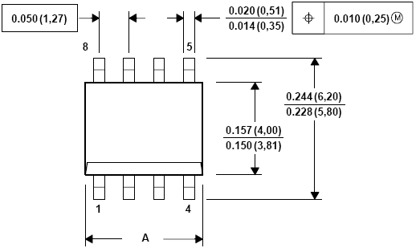Figure 1: Package description for SN75hvd12 (source: datasheet)
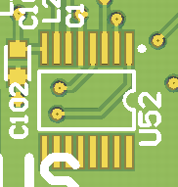Figure 2: Chosen footprint for SN75hvd12 (U52)
Figure 3 shows the patchwork used to connect the level changers to the wrongly chosen footprints.
The same problem holds for the two operation amplifiers of type MCP6024. As shown in Figure 4, the applied four-channel version consists of 14 pins (three pins per channel and two power connectors). During the layout process, a footprint with 16 pins was chosen erroneously (displayed in figure 5).
Figure 3: Patchwork of both SN75hvd12 level changers
Figure 4: Package description for MCP6024 (source: datasheet)
Figure 5: Chosen footprint for MCP6024 (U5)
The following picture 6 presents the wire-patch.
The solder-plains of the footprint of the crystal providing the ethernet PHY are numbered wrongly. As mentioned in figure 7, the graph and numbering of the plains is drawn from the bottom side. This circumstance was not considered during the layout process which leads to a mirrored footprint.
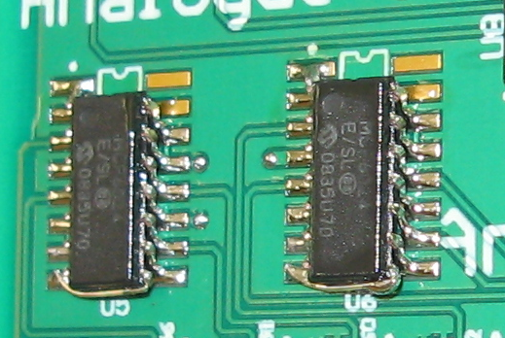Figure 6: Patchwork of both MCP6024 components
The patchwork for this problem is not as complex and difficult as the one mentioned previously, because the crystal consists only of four pins. The patch is shown within figure 8.
Figure 7: Solder-plain description for Aker_50MHz crystal (source: datasheeet)
In addition to the explicit necessary wiring patches, some footprints do not fit exactly to the corresponding components. In these cases, it was possible to bend individual pins or pin-rows to make the component fit to the solder-plains (see figure 9 and 10). Additionally, the removal of the middle-pin of the LM317 stepdown regulator is shown. This is caused by the capacitor positioned directly in front of it, which leaves no space for the middle-pin. The bottom plate of the LM317 represents the same connectivity (VCC_OUT) as the middle-pin so its removal does not cut the component's functionality.
Figure 8: Patchwork of the Aker 50 MHz crystal
Figure 9: Pin-row bending of the digital-analogue converters
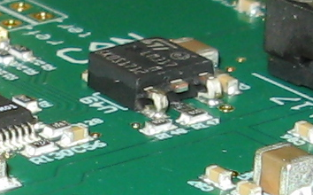Figure 10: Pin manipulation of the LM317 stepdown regulator
In case of the electrolytic capacitor shown in figure 11, the footprint was chosen too big. This actually does not represent an assembly problem but is a redesign issue, because the momentary footprints wastes layout space.

Alternative hardware description and confinement
Figure 11: Wrong dimensioned electrolytic capacitor footprint
The alternatively used, so-called IO-Controller, is based on the same ARM7 processor, is in several parts similar to the hardware designed within this paper and was therefore the base of this development. Nevertheless, it only represents a temporary solution and is not sufficient to fulfil the task's requirements.
The IO-Controller contains eight digital outputs and furthermore eleven digital inputs. The connectivity circuits and their link-up to the processor are similar to the tester board. The same holds for the analogue input and output circuits. In contrast to the specific designed board, the alternative only consists of four analogue inputs instead of six. In order to check the relays available on the test item, the digital in- and outputs must be re-used. In addition to that, the applied multiplexing for extension-board- ests are not available, which also prohibits an automated use.
For communication, the IO-Controller contains the same RS 485 bus connectivity as the tester hardware does. In contrast to that, ethernet and CAN interfaces are not available. Eventually, it contains a similar SD reader and a similar EEPROM. Figure 12 provides an overview of the connectivities and the mentioned components available on the IO-Controller.

Communication
Figure 12: Overview of the alternatively used IO-Controller
The communication between both devices is based on an already finished and proved communication protocol. It stands for one of the major parts of the development, because the complete environment is based on this.
Originally it was expected that the implementation of this protocol will only cause minor problems concerning the task stack size and minimal timing difficulties. During the consolidation it turned out that the communication protocol is based on a half-duplex communication interface. This means that a member of the communication can either read or write but is not able to do both coevally. In general, a RS 485 interface is built in full-duplex with five wires, of which two represent plus and minus for transmitting as well as for receiving data. The fifth line represents the interface GND signal. The mode-reducing is affected by a special component. It is built to normally just read from the interface and only to be enabled to write by setting the ENABLE signal. The special component is shown in figure 13.
During the considerations it was expected that the test item also contains two half-duplex RS 485 interfaces. During the first communication attempt this mistake was found because the protocol was not able to establish a connection. During the debugging phase it turned out that the testee was either able to send or to read. But the normal protocol functionality includes confirmation as well as pure data packages which comes out to the fact that a normal operation is only possible with a two-way communication. Even without confirmation, data transfer in both directions is necessary because the test item needs to send test results back to the test device.
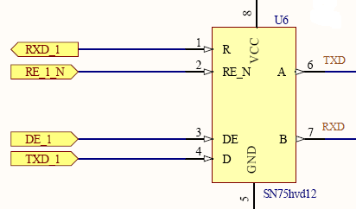Figure 13: RS 485 transceiver
There are five possible solution statements for the communication problems, which more or less interfere with the hard- and/or software of both devices. Firstly, it is possible to change the testers RS 485 interface to full-duplex mode as well. On first sight this seems to be the easiest solution. Beside of the complex patchwork on the test device PCB, this possibility also enforces changes to the interface driver software as well. Another reason against this option is the fact that the PCB changes are not allowed to be done on the alternative hardware. Because of that, no further development would be possible as long as the tester device becomes available, which costs a lot of time. Thus this possibility is no option. The second possible solution would be the modification of the full-duplex interface on the test item. In fact this option requires at first the patching and afterwards the de-patching of the RS 485 connection and also changes to the Linux kernel system, which makes this solution even more unhandy than the first one. A third solution is an additional piece of hardware which is connected to the RS 485 interface of the test item and reduces the transfer to half-duplex mode. Although this option does not require any patchwork it costs develop- as well as assemble time and enforces changes to the Linux kernel like the second option. As a forth option, it is possible to change the communication interface. Basically, an RS 485 interface is driven by an UART which means that any other UART connection may be used instead of the RS 485 connection. The test item contains one more interface driven by an UART, which is the RS 232 serial connection. Unfortunately, this connection is already used by the operating system as standard input and output for commands and messages. With the use of this connection for the communication it will not be possible anymore to interact manually with the Linux operating system. Also it would not be possible to print out messages to a terminal. Lastly, it is possible to modify the protocol software on the test device to use both available RS 485 interfaces to create a full-duplex transfer. The advantages of this method are that no patchwork is required and that this solution is runnable both on the original test device as well as on its alternatives. Furthermore, the required software changes are minimal because in the end only the central read and write calls must be modified to work with the right interface. Fortunately, each of these calls are only used once in the protocol and are not able to collide. In order to be able to modify the interface number used to write and read, the protocol initialisation is extended with arguments to set these configuration manually.

Adjustment of applications
Several parts of the software require a fine-adjustment or special additions in order to create a fully applicable test environment. This mostly concerns the communication between both devices as well as necessary wait-states on certain code locations.

Remote access
The communication protocol is a circular system. This means that a call from outside is usually not executed immediately but on the next cycle. This certainty causes a natural delay which must be taken into account if a two-way data transfer is requested. The easiest method to handle this problem is a blocked programming, based on semaphores.
Table 1: Flow example with and without semaphore blocking
Master | Slave
Software activity
Call function on test item to write data to an output  Data gets written  Call result function to note that the writing is finished  Result function is called and semaphore released  Driver reads result handled from result function and quits afterwards  Flow 1  Flow 2  Wait for semaphore release or time out | Function to write data to an output is called

Table 1 shows the main difference between a blocked and a non-blocked two-way transfer. The non-blocked method (Flow 1) automatically reads the result created by the result function right after the remote call. The remote device is not able to execute the requested command and to call the result function within this short time. If the result function was already used before, the previous result is still active and will be used instead of the new requested one. In worst case, the result is not initialised and contains meaningless information. This circumstance leads to an undesired software behaviour which is hard to debug. The blocked method (Flow 2) is extended with a semaphore, which is requested right after the remote function call. The semaphore is already taken and will be released as last statement of the result function. This approach assures that the remote function was executed and finished and the result was generated. A further advantage of this method is the prevention of deadly time-outs. The request for a semaphore is able to be bound to a maximum time. In case of a fault, the semaphore will not be released within the specified time and the request returns an error. The detailed semaphore approach is shown in figure 14. The mentioned three seconds in this figure are a sample value. During the merge of the devices it will be necessary to improve such values. These timings do not have to be very hazardous because the test environment has no claims to act as a high performance system. In general it is expectable that the communication is workable. The time-out represents the worst case and should only be entered if the collapse of the regular communication is definitely assured. Every time-out will automatically cause a negative test result. It must be taken into account that this in turn enforces a manual check-up which takes a lot more time then a generously calculated time-out.
Figure 14: Flow chart of the block method

General wait-states
The FreeRTOS provides a function to hold a task for a certain time (see chapter XYZ FREERTOS on page ZYX). In several parts of the software, a so-called wait-state increases the reliability and functionality.
One of the most important wait-states is implemented in the command-line interpreter. The menu structure is designed so as to wait for incoming data the whole time. Because of that, the read-statement is written into a loop which is only quitted if a command has been inserted. Without a wait-state within here, the operating system would spend all execution time of the processor only for this loop. This in turn implies that no calculation time is left for the circular communication protocol or other tasks running in the background. Code 1 shows the input loop mechanism. The wait-state holds the loop for ten microseconds, which frees enough execution time for all other tasks. In turn there is no risk to miss an incoming character because no human is able to type with that speed.
Apart from the command-line interpreter, wait-states are usually used to make sure that a previous command was executed. This is for instance used in the analogue connectivity sequences; if an in- or output is switched between voltage and current, it is necessary to wait a certain time until the mode is changed. It is not possible to get any feedback to make sure that the mode-change is finished. The same holds for some more cases, in which it is not possible to clamp the status of a certain command. Usually a wait-state represents a less complex method to assure the completion of a previous function. The hold-times must be adjusted during the merge. In general, it is possible to use more generous values, which in turn may be unhandy if the corresponding code sequence is used more often.
UINT8 buffer; /* Contains the momentary received character */
BOOLEAN receive; /* Indicates whether a character is available */

do /* Do-while loop for String input */
{
if ((receive = serGet(MenuPort, &buffer) == TRUE))
{
/* Key detection algorithms */
}
vTaskDelay (10); /* Share Calculation Time to FreeRTOS */
} while (buffer != 13); /* Read input until ENTER-Key */
Code 1: Menu input loop with implemented wait-state

