Declarations

Erklärungen

Preamble
Dankesrede, Zusammenarbeit mit firma, Erst- und Zweiprüfer.. blablabla

Abstract
Zusammenfassung in english

Abstrakt
Zusammenfassung in deutsch

Expectations to this thesis

Was kann der Leser von dieser Diplomarbeit erwarten, was kommt auf ihn zu? Was denkt der Autor von dieser Diplomarbeit?

Table of content
1. Declarations 1
2. Erklärungen 1
3. Preamble 2
4. Abstract 2
5. Abstrakt 2
6. Expectations to this thesis 3
8. Table of figures 7
9. Table of tables 8
10. Abbreviations 9
11. Task 10
11.1. General considerations 10
11.2. Hardware development of the specific tester 11
11.3. Software development for the specific tester 11
11.4. Software development for the testee 12
11.5. Consolidation of tester and testee 12
12. Introduction to the thesis 13
13. Used software on this thesis 14
13.1. Altium Designer package 14
13.1.1. Altium schematic editor 14
13.1.2. Altium PCB editor 14
13.1.3. Altium component editor 16
13.2. YAGARTO GNU-ARM Eclipse toolchain 17
13.2.1. Eclipse IDE 18
13.2.2. Open OCD 19
13.3. Visual Studio C# Express 2008 20
13.4. Notepad++ 20
13.5. Putty 20
14. Testee 21
14.1. Processor board 22
14.2. Main board 24
14.3. Extension board 24
15. Considerations 25
15.1. Test scheme 25
15.2. Tester hardware 25
16. Hardware development of the tester 26
16.1. Schematic development 26
16.1.1. General information for schematic designs 26
16.1.2. Introducing information 27
16.1.3. Designators, values and synonyms in schematics 27
16.1.4. Power supply section 28
16.1.5. Central processor 30
16.1.6. In- and outputs 32
16.1.6.1. Digital 33
16.1.6.2. Relay 34
16.1.6.3. Analogue 34
16.1.7. Communication 36
16.1.7.1. RS 232 36
16.1.7.2. RS 485 38
16.1.7.3. Ethernet 38
16.1.7.4. CAN 39
16.1.8. Memory 39
16.1.8.1. EEPROM 39
16.1.8.2. MCI 40
16.2. Printed circuit board design 41
16.2.1. General information on the printed circuit board design 41
16.2.2. Designators, values and synonyms in PCB designs 42
16.2.3. Component positioning 43
17. Software development 46
17.1. Tester 46
17.1.1. Hardware configuration 46
17.1.3. FreeRTOS operating system 50
17.1.4. Drivers 52
17.1.5. Communication protocol 54
17.1.6. Test applications 54
17.1.7. Additional software 54
17.2. Testee 54
17.2.1. Test software integration to the existing software 54
17.2.2. Communication 54
17.2.3. Script and C-Code development for individual test applications 54
18. Merging of both devices 54
18.1. Analysis of accrued problems 54
18.2. Adjustment of applications 54
18.3. Development and Adjustment of result calculating applications 54
19. Test application run cycle 55
20. Fazit 56
21. Literature 57

List of figures
Figure 1: Altium PCB Designer with focus on the processor routing on all layers 16
Figure 2: Schematic symbol example 17
Figure 3: PCB symbol example (TO-263) 17
Figure 4: Eclipse IDE with opened projects 19
Figure 5: Yacht hull with attached stabilisation weights (video animation) 21
Figure 6: Yacht hull with attached stabilisation fins (video animation) 21
Figure 7: Overview to the complete testee device with all extensions 22
Figure 8: Example of the usage of the different specifiers 27
Figure 9: Power protection circuit on power supply 29
Figure 10: Scheme of the separation of the digital output power supply 30
Figure 11: Filtering of analogue supply voltage 30
Figure 12: Partial drawing of a pin bank of the central processor 31
Figure 13: schematic of the optocoupler input circuit 34
Figure 14: Pin-grid example 34
Figure 15: Analogue input frontend with current detection 35
Figure 16: Analogue output backend with both operation amplifier circuits and switch 36
Figure 17: RS 232 interface with attached In-System Programming interface 37
Figure 18: Scheme of a parallel bus structure 38
Figure 19: CAN connection circuit 39
Figure 20: Power supply and control of the MCI 41
Figure 21: Overview of the component positions 43
Figure 22: Pin-grid placement of the analogue outputs (numbers added manually) 44
Figure 23: Communication circuits (ethernet, CAN, bus) 44
Figure 24: Impedance-relevant connections on power supply in schematics 45
Figure 25: Impedance-relevant connections in PCB 45
Figure 26: Example of the mouseover display function in Eclipse IDE 49
Figure 27: Multitasking principle of FreeRTOS (source: FreeRTOS.org) 51
Figure 28: Driver file structure 52

List of tables
Table 1: Comparison of abbreviations and their meaning 9
Table 2: Overview of used synonyms and their component-meanings 27
Table 3: Table of used voltages with schematic-used names, values and general purpose 28

List of code sequences
Code 1: Example of register manipulation to set and clear an external pin 49
Code 2: Example of the register manipulation codestyle with set and clean statements 50
Code 3: Definition and usage of the pinset switch 51

Abbreviations
Within this thesis, several abbreviations are used to increase the abridgement of the text. These Abbreviations mostly describe technical expressions, which are more or less common in the field of technical engineering. Table 1 shows all used abbreviations in alphabetical order.
Table 1: Comparison of abbreviations and their meaning
Abbreviation | Meaning
ARM | Advanced RISC machine, formerly Acorn RISC machine
CAN | Controller area network
CF | Compact flash
EEPROM | Electrically erasable programmable read-only memory
GPIO | General purpose input output
JTAG | Joint test action group
MAC | Media access control
MCI | Memory card interface
MMC | Multimedia card
PCB | Printed circuit board
PowerPC | Performance optimization with enhanced RISC performance chip
RISC | Reduced instruction set computing
RMII | Reduced media independent interface
RTC | Realtime clock
SD | Secure disk
SPI | Serial peripheral interface
SRAM | Static random access memory
UART | Universal asynchronous receiver transmitter
USB | Universal serial bus

Task
This thesis deals with the topic „Hard- and Software development of a test environment for a maritime stabilisation system“. The main task is to create a vicinity which is able to assure the quality of a mass-produced Hardware. The test is based on a multiple device environment where one device is the testee that comes from production on one or more other devices are used as testers. The idea behind this test principle is to have a specific designed device that is able to test every wanted part of the testee individually and for the mass-production usage, fully automated.
The main focus for this elaboration is on the development of the specific tester, although it will also be necessary to work on the testee as well. The whole thesis can be parted in five sections , which both chronological and logical are:
- General considerations about the mode of operation
- Hardware development of the specific tester
- Software development for the specific tester
- Software development for the testee
- Consolidation of tester and testee

All section-specific tasks will be explicitly given in the following.

General considerations
General considerations should be done before the first development step begins. A complete abridgement for the whole project is the base for all further sections. These deliberations should result in a procedure for the project. It must be both figured out what parts of testee should be proved and with which method this test can be achieved. For some parts it may be useful to compare the theoretical considerations with sufficient practical methods.
Also a balance between the possibilities and the costs must be proposed. Possible abandonments should be declared and alternated. A defined test procedure, the content and the assortment of the tester-hardware and a general advisement and flow of the test-software should be available before entering any further development steps.
Concerning to the limited time-frame, this approach helps saving time in development stages.

Hardware development of the specific tester
The conception of a specific piece of hardware should be the first step of development. This is mostly caused by the production time of the device, in which other grades of this thesis can be attended.
At first, a complete schematic is to be created. Already existing resources can be used. This usage must be declared. The circuits of the different test parts should be created according to the deliberations from the first step of task, which then allows a design as far as possible specialised to the application with minimised patchwork. Beside these test circuits, the design must content an own power supply for the CPU, the test circuits and all ulterior parts of the design. Also, minor circuits like eventually memory or interfaces must be drawn. Every contiguous circuit should be drawn on an own sheet.
From the schematic, a printed circuit board then must be designed. There are no guidelines available concerning the board size and number of layers but both criteria should be considered because of the design costs and the usability. The arrangement of the components, especially the different connectors for the test circuits should be structured logically and easy understandable and usable.

Software development for the specific tester
The software is responsible for the operation of the central processor as well as the whole testing act and several more things. Because of that, the code should be split up in different, contiguous parts like hardware-setup code, drivers, communication, test applications and others. Depending on the previous considerations, the software can be based on an operating system. If so, this system must either be chosen or written and configurated to the used hardware.
Driver-files should allow access to every available part of the tester including the test circuits and all miscellaneous devices. An easy-to-use structure for the drivers should be created.
The communication with the tester is also software-based. Because of that, a communication protocol needs to be found or created which is runnable both on the tester and the testee. The protocol should allow a device to call functions on other attached devices and also handle variables and parameters between them.
Test applications are functions using the test circuits to generate stimuli values for the testee. These functions are based both on the drivers and the communication software. Also, self-test functions to assure the functionality of the test-circuits are needed.
At least some miscellaneous functions are necessary for a more comfortable usage. Especially during the development phase, a menu leaned to the DOS-Prompt or a Linux terminal from which functions and applications can be called will be useful.

Software development for the testee
For the testee, as less software as possible should be created. This is mainly based on the principle that this software will rest on the device for future tests and should not take much space in memory. Because a basic software is already available on the testee, only additional parts must be generated. The communication protocol will be the most important of these. The odd software will be preperations of hard- and software on the testee as well as calls for stimuli from the tester.

Consolidation of tester and testee
In the last step, the created software on testee and tester will be synced. During this phase it must be assured that the written test applications are reliable. Also, a logical order of the single tests must be generated. At least, certain functions are necessary to calculate the test result after a finished run.

Introduction to the thesis

Used software on this thesis
During this thesis, several programs, packages and software are used. The frequently used and/or special software will be shown and explained in this chapter.

Altium Designer package
The Altium Designer package is a powerful and for commercial and industrial purpose created software package. It contains special subprograms for every step of the hardware development and is furthermore able to be comfortably used in network vicinities by one or more designers. It is a commercial software and needs to be licensed by the user.

Altium schematic editor
The schematic editor allows the creation and development of electrical circuits. It can be used just to draw circuits (for instance for documentation) but is commonly for creating a library base for the PCB design. The user is able to develop circuits from every available or self-composed component on multiple sheets. Furthermore, the components can be marked as driving sources, power supplies, inputs, outputs and the like, with which the drawn schematics can be simulated as a electric circuit. Also, a very detailed rule-management allows a complete schematic rule check for almost every possible error or carelessness like open pins, short-lines and much more. A special advantage of the schematic editor is the multi-sheet ability. It is possible to insert already drawn circuits from the actual or older projects as a component and so save development and drawing time. Also, the documentation gets smaller with this. Furthermore, the editor is able to annotate the component designators. This function allows to automatically order and rename the components, so that during the development process every sheet can contain a number one of every kind of component but afterwards the components are all named and numbered unique.
When the schematics are finished and free of errors, the complete schematic hierarchy can be compiled. With this, the drawn components and connections are split into a component list, a pin list and a netlist, which are then used by the PCB design editor.

Altium PCB editor
The PCB editor is for the development and design of (multilayer-) PCBs and is normally based on the lists composed by the schematic editor before. From this, normally the PCB is created by exporting all available circuits to a new PCB. After setting the properties of the board (e.g. number of layers, size), all used components from the schematic are added to the PCB design including their connections to each other.
The PCB editor is a powerful tool mainly based on extensive graphics. Nevertheless it is also usable on older PCs, although with lower performance. Its advantage lies in many additional graphical or organisational functions and routines, which allows to keep an overview over the design even on big multilayer design with less processor stressing. Also, the graphic engine is completely adjustable, so that every layer and component can be set to every colour and almost every behaviour. For control, the design editor is based on the same rule engine like the schematic editor, which allows to set different priorities and warning or error levels for certain rule violations. The PCB design rules mostly contain isolator spaces, distances between nets, widths of wires and the like. They are adjustable for general use or also for certain nets or components.
The design is all time update-able. This means that if changes in the schematics are necessary after the design process already started and components or nets are added or deleted, the PCB designer can easily be updated from the new compiled schematic component- and netlists. Even changes in the inverse directions are possible. Figure 1 shows the PCB design editor window with focus on the central processor of the tester board, where red wires are on the bottom and blue wires are on the top signal layer.
Figure 1: Altium PCB Designer with focus on the processor routing on all layers

Altium component editor
Although the Altium package already contains several thousand common components like resistors, capacitors, standard ICs, processors, diodes, LEDs connectors and the like, it will be necessary to create or update components within the design process. For this, Altium created an own component editor, which allows to create schematic and layout symbols and combine them.
A schematic symbol is an abstract drawn component which contains every used pin. Furthermore it should contain important internal connections and a logical structure for the pin order (for instance power pins above, input pins left, output pins right, GND pins below). The symbol is combined with a library containing additional information like the manufacturer name, order codes, datasheets and more. At least, it is possible to attach one or more layout symbols to it. These so-called footprints are exact mechanical and graphical descriptions of the component and displays every mechanical existence on every used layer. Mostly this concerns the pins of a component on the top-layer, component names and drawn shapes on the overlay (or text) layer and on throughole components also the hole with its corresponding drill. Most footprints are normed to certain sizes and already included in Altium Desinger, so that in most cases, just a new schematic symbol needs to be created and then combined with an existing footprint.
Figures 2 and 3 show examples of schematic and PCB symbols, both created with the component editor. They both stand for the same component, which is a LM2678 step-down voltage regulator. In figure 2 the logical pin order mentioned above is visible. The footprint in figure 3 comply with the TO-263 footprint standard.
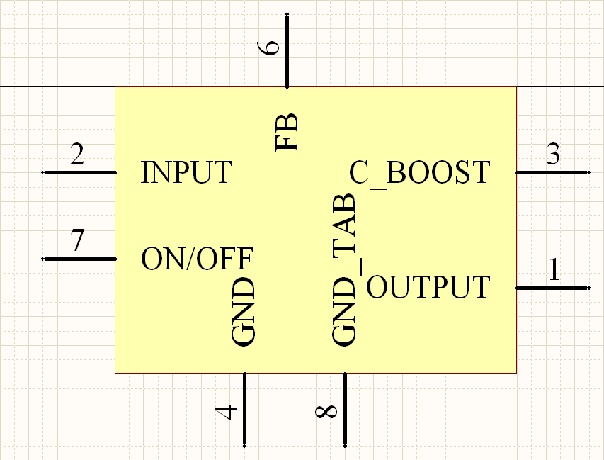Figure 2: Schematic symbol example
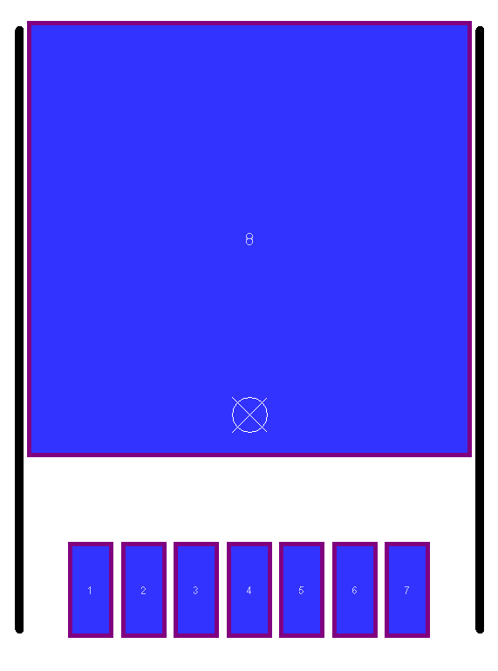Figure 3: PCB symbol example (TO-263)

YAGARTO GNU-ARM Eclipse toolchain
YAGARTO stands for Yet Another GNU ARM toolchain. The term GNU is from 1984 and stands for an Unix-like software project and is a recursive acronym for GNU is not Unix. The idea behind this project was a free and open source operating system similar to Unix. From that the GNU-Manifest and later on the GNU-licence have raised. The basic idea of this is to involve as much programmers and other helpers as possible to support a certain software project. Every software under the GNU-licence is open source and free for usage, handing and changing in private use. All rights remain at the developer. In case of commercial use, special agreements or limitations are to be arranged.
A toolchain is composed of a number of single programs that are forced into a project to work with each other. Usually it is hardly possible to combine different software when it is not supposed for that. In prebuild toolchains, the developer already did all the combination work.
The YAGARTO toolchain contains:
- the IDE Eclipse (open source)
- the GNU-licenced GCC (GCC: GNU Compiler Collection)
- the OpenOCD (OCD: On Chip Debugger)
- some small support programs

Eclipse IDE
Eclipse is a IDE based on JAVA and originally just supposed for JAVA development as well. Within the last years, Eclipse became the number one open source IDE because of its quality to be easily extended with plugins. In this way it is for example now possible to use Eclipse also for development of software in C and C++. This great popularity could be ascribed to Eclipses possibilities of handling big projects, work with more then one opened project once and combine a clear, structured surface with helpful additional functions like Auto-Complete or a Mouseover-Display. Moreover, Eclipse is unlike many other IDEs able to be setted up in almost every way the user wants it to. For example the text editor can be configured in many different ways of code style, just like the user or the corresponding company wants it to be.
Figure 4: Eclipse IDE with opened projects

Open OCD
The Open On-Chip Debugger (Open OCD) is a small tool that allows a comfortable debug communication with the processor via the Joint Test Action Group interface (JTAG). Required for this is a supported JTAG controller. The tool creates an environment that enables a connection to the board via a telnet connection and provides a UNIX-like Application Programming Interface (API). With this vicinity, it is for instance possible to read or manipulate every available register or memory address. For every action, the processor must be halted. With this method, even one-time readable registers, which lose their content after reading in normal processing mode, are readable multiple times.

Visual Studio C# Express 2008
The Visual Studio package is a professional development environment created by the company Microsoft (MS). The full Studio package contains IDEs for the languages C, C++, C#, Virtual Basic and J++ and provides own compiler for each of them. The Visual Studio series is designed for software development for x86 systems, so usually personal computers and is hardly applied to embedded systems.
Microsoft provides two different versions of Visual Studio; either the complete package, which must me licensed, or single, limited versions of each IDE for free use, which are marked with the additional name “Express”. Although the used version of Visual Studio is limited to more basic interaction with the operating system, it is sufficient for the purpose of this thesis and does not require a new license on Visual Studio. The environment is used to create the window test application control.

Notepad++
Notepad++ is an easy-to-use open source text editor, published with the General Public License (GPL). Its advantage is automated keyword- and text highlighting for different programming languages and a teachable behaviour. Some functions like auto-completion or mouseover-display are similar to the ones already mentioned with the Eclipse IDE (see chapter 14.2.1. Eclipse IDE on page 19), which makes it easier to switch between them or work with both programs at the same time. On this thesis, Notepad++ is mostly used to develop the linux applications for the testee, which can either be scripts or small C programs. A server-based version of the GCC is used to compile the C code written in Notepad++.

Putty
Putty is a open source terminal, ssh- and telnet client for Windows operating systems. It is used to establish almost every connection between the PC and the used boards, normally on the serial ports. The connection to the Open OCD is also established with Putty. It is multiple usable, which means that multiple instances of this application can be opened and used at the same time. Although the Windows operating systems contain an own terminal client called Hyperterm, Putty is preferred due to its smaller size and its better adjustability. The practical use showed also that Hyperterm is less reliable.

Testee
The testee is the device that should be tested. As mentioned in the task, it is created and designed to be used as a ship stabilisation system. The principle of this stabilisation is rather new and not well known to a broad public. It insists in fact of a artificial horizon device, weather and atmospheric sensors shared all over the ship and several fins and heavy weights build to the ship hull. With this the controlling device is able to compensate wave and wind influences and balance the ship to a cross-movement of just 0,7° to each side where it was before more than 10° per side. This balancing is done by moving the weights near to or away from the hull. Also, the system is able to compensate movements ahead or sidewards by moving and rolling the attached fins. The weights as well as the fins weigh several tonnes per part, so they are moved by strong engines, which are controlled but not directly powered by the testee device.
The main purpose of the system is the stabilisation of luxurious offshore yachts. Because of the high water-resistance of the weights, they can only be used when the ship stands still or moves very slow. The fins are designed to be used also while sailing and reduce the rolling of the hull on heavy sea. The main reason to implement a system like this to an offshore yacht was the problem to safely land a helicopter on a strong and incalculable moved ship. Also, yachts from that size often are too big to directly enter a port, which forces the owner to anchor outside in the unguarded sea. In this situation, the stabilisation system increases the comfort on the ship extensively. The figures 5 and 6 show the attached weights (figure 5) and fins (figure 6) in action. The figures are from demonstration and public relation video animations created by the customer company.
Figure 5: Yacht hull with attached stabilisation weights (video animation)
Figure 6: Yacht hull with attached stabilisation fins (video animation)
Apart from the main purpose of the device, there are several more functions it should fit to. Because luxurious yachts are equipped with a ship-internal network and attached to that a high-level multimedia system, the stabilisation system board can be integrated to this network up to a certain level, where the stabilisation of the ship is in every situation highest prioritised.
The complete controlling software is developed by the customer. The device is produced and afterwards delivered with a basic linux operating system that supports all available periphery. The test application environment developed with this thesis is placed in the production chain between the production and the delivery of the devices. Because the controlling software is not available, the purpose of the device is of minor importance to the further hardware design test.
The stabilisation system device insists of three different boards. This is mainly caused by the requirements of the customer for a better adjustment of the product to the future purpose; there is no technical need of division. Figure 7 shows the complete device with all three parts.
Figure 7: Overview to the complete testee device with all extensions

Processor board
The processor board is the only “intelligent” part of the device. It contains every component directly required by the processor. This includes memory devices as well as interfaces.
As main processor, a Freescale MPC 5200 based on the Performance optimization with enhanced RISC performance chip (PowerPC) architecture is used. Freescale (formerly Motorola) is, beside of Apple and IBM, one of the developers of this architecture and is nowadays one of the leading manufacturer for PowerPC chips. PowerPCs are often used in embedded systems because of their high performance and the ability to calculate with floating points in double correctness, which is interesting for measurement devices like the actual system. The PowerPC processors nowadays available are normally based on 64-bit architectures, only IBM supports some 32-bit chips. Beside of the embedded purpose, PowerPCs are used in almost all actual gaming consoles (Nintendo Wii, Microsoft Xbox, Playstation 3), in all Apple computers produced before the year 2006 and in high performance server stations and supercomputer grids (mostly from IBM). Also, the military industry uses PowerPCs, for instance in the latest US pursuit plane F22 Raptor.
Beside of the main processor, a co processor is used to control the inputs and outputs of the device. Although this causes a discharge on the PowerPC, the main reason for the second processor is the realtime behaviour. The linux operating system on the main processor is a non-realtime system, which means that the software can not warrant the exact time of input values. In contrast to that, the co processor only contains an cyclic, interrupt-based software that warrants the compliance of requested timings. The communication between both processors is mainly implemented with SPI, where the main processor represents the master device. Where all inputs are read circular, also the outputs are driven in the same cycles. The applied co processor is a NXP LPC 2108, based on the Advanced RISC Machine (ARM) chip architecture. These chips became famous in the embedded and mobile sector within the last years because of their power saving features and the consequent 32-bit design. According to estimates, more than 75% of the used embedded 32-bit RISC processors are based on an ARM core. Famous example devices based on ARM processors are the iPhone and the iPod (both developed and traded by Apple) and the mobile gaming console DS (developed by Nintendo).
Beside of the two processors, the most important components are the memory devices. The board possesses 128 MB SRAM and 64 MB FLASH, where the FLASH is used store the original software code, which is copied to and afterwards executed from the SRAM on a boot up. Furthermore, the processor board insists of a eight-port ethernet switch, a ethernet uplink port, an USB host interface connector and a Compact Flash (CF) card reader. Lastly, the processor board content several connector interfaces for different purposes; for instance a JTAG connection for debugging, RS 232 connections to program and communicate with both processors and three connector rows at the bottom side of the board to establish connections to the peripheral devices on the other boards.

Main board
The main board is the biggest part of the stabilisation system device and is used to mount on the one hand the system to a rack and on the other hand the processor and the extension board to itself. Furthermore, it contents the basic input and output connections available on the system and provides the complete power supply of the board, inclusive the step-down stages and fuses.
The connector periphery insists for most parts of the analogue and digital inputs and outputs, of which each eight channels are available. Only the analogue inputs contain six channels. The digital connections work with industrial standard logic of 24 V, the analogue connections are only used to drive and read current between 0 and 20 mA. In addition, four relay throughputs are implemented to the main board, which allow to switch an incoming signal directly to an outgoing. Lastly, a CAN and two RS 485 ports complete the connection section. Because the additional extension board can be mounted to the main board as well as the processor board, there is one more signal connector available to attach the extension board to the system.

Extension board
The extension board is an additional component of the stabilisation system to extend it with more analogue and digital connections and relay throughputs. In fact, the extension board contains eight more analogue inputs, six more analogue outputs and both four more digital in- and outputs. Furthermore, two more relay throughputs are available with this extension.
All in-, out- and throughputs are attached directly connected to the co processor on the processor board through a connector placed on the main board. The power supply is done by a special power connector from the main board.

Considerations

Test scheme

Tester hardware

Hardware development of the tester

Schematic development
The hardware development usually begins with the design of the schematics. These contain every electrical component and connection which should be prospectively available on the PCB. On projects with a higher amount of electrical devices and wirings, the schematic drawings are usually divided to contiguous circuits like the boards power supply, the input- and output section of the main processor and the like. Also, multiple used circuits or circuit parts should be split to an own schematic to prevent of repeated drawing.
In order of a better abridgement, the schematics for this project should also be divided as mentioned above.

General information for schematic designs
The schematic design represents the actual research part of the hardware development. Because of that, this activity usually takes a higher amount of time than the PCB design afterwards. Depending on the future purpose of the device, the designer is not only responsible for the pure electrical circuits but also for the compliance of (international) norms and/or the costs of the device. These topics are normally more important on mass produced and public-used products and force the designer to search and compare several and partial a lot of different devices to make the circuit fit as much as possible to the wanted target. But although the costs or norms are minor motivations on a prototype or single device development, the choice of the components takes some time. In addition to that, the use of non-common devices or ICs mostly forces the designer to create new component symbols in the design environment. Although in the schematics only a few different symbols are used, these components may differ on the further PCB in size (e.g. common resistors and power resistors, which both got the same schematic symbol but need size-different PCB symbols). On SMD devices, these symbols need to be very accurate. In a commercial facility, it is usual to supplement the components with the manufacturer name, the manufacturer code and order codes of the common used device distributors. Also alternatives are sometimes necessary.
These tasks rather concerning organisation parts are mostly important in commercial surroundings, where usually more then one designer design several PCBs and is commonly called “library care”. The more accurate these libraries are created and supported, the easier is the future use of it for all designers, who all then can access new libraries and/or components.

Introducing information
The schematic drawings will contain several components and circuits with different purpose, so the division of the schematic to more sheets is advisable. The following chapters are to explain the created circuits and their purpose.
The schematic drawings are organised in a hierarchical way with three layers. The lowest of these are circuits, which are used several times and are included to other circuits. The mid layer contains all one-time used circuits and are brought together on the highest layer, which is called top sheet.

Designators, values and synonyms in schematics
Every component in the schematics must be explicit assignable and as far as possible specifiable. For this, normally three different specifiers are used, either in the schematics but also later on in the PCB. These specifiers are: designator, value and synonym. Figure 8 shows the usage of these specifiers, where the letter “C” is the synonym, “22uF_16V” is the value and the number “C92” is the designator, which is in fact a combination of the synonym and an individual component number. Where this number can exist several times on different components, its combination with a synonym is unique.
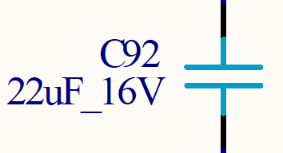Figure 8: Example of the usage of the different specifiers
The synonyms are used to show the kind of the component on first sight. They are not normed but normally used akin. Table 3 explains the used synonyms in this thesis with their component meanings.
Table 2: Overview of used synonyms and their component-meanings
Synonym | meaning
C | Unipolar capacitor, Electrolytic-capacitor
D | Diode, Schottky-diode, LED
F | Fuse
L | Inductor, Choke
P | Connector, Pin-grid, Header
Q | Transistors, Crystal
R | Resistor, Power-resistor
S | Switch
U | ICs, processors, any kind of integrated devices

Power supply section
As mentioned in KAPITEL 2, ÜBERLEGUNGEN, the whole board will only be supplied with a constant power source of 24 Volts. Nowadays, this is the most common power supply available in development and industrial vicinities.
Although there are some circuits that are designed to work on 24 Volts supply, most of the circuits and components are to be supplied with a much lower voltage. It is advisable to chose the components that way that they fit as far as possible on the same voltage. In the actual schematic, seven different voltages are needed, which are mentioned in table 2 with their schematic names, values and main purpose.
Table 3: Table of used voltages with schematic-used names, values and general purpose
Name | Value | Purpose
VIN | 24 V | - Unfiltered voltage from the external supply  - Supply of VIN_DIGI
V24 | 24 V | - Switching voltage of multiplexers  - Further transformation to VCC
VIN_DIGI | 24 V | - Reference voltage of digital in- and outputs
VCC | 5 V | - Supply of integrated circuits like level changer  - Supply of status LEDs  - Further transformation to VIO and VCC_ETH
VCC_ANA | 5 V | - Extra filtered 5 Volts supply for analogue in- and outputs
VIO | 3.3 V | - Supply of main processor  - Supply of integrated circuits  - Supply of JTAG interface
VCC_ETH | 2.5 V | - Supply of external ethernet PHY circuit

As protection, the power supply circuit contains several special components. Directly parallel to the power supply connector (P19), a supressor diode (D26) protects the following circuits against overvoltage. In row-connection to the following circuits, a 1.35 A fuse (F1) protects the boards against high current flow e.g. caused by short lines and in connection to that a common diode (D25) prevents of fault connection on the main power supply connector. At least, a choke reduces possible noise of the supply. The protection part of the power supply circuit is shown in figure 9:
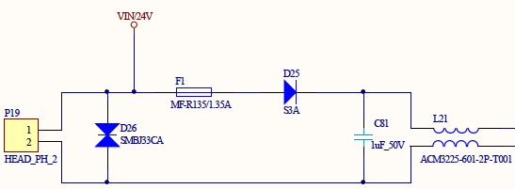Figure 9: Power protection circuit on power supply
The filtered 24 V behind the choke is used to supply the multiplexers with a high switching reference voltage as well as also supply further step-down regulators to lower voltages. The first of these step-down regulator takes voltage down to 5 V. This transform-stage is mainly responsible for the correct supply of the whole board, because it supplies several devices directly as well as it also drives a second step-down stage to 3.3 V and a third stage to 2.5 V. Because of this requirements, a high quality and stable step-down regulator with high current throughput is necessary. Since the possible high current, it is highly recommended to adhere the impedance of the regulator and its wiring. The second step-down stage to 3.3 V is directly driven by the first one and is mainly to supply the central processor as well as several internal devices like level changers and memory interfaces. These devices are all not highly sensitive against voltage-fluctuation, but nevertheless a regulator with high output should be chosen since otherwise a consumption peak may cause voltage drops, which in turn may cause a unmeant restart of the processor. The third, last stage only partly supplies the ethernet PHY and must not be chose as a high quality device due to the PHYs purpose.
As seen in table 3, the digital and analogue in- and outputs are supplied with an own voltage. This is mainly caused by their purpose. The supply for VIN_DIGI is gripped directly from the external supply in front of any filters or security components like fuses. In future use, this voltage supplies the digital outputs, which are mainly designed to drive optocoupler-circuits on a second, unknown device. Because the functionality of these inputs cannot be warranted and may be short-lined for any reason, they can cause a much higher current than the outputs are designed to drive. To prevent the whole board of the risk of damage, this supply voltage is separated and secured by an own fuse right in front of the main fuse of the board. This is shown in figure 10, where P19 is the connector for the external power supply (Pin 1: 24 V; Pin 2: GND).
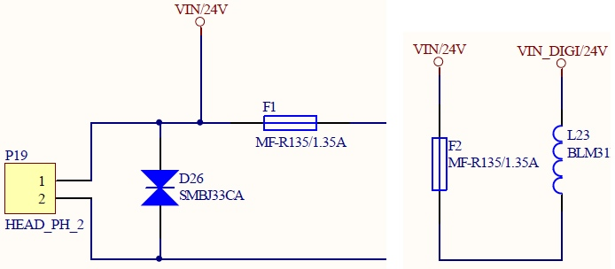Figure 10: Scheme of the separation of the digital output power supply

From the already to 5 Volts transformed voltage VCC, the additional supply VCC_ANA is split for the analogue in- and outputs. This is mainly caused by noise reduction on the power lines in order to achieve a more stable reference voltage on the analogue-digital (ADC) and digital-analogue (DAC) converters as less as possible influenced by the current consumption of all other VCC-supplied components. To achieve this, VCC_ANA is filtered and stabilised from VCC as shown in figure 11:
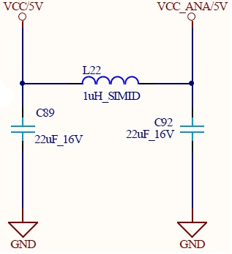Figure 11: Filtering of analogue supply voltage

Central processor
The central processor is, according to its name, one of the most important components in a digital circuit. Most common designs are based on only one central processor to do all work, where bigger or more complex designs divide several tasks like communications or special memory algorithms to so-called co processors, which are in turn controlled by one or more, to a cluster connected central processing unit(s). The actual design contains one central processor to do the whole work.
The LPC 2388 in the applied version with 144 pins causes a quite big schematic symbol. Due to the abridgement, this symbol should be divided to two or more single signs, which then can be split to several schematic drawings. It is advisable to split the symbol according to the purpose of the pins, e.g. GPIOs, power connection, the debug interface and the like. The processor is able to use most of its pins as a general in- or output, but also use them for instance as special communication or memory interfaces. In case of the LPC 2388, most of the pins support four different purposes. These different possible usages should be mentioned in the schematic symbol for each pin. Secondly, it must be decided, in which order the pins are printed. All applicable pins are grouped to five banks with up to 32 pins. These pins are not compulsorily consistent with the external pin number, which then allows a printout either according to the external pin numbering, which is more interesting for the further PCB design, or the logical bank order allowing a better overview for the software development. In this thesis, the second option will be used due to the design software which already contains a ready-to-use symbol for the LPC 2388 with the specified order. Figure 12 shows a partial pin printout. It shows the pins ten to 26 of the first pin bank (bank 0) with their different possible purposes. It is observable that the pins used for the digital inputs are setted to the general purpose where the pins concerning the MCI mostly are setted to a special interface function. Also, the figure shows the difference of the two ordering methods mentioned above where the external pin numbers are mentioned outside of the component above their corresponding pin.
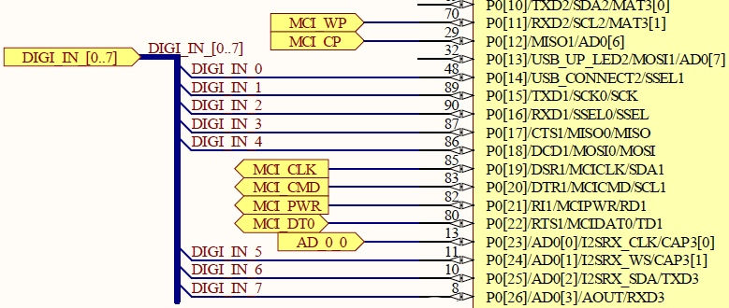Figure 12: Partial drawing of a pin bank of the central processor
Beside the adaptable pins, the LPC contains several more connections to the outside which are also grouped to four more schematic symbols. The first of these is the power connect block, which contains every pin used to supply the processor. Because the LPC contains several, independent interfaces, it is possible to supply some of them individually, for instance the build-in converters. Also, reference voltages can be connected separately. At least, the processor is able to be partly supplied with a battery. With this, the internal real-time clock (RTC) on a special part of the memory is still on power, so that for instance the clock does not need to be set up every time the processor is switched on. In the actual design, a battery supply is not designated, so that all of the supply pins are directly connected to the power supply of 3.3 V. Except for the battery supply pin, all power connections need to be buffered with an own blocking capacitor of 100 nF.
The next schematic symbol contains the crystal connections. The LPC 2388 must be driven at least by one crystal commonly with 12 MHz. Without this clock, the processor is not runnable. Although the internal circuits of the processor need different clock speeds, the whole component only needs to be supplied with one external crystal. The LPC contains special, individual clock divider registers for the interfaces and circuits that must be driven with different clock speeds. A second, much slower crystal with 32.768 kHz exclusively supplies the RTC. This is as mentioned above because the RTC is driven by an own supply-pin either on the normal power connection or on battery so that even in battery mode, the RTC crystal is supplied.
The fourth symbol contains the Joint Test Action Group (JTAG) debug interface connections. This interface allows comfortable debugging directly on the chip and is a powerful tool especially on prototype development. The interface connections are ready-to-use and only need to be added with pull-up resistors on the data and a pull-down resistor on the clock connection. Although the JTAG interface only contains six connections, it is common to use a 20 pin connector with 2 times ten pins in a row. This is because the JTAG controller outside the board (for instance a PC) gets also its power from the board via two pins and is able to act on some more pins with special actions. In the actual design, the JTAG controller can also drive the global RESET signal on the board.
The last symbol contains every not connected pin of the LPC. Although there are of course no connections to this symbol, it should be mentioned in the schematics to show which pins are not involved in the design.

In- and outputs
The design contains several kinds of in- and outputs with each several pins or channels. Because of this, this chapter will be split up to these different kinds.

Digital
The digital in-and output section is mainly designed to be connected to industrial sensors or devices. Digital means that each output contains two states, which are either HIGH or LOW. In industrial vicinities it is nowadays common to use 24 V logic, because electrical signals than can be carried on long distances. Also, each channel both of the in and outputs should contain an own LED that shows the actual state, where an illuminated LED means HIGH. Each eight digital in- and outputs are needed, from which each four must be switchable to an alternative connector.
To achieve in- and outputs fulfilling these requirements, on both ports some special circuits are necessary. On the outputs, the first step is to raise the LPC output level from 3.3 V to the required 24 V. For this, special so-called high-side switches are available. This device is designed to a certain input logic and raises this to a also certain output level. The high-side switch is supplied by the special secured digital 24 V voltage. The output signal from the switch is then filtered with a CLC low-pass to protect the output against chattering and reduce noise. At least, the signal is wired to a connector to be able to grip the signal externally. Before, the required LED is connected to the signal between the CLC and the connector with a series resistor to ground. A special component is the four-channel multiplexer that allows to switch four digital outputs between two connectors. It is controlled by only one line coming directly from the central processor. The signals the multiplexer should switch are gripped between the CLC filter and the LED connections.
The digital inputs are working the inverse way to the outputs. The only difference is the method to reduce the incoming voltage of 24 V to a level the processor can handle. This is done with a optocoupler circuit that also realises a complete electrical detachment between the incoming signal from a foreign device and the own board, which is shown in figure 13. The optocoupler is secured with a special diode (D3) component that prevents of misconnection and wired to a LED (D2) showing the actual signal status. The coupler (U2) output creates a inverted signal with a pull-up resistor (R5) pulling the output to HIGH when the coupler is not active and pulling down the signal to 0 V when the coupler becomes active. This inversion must be considered in the software. Afterwards, eight of the input signals are wired to a multiplexer to use each four of them. The multiplexer is already known from the digital outputs.
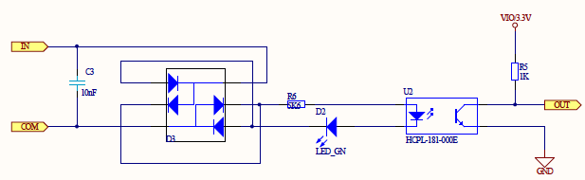Figure 13: schematic of the optocoupler input circuit

Relay
The relay inputs are working the same way then the digital inputs described chapter 17.1.6.1. Digital on page 34, which means that in fact they consist of the optocoupler circuit shown in figure 13. The only difference to the digital inputs mentioned before is the circuit on the testee, which not drives only 24 V to an output but switches an incoming signal, so that it has no power consumption of this action. Because of that, every relay-input got its own 24 V output signal, that should be switched by the testee. In addition, the incoming signal must not refer to 24 V, which is just the maximum the relais is able to switch. A certain range of voltages between X and Y can be switched.

Analogue
The analogue in-and output circuits are the most complex circuit parts in the design. This is mainly caused by three specific requirements to these circuits. Firstly, the internal converters of the central processor should not be used due to their insufficient accurateness which causes external devices inclusive their required wirings. Secondly, the in- and outputs should be able to read both voltage and current, which requires a special circuit combination, because converters are only able to read voltages. Lastly and due to debugging, the values from the converters should be accessible with a measure device, which causes an additional pin-row to grip the signals. Eight analogue inputs and six analogue outputs are needed. As on all in- and outputs, at least a few of the signals must be switchable to a alternative connector. In case of the analogue connections, all channels are involved, which requires two four-way multiplexers per port.
On the analogue inputs, the multiplexers are the first devices involved into the circuit. This is mainly to reduce the further needed components and based on the principle that all channels are switched at the same time. Also based on this is the connection to the pin-grid (see figure 14). It is wired that way that is possible to grip voltage as well as current. For this, each of the eight channels is wired to one input pin on the grid and one output pin. With this, a current measure device can be connected in series to the circuit as well as a voltage measure device can grip the voltage parallel between on both pins shorted (for instance with a jumper) and GND. Afterwards, The signal is led to a special circuit that allows the detection of either voltage or current, which is shown in figure 15. This is basically realised with a MOSFET transistor (Q1) and a series power resistor (R2) in front of four-way operation amplifier (U1A), on which each one channel uses one amplifier. The MOSFET is controlled by an output (CURRENT_IN_A) from the LPC. When inactive, the signal is led directly to the amplifier. When the control line becomes HIGH, the transistor connects the power resistor to GND and so terminates the current throughput. This causes a voltage drop on the amplifier, which is linear to the current though the resistor.
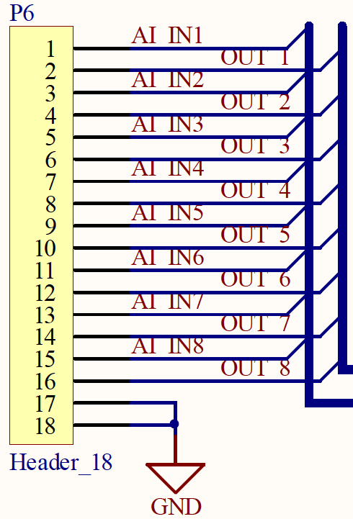Figure 14: Pin-grid example
The applied converter works with a accurateness of twelve bits and is connected to processor via the Serial Peripheral Interface (SPI). It contains eight individual analogue-digital converting channels, so that only one device is needed. To reduce the measurement inaccuracy, a high precision, low power reference device stabilises the reference voltage of the converter.
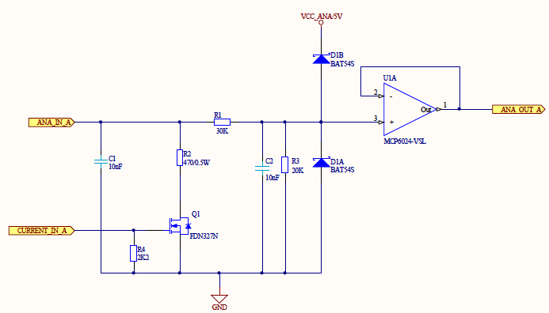Figure 15: Analogue input frontend with current detection
The analogue outputs work the inverse way of the inputs with the difference, that three two-way digital-analogue converters are needed and because of that three CHIP-ENABLE (CE) connections are required to be able to control every converter individually. The converters are also connected to the SPI, so that except for the CE-wired no further connections to the processor is needed. As well as the analogue-digital converter, a high precision reference device stabilises the reference voltage. The outlet of the converters are connected to the specific analogue out circuit allowing to differ between voltage and current output, which is partly shown in figure 16. It consists of two divided circuits based on a two-way operation amplifier (U3) where one of these simply amplifies the incoming voltage and the other controls a power transistor (T1) which realises a current flow depending on the output of the amplifier. Both circuits are brought together in a two-way multiplexer (U4) where both channels are controlled by only one connection from the processor (CONFIG). This is because one of the two switches in inverted and so only one of both amplifying circuits becomes active.
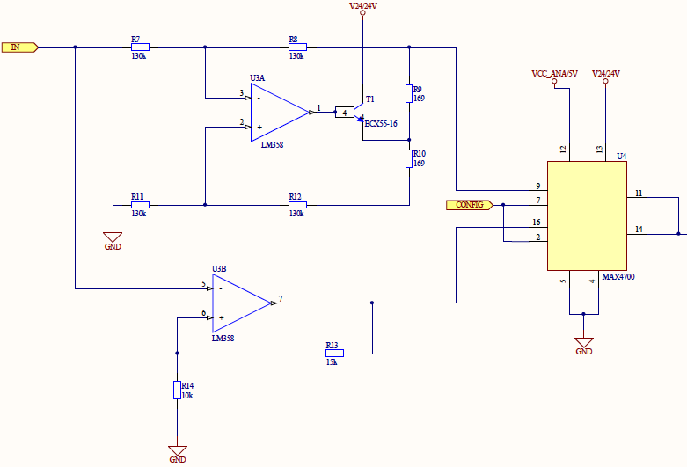Figure 16: Analogue output backend with both operation amplifier circuits and switch
As well as on the analogue inputs, the signals should be accessible on a pin-grid for measuring with the same connection principle. Afterwards, the six signals are connected to two multiplexers to be able to switch them between two connectors.

Communication

RS 232
The Recommended Standard 232 (RS 232) interface is the most used communication interface on the design. It will be both used to control the program flow of the processor and to write program code into the processor-internal memory.
The Recommended Standard 232 describes the level and way of connection of a certain serial interface. RS 232 is the most common used serial interface an realisable with a LPC-intern universal asynchronous receiver transmitter (UART) and a RS 232 certified level changer. To communicate with the processor, these two connections (TX: transmit; RX: receive) are sufficient. The Standard prescribes more connectivities, for instance flow-control mechanisms to communicate with modems and the like, which are not necessary in the actual context. The two connections should be filtered with a CLC filter to reduce high-frequency noise. The values of this CLC part should be chosen carefully, because the filter limits the transfer rate of the connection due to the buffer-effect of the capacitors.
In order to be able to write program code into the processor-internal memory, the serial connection must be switched in some way. To prevent the processor of unintended reprogramming, this change must be done by the user manually with a jumper. With that, the global RESET signal can be pulled to GND with a reset signal from the programming device (e.g. a PC) which in turn resets the processor to the starting address. On another line the programming device then can start programming the processor via the In-System Programming Interface (ISP). The RS 232 connection with the attached ISP interface is shown in figure 17. On the RS 232 connector (J1), the lines 2 and 3 are for the serial communication with the processor, where line 2 represents RX and line 3 TX. The figure also shows the manual accessible jumper (P1) to enable the ISP interface. At least, the whole board is reset-able via a switch (S1) that pulls down the RESET signal to GND.
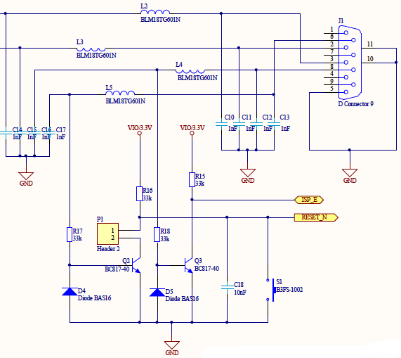Figure 17: RS 232 interface with attached In-System Programming interface

RS 485
The Recommended Standard 485 as well as the 232 describes the level and way of connection of a serial interface. In difference to the 232 standard, the levels on the 485 are higher so that both interfaces are not directly connectable. The principle behind both interfaces is similar, so that also the RS 485 is supplied by a LPC-internal UART with an attached level changer.
On the actual design, the RS 485 connections are used to create a parallel bus structure. This means that the whole bus consists in fact of two wires, on that several devices can be attached parallel. This principle is also shown in figure 18.
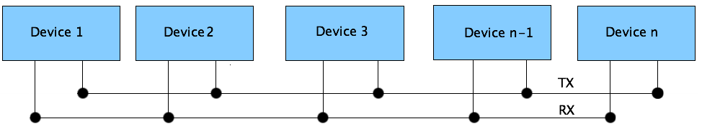Figure 18: Scheme of a parallel bus structure
The actual design contains two RS 485 interfaces and two external connectors to attach them, so that two individual bus structures are possible. Both connectors contain both interfaces, so that the connectors are not bound to one bus. Normally, a device within the bus requires two connectors to be build into the existing structure, because on both sides other members are available. The only exceptions are the master device at the beginning and the last slave device at the end of the bus. The actual design can represent both one device within the bus or up to two devices on one the two ends. Also, the device is able to be attached to both busses at the same time.

Ethernet
The ethernet connection is based on the multilayer principle of the OSI-model. The specific layers are designed in two different hardware devices, firstly the Physical Layer (PHY) and secondly the Media Access Control (MAC) .
The PHY is responsible for the physical connection between the outside network and the central processor. It is as far as possible automated and only contains a few registers to be configured. The physical layer is the first, bottom layer of the OSI-model. The MAC as second, next layer is the data link layer and responsible for a reliable, as far as possible error-free data transfer. On the LPC, the MAC is integrated as a hardware interface and communicates with the PHY with a special interface called Reduced Media Independent Interface (RMII). This interface is designated to the communication between these two OSI layers and can either be in full transfer mode with four bits parallel (MII) or in reduced mode with two bits parallel (RMII).
The ethernet layers are supplied by an own crystal and the PHY is partly supplied by an special power supply of 2.5 V.

CAN
The Controller Area Network (CAN) is a common used bus in industrial or automotive vicinities. The LPC 2388 processor contains two independent CAN interfaces, which both consists of each a receive and transmit line. To access a CAN bus with the processor, a external CAN receiver transmitter device is required to change the receive and transmit lines to the specified levels. Depending on the transfer speed, the number of connected devices and the distance to the bus, a 120 Ω resistor is required to terminate the bus between its high and low signal wires. The complete CAN connections circuit is shown in figure 19, where P14 represents a jumper to manually terminate the bus connection as mentioned above if necessary.
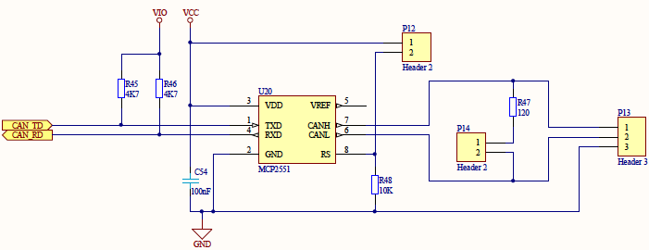Figure 19: CAN connection circuit

Memory

EEPROM
The Electrically Erasable Programmable Read-Only Memory (EEPROM or E²PROM) is accessed via SPI by the processor. To warrant low latency, the memory is attached to an own serial interface on which no other devices are connected. Due to its properties as a non volatile memory, it is used to store important variables or data concerning the device or a special part of a program, that belongs to this device and should be accessible even if the original program code in the processor is updated or changed. The advantage of this memory is the fact that it is accessible byte-by-byte, which allows a comfortable and fast access and storage of single variables or smaller arrays. In difference to that, most memories are accessed in a certain page-size which demands to read or write always a whole block, mostly of 512 bytes, which is more comfortable on working with bigger data sizes, which is not given in this case.
The EEPROM is used to store board-specific data like serial numbers, certain MAC-address spaces or special values like calibration multipliers. Because these data belongs to the device and not to the specific program running on it, it is more comfortable to store them externally. To attach the memory device to the processor, no further devices like level changers are needed. It is directly connected to the first SPI of the LPC.

MCI
The Memory Card Interface (MCI) is used to attach removable memory to the processor. It can either work with Multimedia Cards (MMC) or Secure Disks (SD). The LPC contains a implemented MCI, that can be set up with just a few registers. It works with a certain set of commands, that mostly fit to both kind of cards. Only one command on the initialisation and a few commands for multiple access to the card differs. With the initialisation difference it is possible to scan which kind of card is inserted to the card. In hardware, the MMC is only reachable with one data line, where a SD can be attached either to one or four data lines parallel, which allows a much higher transfer rate up to 5 MB/s. Due to interoperability, all four data connection will be realised. In addition to that, the MCI contains one clock line and one command line. Furthermore, two switches allow scans whether a card is inserted and if its write-protected (SD only). This protection is based on a mechanical switch build to the SD card, which can easily be overridden by software. It will be implemented and used as a kind of notification to prevent of accidentally overwriting.
The data lines all need to be pulled up to 3.3 V as well as the both switch lines. A own power line (MCI_PWR) from the MCI is used to switch the power supply of the card. This line is automatically controlled by the interface. The power status becomes visible with an included LED. This supply control circuit is shown in figure 20.
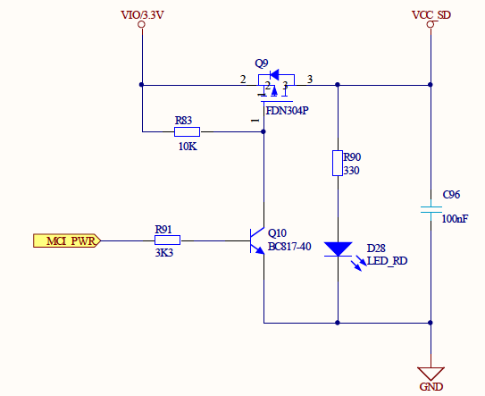Figure 20: Power supply and control of the MCI

Printed circuit board design
The design of a printed circuit board is the more complex part of the hardware development. Although there is hardly research action left to do, there are a lot of possible errors in this step of development.

General information on the printed circuit board design
Printed circuit boards are common devices available and used almost everywhere in normal life, from the coffee machine up to the mobile phone or the notebook. A board is not only used to support electrical connections between components but also to hold them. So aside from electrical attributes, also the mechanical and even thermal properties are important for the design. In some cases, a board holds bigger and heavier components or is used to conduct lost heat from components like processors or integrated power circuits. These an probably several more issues must be considered on a PCB design before the first connection is drawn.
The starting point of a prototype board like the actual design differs from a commercial, maybe massed-produced product. The first difference is given with the size of the board, which is mostly prescribed on commercial products by the used enclosure. In most cases also the positions of some special components like switches or LEDs are given due to their accessibility. These specifications decreases the possibilities of the designer, which may be a advantage in the beginning but can also be turned to a drawback at the last connections. On a prototype development with no specifications about positions and sizes like the actual design, the first step normally is to chose positions for attachable components like connectors, interfaces, LEDs and switches. Also it is common to place the central processor in the middle of the board in order to reach it from every side. The size of the board is at first chosen a bit bigger than necessary and is firstly fitted to a possible size when the mentioned positioning is done. Many further positions and design parts of components and circuits result from this. The last decision before the designing process is the definition of the used layers. Normally, the designer chose between a one, two or a multilayer design. The difference between these is mainly given in the power supply and the costs. PCBs with inner layers are more expensive but allows inner power and GND plains, which permits a low-impedance power supply at every position of the board without getting problems to route the signal layers. Smaller design are normally designed on two or even just one layer. On larger or more complex designs, usually a multilayer design is chosen, because the advantage of easier routing and the lower impedance outweighs the higher costs. Multilayer PCBs must always contain an even number. It is common to start with four layers and add more signal layers only if necessary. Normally, the inner layers are used for GND and power and the outer layers for the signal routing. This is mainly caused by the fact that all components are mounted on the outer layers and must be attached on them. Also it is advisable to route the signals of both layers 90° staggered to prevent of crossed connections on one layer.
The different layers are connected to each other by so-called vias, which are small, metallised holes, that establishes a connection between at least two layers. A via can be build on two ways, where the first is a fully metallised hole through the complete board that connects every layer. The second kind only contains conducting material between the layers that should be connected to each other. The first possibility requires an isolating area around the via on every layer, that should not be connected to the signal. The second method only involves the layers that should be connected to each other but is more complex in production and because of that more expensive than the full metallised via.
The not-used areas on the signal layers can either be left free or filled with plains connected to GND. Filling reduces the impedance and saves vias to the GND layer. It also reduces noise and interaction between signal lines and can cause a more stable system.

Designators, values and synonyms in PCB designs
The designators, values and synonyms already described in17.1.3. Designators, values and synonyms in schematics on page 28 are also used in the PCB design. It is common to just write the designator next to the component on the board surface. The reason why values are normally not added to the board is that values are usually mentioned on the component by the manufacturer. The designators are helpful additions to the design both for the person that places the components on the board and also for the designer on checking and eventually debugging the design. It is advisable to keep one or at most two different writing directions on the board and also to place the designators as near as possible to the component. Only if a lack of space occurs, designators should be left out.

Component positioning
A complete overview on the layout of the PCB with the positions of every component is shown in figure 21.
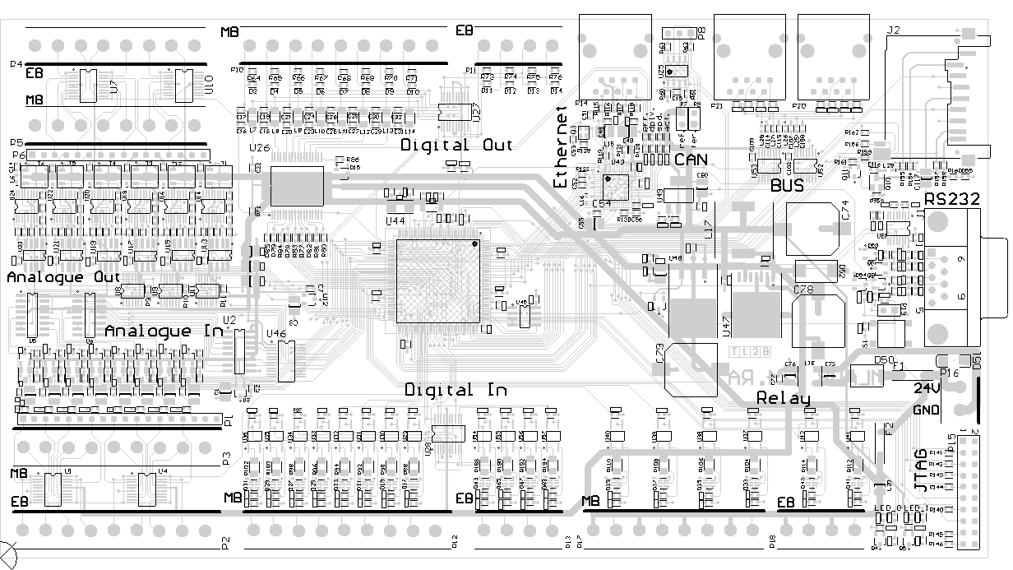Figure 21: Overview of the component positions
As shown, both the analogue as also the digital in- and outputs are routed to a adversed, similar design. The outputs are all located at the top edge and the inputs at the bottom edge of the board. This is mainly caused by a better overview and to minimise the risk of wrong connections. All these in- and outputs sections and in addition to that the relay inputs insist of two connectors, where one is routed to the basic settings and the second one can be used instead of at least several of the basic channels. In case of the analogue circuits, all channels are switches either between the main board (MB) or the extension board (EB) connector. On the digital circuits, only four of the eight existing channels are switched. These are the first four channels from the left on the main board connector. The last four channels are applicable in both modes. On the relay inputs, all channels are reachable without a switch in between. The analogue circuit connectors are placed in a special way with the pin-grid, where the pin wired to the connector (Xi) is always routed in a row to its corresponding pin on the connector, and the other pin of the grid wired to the converter circuits (Xo) is placed in the gap between two connector pins. This placement is exemplary shown in figure 22 by the connectors of the analogue outputs.
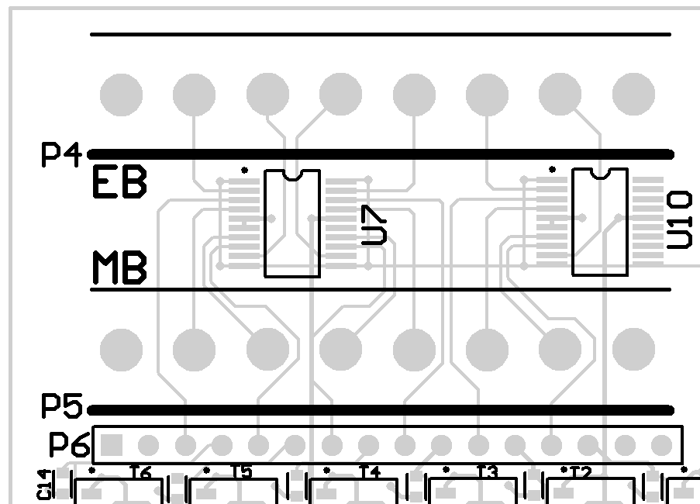Figure 22: Pin-grid placement of the analogue outputs (numbers added manually)
On the top edge next to the outputs, all circuits concerning the communication with the testee are located. This affects the complete ethernet circuit including the PHY, the CAN circuit and the RS 485 bus assembly. To reduce impedance, the last step-down voltage regulator stage for the ethernet circuit is located directly next to the PHY.
Figure 23 shows the layout of the communication circuits. Because the ethernet and the bus assembly both use the same connector, they are separated from each other with the CAN interface to reduce the risk of wrong connections which may harm the RS 485 level changer or the ethernet PHY. Also shown with this figure is the possibility to manually add text strings to the board. This is advisable on some components like jumpers or special LEDs. In case of the PHY, the four available LEDs show different stats of the actual ethernet connection, which are rather readable with their logical meaning than just with their designators. Same is for the two jumpers of the CAN interface, where one of them activates the bus termination and the other one disables the transceiver.
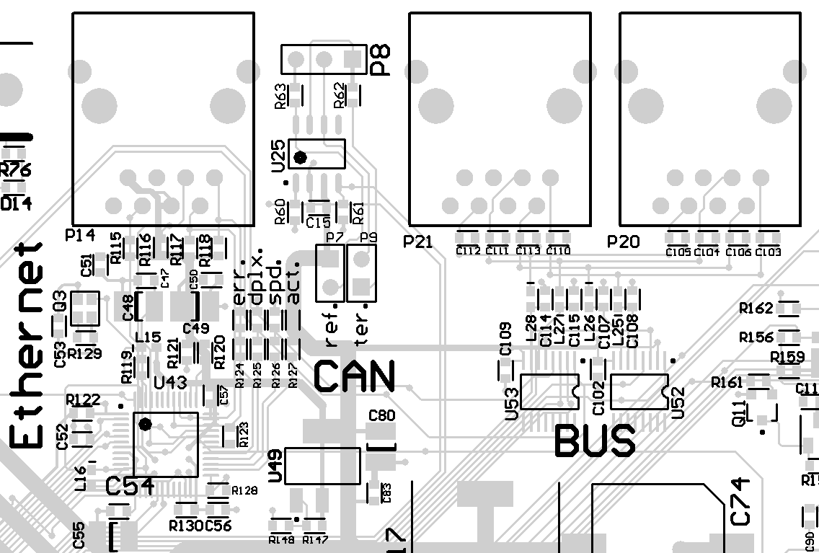Figure 23: Communication circuits (ethernet, CAN, bus)
On the right edge of the board, the more user-specific components are placed. This mostly concerns the RS 232 and the JTAG interfaces, with which the user controls the board. Also, the power connector, the reset switch and the MCI cardholder are placed in this area. This is chosen this way, because the surrounding circuits (bus, CAN, ethernet at the top, relay inputs at the bottom) leave much free space to place the relatively big power circuit components like step-down regulators or capacitors. To reduce the impedance of the supply circuits, the lengths of the wires between them should be kept as short as possible, which is easiest done in this free area of the board. Figure 24 and 25 show the impedance-relevant connections on the power supply circuits in the schematic (figure 24) and in the PCB (figure 25) with red highlights.

Figure 24: Impedance-relevant connections on power supply in schematics
Figure 25: Impedance-relevant connections in PCB
At least, two free usable LEDs are located at the bottom right of the board. They are designated to show the actual status of the processor, for instance a normal running mode with a blinking LED and an active procedure with a permanent illuminated LED.

Software development

Tester
The software for the tester device is split into several sub-projects, which is on the one hand caused by a better abridgement but on the other hand makes the single software parts much easier portable to other projects based on the same processor architecture.
The following chapters deal and explain the individual parts of the software. The annotations are kept to the more general functionality of the code and will not be too detailed. Only basic approach used in the whole project (for instance register manipulation) or very special program sequences will be clarified with example code lines or the corresponding, special code section. Also, special approach of code-style is shown with short examples in the chapter, where the example belongs to.
As far as possible, already written code or software parts, which are only assumed to this thesis, will be marked as so. Every code file in the addendum got an file header, in which the initials of the author or authors and the date of the file creation is mentioned. Foreign sources such as open source projects contain own file headers with the licence agreement, which regulates the private and commercial usage of this code.
The most parts of the software mentioned and explained in the following chapters were created and tested on the target hardware. Nevertheless, the complete software is based on the considerations from chapter CONSIDERATIONS on page XYZ. Occurring problems with this software during the development and testing/debugging of the complete test environment with the testee will be mentioned, explained and (if possible) solved in chapter MERGE on page ZYX.

Hardware configuration
The hardware configuration of the processor is split into four different parts and several different files of the project. The most elementary part is the linker script, which is used by the compiler to manage the memory parts of the processor. The used LPC 2388 processor contain several different memory sections like the FLASH to store the software code and a general RAM section on which variables are created and commands are executed. Moreover, the ethernet and the USB interfaces contain own, small RAM sections to store the corresponding stacks. These Sections are all mentioned in the linker script.
The second part is the basic processor configuration, which mainly insist of the different clock settings. Although the processor component is attached to only two different crystals, the internal devices and interfaces need several different clock cycles. This is done by internal clock prescalers, which are to be configurated, set and enabled as one of the first steps done with the processor boot up. In fact, the complete clock management depends on the external 12 MHz oscillator. The second crystal of 32,768 kHz is exclusively used by the intern realtime clock.
Where the first two parts of the processor set up are more general settings which can be used on almost every project based on the LPC 23xx family and are set before any application is called, the other two steps depend much more on the application(s) executed on the processor. The third step is the enabling and configuration of used internal devices like the interrupt vectors, the memory acceleration module or the watchdog module. The last hardware set up part is the pin configuration. These settings depend only on the application and the attached peripheral and are set just the application using these pins.
Any hardware setting must be written to the corresponding registers of the processor. Because of the strict 32-bit architecture of the ARM cores, all registers are accessible on 32-bit addresses and are 32-bit wide. As already mentioned in HW_DEVELOPMENT, the GPIOs are bundled to five banks with up to 32 pins, which can be set with writing a logical '1' to the corresponding bit in the banks SET register and are deleted by writing a logical '1' to the corresponding bit in the banks CLR register. Writing a logical '0' to one of these registers has no effect. The procedure of using two different registers to set and delete a pin is not common but allows an interrupt-stable programming and write- or read-access to all to the corresponding register attached pins in only one clock cycle. On regular registers, setting and deletion of a bit is done in the same register.
Beside the GPIO configuration registers, the processor contains a lot more set up registers for the several interfaces, which partially need many configuration data. The general access to the registers is possible either directly on the 32-bit address or with pointer variables to these addresses. The first method is easier and faster usable, because no additional file containing all the pointers must be written. On bigger projects, the second method is advisable because the code becomes much more read- and serviceable if the pointers are named like the corresponding registers in the processor user manual. Appropriate files containing already defined pointers are available for most ARM processors in example projects of development board manufacturers. In this thesis, this file is called LPC23xx.h and contains individual pointers to all accessible registers.
The application of pointers allows direct access to the registers but also requires detailed bit-manipulation. It is always advisable to only change the actual bit(s) with logical AND or OR assignments. When using this, it is not possible to set and clear bits in a register within one step. This must be done successive. The only exception is to change the complete register value coevally, which should only be used if the non-actual bits do not matter or are not used. Otherwise, certain initialisation or function sequences could be disturbed by setting bits in wrong moments. The following code fragment (code 1) shows the definition and usage of register pointers to set and delete a pin with an attached LED.
The next code fragment (code 2) shows a typical register set up with predefined bit-masks and afterwards logical assignments to set or clear certain bit in a register. As shown, the first writing to the register overwrites every available bit, because this special register is not used before this statement and all other important bits are changed afterwards. This style of code-writing is more extensive but on the other hand easier readable and serviceable, because the use of the mask names shows at first sight, what part of the configuration is affected and the used method of writing the operator shows directly if the corresponding bit(s) are set or deleted. To get to know the meaning of a set or cleaned bit in a register, the mask definitions are commented with their effects to the processor.
/* Fast Input/Output pin setup registers in LPC23xx.h */
#define FIO_BASE_ADDR 0x3FFFC000
#define FIO4DIR (*(volatile unsigned int *)(FIO_BASE_ADDR + 0x80))
#define FIO4MASK (*(volatile unsigned int *)(FIO_BASE_ADDR + 0x90))
#define FIO4PIN (*(volatile unsigned int *)(FIO_BASE_ADDR + 0x94))
#define FIO4SET (*(volatile unsigned int *)(FIO_BASE_ADDR + 0x98))
#define FIO4CLR (*(volatile unsigned int *)(FIO_BASE_ADDR + 0x9C))

/* LED Mask definitions in LED.c driver file */
#define LED0_MASK 0x00000010 /* LED is attached to pin 4 of bank 4 (P4.4) */

FIO4SET = LED0_MASK; /* Switch on LED by setting corresponding pin */
FIO4CLR = LED0_MASK; /* Switch off LED by deleting corresponding pin */
Code 1: Example of register manipulation to set and clear an external pin
If a mask is used in Eclipse, the mouseover display shows this comment, although the definition is outside of the actual screen or even the file. This special behaviour is shown in figure 26, where the mouse (not visible) points to the EMC_WRITE_PROTECT mask.
/* static RAM access register configuration in LPC23xx.h */
#define EMC_STA_CFG0 (*(volatile unsigned int *)(EMC_BASE_ADDR + 0x200))

/* EMC CONFIGURATION REGISTER MASKS in EMC.c */
#define EMC_BANDWIDTH_8 0x00000000 /* Bit 0-1. 00: 8 Bit */
#define EMC_PAGE_MODE 0x00000008 /* 1: Async mode, 0: disabled */
#define EMC_CS_POLARITY 0x00000040 /* 1: Active HIGH, 0: active LOW */
#define EMC_EXTENDED_WAIT 0x00000100 /* 1: EW enabled, 0: disabled */
#define EMC_BUFFER_CONTROL 0x00080000 /* 1: Buffer enabled, 0: disabled */
#define EMC_WRITE_PROTECT 0x00100000 /* 1: protected, 0: not protected */

/* Set up Static Memory Configuration Register in EMC.c */
EMC_STA_CFG0 = EMC_BANDWIDTH_8; /* 8 Bit Buswidth and Register Reset */
EMC_STA_CFG0 |= EMC_PAGE_MODE; /* Async Page Mode */
EMC_STA_CFG0 &=~EMC_CS_POLARITY; /* Active LOW Chip Select */
EMC_STA_CFG0 &=~EMC_EXTENDED_WAIT; /* Extended Wait disabled */
EMC_STA_CFG0 &=~EMC_BUFFER_CONTROL; /* Write Buffer enable */
EMC_STA_CFG0 &=~EMC_WRITE_PROTECT; /* No write protection */
Code 2: Example of the register manipulation codestyle with set and clean statements
Figure 26: Example of the mouseover display function in Eclipse IDE
A last option to manipulate the processor registers is to build structures of every register with members for all mated bits. This method allows an easier usage, because the members can be used as normal variables and so set and clean bits within one step. The disadvantage of this method is the high effort to create the structures as well as the compiler will in fact build the same bit manipulation commands like the method shown in code 2, with the difference that the structure method does not show what the compiler will generate of the code as good as the direct manipulation method does.
Because the software development is for most parts done on other devices than the target tester board, the individual hardware-using software segments are switchable between three different hardware environments by changing only the switch. These environments are firstly a development board from the manufacturer Olimex, a company-intern product called IO-Controller, which is in several parts similar to the tester board and lastly the tester board itself. Code 3 shows the switch definition and the general usage within this thesis. The keyword \MARK is part of the Eclipse task function, that allows to mark codelines or -sections with several, self-created keywords like for instance \TODO, \NOTICE, \REMIND. The slash identifies the following word as a task keyword. All lines marked this way are mentioned in the Eclipse task window and allow a direct step to this line or section.
/* Pinset Switch declaration and definition in LPC23xx.h */
/* For Olimex DemoBoard : PINSET_TESTER = 0
* For Pinsettings of IO-CTRL REV_C: PINSET_TESTER = 1
* For QUA_2475_TESTER : PINSET_TESTER = 2*/
#define PINSET_TESTER 2

/* PINSET_TESTER switch usage in example file (dac.h) */
// \MARK NEW PINSETTINGS FOR TESTER (2)
#if (PINSET_TESTER == 2)
#define maxDAC_Channels 6 /* If actual board is tester, set 6 DAC channels */
#else
#define maxDAC_Channels 4 /* If other board than tester, set 4 DAC channels */
#endif
Code 3: Definition and usage of the pinset switch

FreeRTOS operating system
The Free realtime operating system (FreeRTOS) is an open source operating system for embedded systems and is available for many different processors. It is free usable for private as well as commercial applications, but without any warranty. The operating system is already ported to the LPC23xx processor family, which allows an easy usability and require just minor customising to the tester application, such as memory allocation. FreeRTOS contains realtime behaviour, and beside of that multitasking functionality, time basics and semaphores.
The multitasking principle is in fact just an illusion, because every conventional processor can only execute a single command per cycle. The trick is to rapidly switch between single tasks and make it appearing like multiple tasks are running concurrently. This is shown in figure 27, where the upper graph displays the subjective and the lower graph displays the real behaviour of the system. The order, in which the individual tasks are executed after another can be affected by the priority assigned to every new task.
Figure 27: Multitasking principle of FreeRTOS (source: FreeRTOS.org)
FreeRTOS requires at least one task running in an endless loop. This is caused by the fact that the complete operating system insists of a simple application that is ended, if no more code is available to execute. As long as the so-called idle_task runs, the system is still active and new functions and tasks can be called or created (for instance by interrupts). The idle_task of FreeRTOS is comparable with the idle task of other operating systems like windows or unix. New tasks are created with the command xTaskCreate with parameters like the function name, function arguments, the priority and the stacksize. The task management system is based on the principle of endless tasks, which means that tasks that ends because their code ends are not deleted. They can be started again without any need to recreate them. So of course they also block memory in the stack if they are just ended and not deleted with the command xTaskDelete.
Time basics are of great importance in real time systems. The operating system is able to create a quite simple usable time stamp in milliseconds. This allows to directly handle with times within the code. The command vTaskDelay in combination with a time in milliseconds forces the system to hold the containing process for the given time. Thus, almost 100 per cent of calculation time becomes available for other processes.
Semaphores guarantee the exclusivity of functions. Even in stressed and critical situations, a real time operating system needs to keep its ability of forecasting. In many cases, more than one process are able to access a certain function or variable. In critical situations, these parallel-accessible functions must be secured of a simultaneous access. Usually, this is done by flags behaving like normal variables which are changed and asked for their value. Although this method is the more simple one, it contains a important disadvantage: when multiple accesses for the same flag come in in the same cycle. Because processes are worked serially even in the same cycle, the first process sets a variable and is not able to get to know what happens to it in the rest of the cycle. The more technical form for this is dividable. In contrast to that, semaphores are undividable. In FreeRTOS, semaphores are from an own type and are not used like normal variables but are taken and released. When a semaphore is taken, another access, even in the same cycle, is not possible anymore as long as the same semaphore is not released or an optional time is over. The function xTakeSemaphore returns a numeric value that indicates if the semaphore was taken or not. The software then is able to ask for this and act further. Exceptions are numeric semaphores; they are able to be taken multiple times up to a defined maximum. With xReleaseSemaphore, a semaphore is freed for a new access. If multiple processes try to access an already taken semaphore, FreeRTOS will not create some kind of queue list for it. The access will be given to the first process in stack. Also a queue list based on priorities is not possible. So in worst case a process always or never takes a semaphore.

Drivers
The drivers sub-project contain all functions necessary to access all internal or external attached periphery, which also includes special hardware configurations as mentioned in 18.1.1. Hardware configuration on page 47. Hereby each periphery or device got an own driver structure, which insists of a header- and a codefile (see figure 28). If a certain periphery becomes more complex (like for instance an USB stack), the code should be divided to more than two files and arranged to an own subfolder. The basic idea of this structure is a maximised dynamical usage.
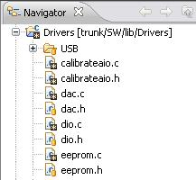Figure 28: Driver file structure
Each driver contain an initialisation function, which sets hardware configurations (e.g. pin settings), starts up or loads special interfaces, allocates memory and sets the periphery to a certain start condition. In the following, functions to interact with the corresponding periphery are available within the codefile, for instance read and writefunctions on the memory drivers or special algorithms to build SPI commands. Each of those functions, that should be available from outside of the corresponding codefile is declared in the drivers headerfile. Also, driver-specific type definitions, settings and variables, which should be used from other functions, are declared in the header. With this method is is possible to simply include the drivers headerfile to an application file and with that get full access to all data types, functions and drivers-specific variables.
The initialisation functions are usually called from the main function right before the operating system becomes active. On the initialisation sequence, a certain order must be complied, because some peripheries depend on each other, as for instance the EEPROM depends on the SPI bus. In general, the whole driver subproject should contain as less dependencies and interactions with other projects as possible. In the actual software, the drivers only depend on the register-definition file LPC23xx.h, the custom data type definition file types.h and in some cases on parts of the operating system.

Communication protocol

Test applications

Additional software

Testee

Test software integration to the existing software

Communication

Script and C-Code development for individual test applications

Merging of both devices

Analysis of accrued problems

Adjustment of applications

Development and Adjustment of result calculating applications

Test application run cycle

Fazit

Literature

