Hardware development of the tester

Schematic development
The hardware development usually begins with the design of the schematics. These contain every electrical component and connection which should be prospectively available on the PCB. On projects with a higher amount of electrical devices and wirings, the schematic drawings are usually divided to contiguous circuits like the boards power supply, the input- and output section of the main processor and the like. Also, multiple used circuits or circuit parts should be split to an own schematic to prevent of repeated drawing.
In order of a better abridgement, the schematics for this project should also be divided as mentioned above.

General information for schematic designs
The schematic design represents the actual research part of the hardware development. Because of that, this activity usually takes a higher amount of time then the PCB design afterwards. Depending on the future use of the device, the designer is not only responsible for the pure electrical circuits but also for the compliance of (international) norms or the costs of the device. These topics are normally more important on mass produced and public-used products and force the designer to search and compare several and partial a lot of different devices to make the circuit fitting as much as possible to the wanted target. But although the costs or norms are minor motivations on a prototype or single device development, the choice of the components takes some time. In addition to that, the use of non-common devices or ICs mostly forces the designer to create new component symbols in the design environment. Although in the schematics only a few different symbols are used, these components may differ on the further PCB in size (e.g. common resistors and power resistors, which both got the same schematic symbol but need size-different PCB symbols). On SMD devices, these symbols need to be very accurate. In a commercial facility, it is usual to supplement the components with the manufacturer name, the manufacturer code and order codes of the common used device distributors. Also alternatives are sometimes necessary.
These tasks rather concerning organisation parts are mostly important in commercial surroundings, where usually more then one designer design several PCBs and is commonly called “library care”. The more accurate these libraries are created and supported, the easier is the future use of it for all designers, who all then can access new libraries and/or components.

Introducing information
The schematic drawings will contain several components and circuits with different purpose, so the division of the schematic to more sheets is advisable.
The following chapters are to explain the created circuits and their purpose.

Power supply section
As mentioned in KAPITEL 2, ÜBERLEGUNGEN, the whole board will only be supplied with a constant power source of 24 Volts. Nowadays, this is the most common power supply available in development and industrial vicinities.
Although there are some circuits that are designed to work on 24 Volts supply, most of the circuits and components are to be supplied with a much lower voltage. It is advisable to chose the components that way that they fit as far as possible on the same voltage. In the actual schematic, seven different voltages are needed, which are mentioned in table 1 with their schematic names, values and main purpose.
Name | Value | Purpose
VIN | 24 V | - Unfiltered voltage from the external supply  - Supply of VIN_DIGI
V24 | 24 V | - Switching voltage of multiplexers  - Further transformation to VCC
VIN_DIGI | 24 V | - Reference voltage of digital in- and outputs
VCC | 5 V | - Supply of integrated circuits like level changer  - Supply of status LEDs  - Further transformation to VIO and VCC_ETH
VCC_ANA | 5 V | - Extra filtered 5 Volts supply for analogue in- and outputs
VIO | 3.3 V | - Supply of main processor  - Supply of integrated circuits  - Supply of JTAG interface
VCC_ETH | 2.5 V | - Supply of external ethernet PHY circuit
Table 1: Scheme of used voltages with schematic-used names, values and general purpose

As protection, the power supply circuit contains several special components. Directly parallel to the power supply connector (P19), a supressor diode protects the following circuits against overvoltage. In row-connection to the following circuits, a 1.35 A fuse protects the boards against high current flow e.g. caused by short lines and in connection to that a diode prevents of fault connection on the main power supply connector. At least, a choke reduces possible noise of the supply. The protection part of the power supply circuit is shown in figure 1:
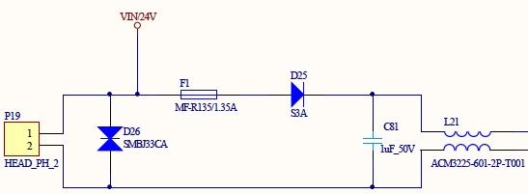Figure 1: Power protection circuit on power supply
The filtered 24 V behind the choke is used to supply the multiplexers with a high switching reference voltage as well as also supply further transformations to lower voltages. The first step-down regulator takes voltage down to 5 V. This transform-stage is mainly responsible for the correct supply of the whole board, because it supplies several devices directly as well as it also drives a second stage to 3.3 V and a third stage to 2.5 V. Because of this requirements, a high quality and stable step-down regulator with high current throughput is necessary. Since the possible high current, it is highly recommended to adhere the impedance of the regulator. The second step-down stage to 3.3 V is directly driven by the first one and is mainly to supply the central processor as well as the most internal devices like level changers and memory interfaces. These devices are all not highly sensitive against voltage-fluctuation, but nevertheless a regulator with high output should be chosen since otherwise a consumption peak may cause voltage drops, which in turn may cause a unmeant restart of the processor. The last stage only partly supplies the ethernet PHY and must not be chose as a high quality device due to the PHYs purpose.
As seen in table 1, the digital and analogue in- and outputs are supplied with an own voltage. This is mainly caused by their purpose. The supply for VIN_DIGI is gripped directly from the external supply in front of any filters or security components like fuses. In future use, this voltage supplies the digital outputs, which are mainly designed to drive optocoupler-circuits on a second, unknown device. Because the functionality of these inputs cannot be warranted and may be short-lined for any reason, they can cause a much higher current than the outputs are designed to drive. To prevent the whole board of the risk of damage, this supply voltage is separated and secured by an own fuse right in front of the main fuse of the board. This is shown in figure 2, where P19 is the connector for the external power supply (Pin 1: 24 V; Pin 2: GND).
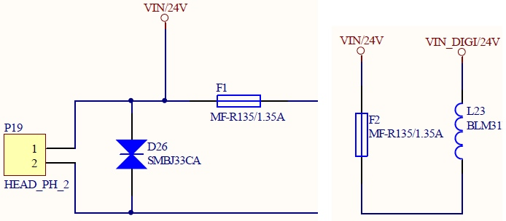Figure 2: Scheme of the main power supply security

From the already to 5 Volts transformed voltage VCC, an additional supply (VCC_ANA) is split for the analogue in- and outputs. This is mainly caused by noise reduction on the power lines in order to achieve a more stable reference voltage on the analogue-digital (ADC) and digital-analogue (DAC) converters as less as possible influenced by the current consumption of all other VCC-supplied components. To achieve this, VCC_ANA is filtered and stabilised from VCC as shown in figure 3:
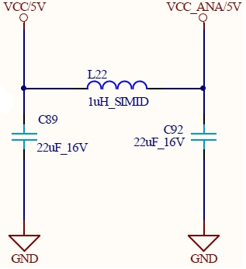Figure 3: Filtering of analogue supply voltage

Central processor

In- and outputs

Communication

