Hardware development of the tester

Schematic development
The hardware development usually begins with the design of the schematics. These contain every electrical component and connection which should be prospectively available on the PCB. On projects with a higher amount of electrical devices and wirings, the schematic drawings are usually divided to contiguous circuits like the boards power supply, the input- and output section of the main processor and the like. Also, multiple used circuits or circuit parts should be split to an own schematic to prevent of repeated drawing.
In order of a better abridgement, the schematics for this project should also be divided as mentioned above.

General information for schematic designs
The schematic design represents the actual research part of the hardware development. Because of that, this activity usually takes a higher amount of time than the PCB design afterwards. Depending on the future purpose of the device, the designer is not only responsible for the pure electrical circuits but also for the compliance of (international) norms and/or the costs of the device. These topics are normally more important on mass produced and public-used products and force the designer to search and compare several and partial a lot of different devices to make the circuit fit as much as possible to the wanted target. But although the costs or norms are minor motivations on a prototype or single device development, the choice of the components takes some time. In addition to that, the use of non-common devices or ICs mostly forces the designer to create new component symbols in the design environment. Although in the schematics only a few different symbols are used, these components may differ on the further PCB in size (e.g. common resistors and power resistors, which both got the same schematic symbol but need size-different PCB symbols). On SMD devices, these symbols need to be very accurate. In a commercial facility, it is usual to supplement the components with the manufacturer name, the manufacturer code and order codes of the common used device distributors. Also alternatives are sometimes necessary.
These tasks rather concerning organisation parts are mostly important in commercial surroundings, where usually more then one designer design several PCBs and is commonly called “library care”. The more accurate these libraries are created and supported, the easier is the future use of it for all designers, who all then can access new libraries and/or components.

Introducing information
The schematic drawings will contain several components and circuits with different purpose, so the division of the schematic to more sheets is advisable. The following chapters are to explain the created circuits and their purpose.
The schematic drawings are organised in a hierarchical way with three layers. The lowest of these are circuits, which are used several times and are included to other circuits. The mid layer contains all one-time used circuits and are brought together on the highest layer, which is called top sheet.

Designators, values and synonyms in schematics
Every component in the schematics must be explicit assignable and as far as possible specifiable. For this, normally three different specifiers are used, either in the schematics but also later on in the PCB. These specifiers are: designator, value and synonym. Figure 1 shows the usage of these specifiers, where the letter “C” is the synonym, “22uF_16V” is the value and the number “C92” is the designator, which is in fact a combination of the synonym and an individual component number. Where this number can exist several times on different components, its combination with a synonym is unique.
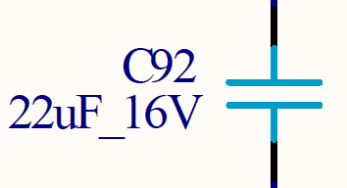Figure 1: Example of the usage of the different specifiers
The synonyms are used to show the kind of the component on first sight. They are not normed but normally used akin. Table 1 explains the used synonyms in this thesis with their component meanings.
Table 1: Overview of used synonyms and their component-meanings
Synonym | meaning
C | Unipolar capacitor, Electrolytic-capacitor
D | Diode, Schottky-diode, LED
F | Fuse
L | Inductor, Choke
P | Connector, Pin-grid, Header
Q | Transistors, Crystal
R | Resistor, Power-resistor
S | Switch
U | ICs, processors, any kind of integrated devices

Power supply section
As mentioned in KAPITEL 2, ÜBERLEGUNGEN, the whole board will only be supplied with a constant power source of 24 Volts. Nowadays, this is the most common power supply available in development and industrial vicinities.
Although there are some circuits that are designed to work on 24 Volts supply, most of the circuits and components are to be supplied with a much lower voltage. It is advisable to chose the components that way that they fit as far as possible on the same voltage. In the actual schematic, seven different voltages are needed, which are mentioned in table 2 with their schematic names, values and main purpose.
Table 2: Table of used voltages with schematic-used names, values and general purpose
Name | Value | Purpose
VIN | 24 V | - Unfiltered voltage from the external supply  - Supply of VIN_DIGI
V24 | 24 V | - Switching voltage of multiplexers  - Further transformation to VCC
VIN_DIGI | 24 V | - Reference voltage of digital in- and outputs
VCC | 5 V | - Supply of integrated circuits like level changer  - Supply of status LEDs  - Further transformation to VIO and VCC_ETH
VCC_ANA | 5 V | - Extra filtered 5 Volts supply for analogue in- and outputs
VIO | 3.3 V | - Supply of main processor  - Supply of integrated circuits  - Supply of JTAG interface
VCC_ETH | 2.5 V | - Supply of external ethernet PHY circuit

As protection, the power supply circuit contains several special components. Directly parallel to the power supply connector (P19), a supressor diode (D26) protects the following circuits against overvoltage. In row-connection to the following circuits, a 1.35 A fuse (F1) protects the boards against high current flow e.g. caused by short lines and in connection to that a common diode (D25) prevents of fault connection on the main power supply connector. At least, a choke reduces possible noise of the supply. The protection part of the power supply circuit is shown in figure 2:
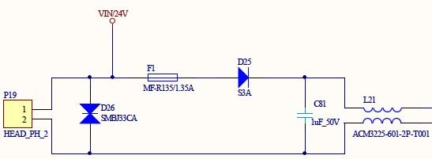Figure 2: Power protection circuit on power supply
The filtered 24 V behind the choke is used to supply the multiplexers with a high switching reference voltage as well as also supply further step-down regulators to lower voltages. The first of these step-down regulator takes voltage down to 5 V. This transform-stage is mainly responsible for the correct supply of the whole board, because it supplies several devices directly as well as it also drives a second step-down stage to 3.3 V and a third stage to 2.5 V. Because of this requirements, a high quality and stable step-down regulator with high current throughput is necessary. Since the possible high current, it is highly recommended to adhere the impedance of the regulator and its wiring. The second step-down stage to 3.3 V is directly driven by the first one and is mainly to supply the central processor as well as several internal devices like level changers and memory interfaces. These devices are all not highly sensitive against voltage-fluctuation, but nevertheless a regulator with high output should be chosen since otherwise a consumption peak may cause voltage drops, which in turn may cause a unmeant restart of the processor. The third, last stage only partly supplies the ethernet PHY and must not be chose as a high quality device due to the PHYs purpose.
As seen in table 1, the digital and analogue in- and outputs are supplied with an own voltage. This is mainly caused by their purpose. The supply for VIN_DIGI is gripped directly from the external supply in front of any filters or security components like fuses. In future use, this voltage supplies the digital outputs, which are mainly designed to drive optocoupler-circuits on a second, unknown device. Because the functionality of these inputs cannot be warranted and may be short-lined for any reason, they can cause a much higher current than the outputs are designed to drive. To prevent the whole board of the risk of damage, this supply voltage is separated and secured by an own fuse right in front of the main fuse of the board. This is shown in figure 3, where P19 is the connector for the external power supply (Pin 1: 24 V; Pin 2: GND).
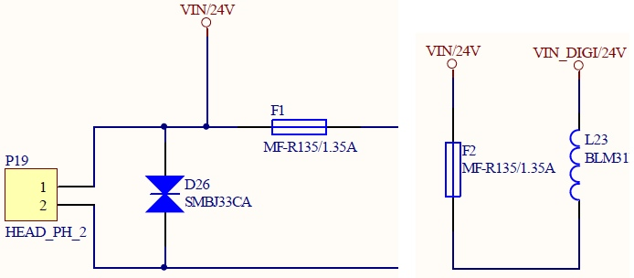Figure 3: Scheme of the separation of the digital output power supply

From the already to 5 Volts transformed voltage VCC, the additional supply VCC_ANA is split for the analogue in- and outputs. This is mainly caused by noise reduction on the power lines in order to achieve a more stable reference voltage on the analogue-digital (ADC) and digital-analogue (DAC) converters as less as possible influenced by the current consumption of all other VCC-supplied components. To achieve this, VCC_ANA is filtered and stabilised from VCC as shown in figure 4:
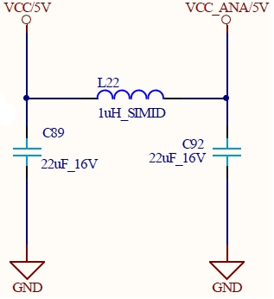Figure 4: Filtering of analogue supply voltage

Central processor
The central processor is, according to its name, one of the most important components in a digital circuit. Most common designs are based on only one central processor to do all work, where bigger or more complex designs divide several tasks like communications or special memory algorithms to so-called co processors, which are in turn controlled by one or more, to a cluster connected central processing unit(s). The actual design contains one central processor to do the whole work.
The LPC 2388 in the applied version with 144 pins causes a quite big schematic symbol. Due to the abridgement, this symbol should be divided to two or more single signs, which then can be split to several schematic drawings. It is advisable to split the symbol according to the purpose of the pins, e.g. GPIOs, power connection, the debug interface and the like. The processor is able to use most of its pins as a general in- or output, but also use them for instance as special communication or memory interfaces. In case of the LPC 2388, most of the pins support four different purposes. These different possible usages should be mentioned in the schematic symbol for each pin. Secondly, it must be decided, in which order the pins are printed. All applicable pins are grouped to five banks with up to 32 pins. These pins are not compulsorily consistent with the external pin number, which then allows a printout either according to the external pin numbering, which is more interesting for the further PCB design, or the logical bank order allowing a better overview for the software development. In this thesis, the second option will be used due to the design software which already contains a ready-to-use symbol for the LPC 2388 with the specified order. Figure 5 shows a partial pin printout. It shows the pins ten to 26 of the first pin bank (bank 0) with their different possible purposes. It is observable that the pins used for the digital inputs are setted to the general purpose where the pins concerning the MCI mostly are setted to a special interface function. Also, the figure shows the difference of the two ordering methods mentioned above where the external pin numbers are mentioned outside of the component above their corresponding pin.
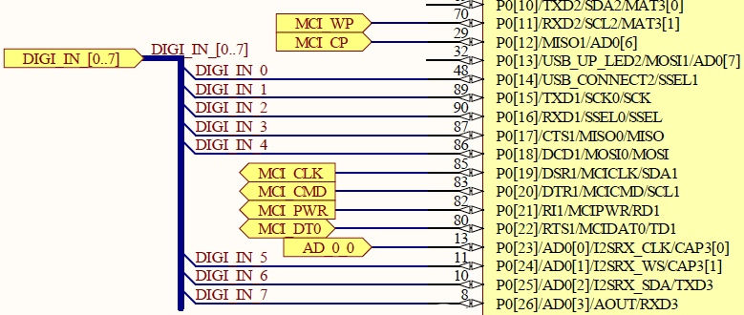Figure 5: Partial drawing of a pin bank of the central processor
Beside the adaptable pins, the LPC contains several more connections to the outside which are also grouped to four more schematic symbols. The first of these is the power connect block, which contains every pin used to supply the processor. Because the LPC contains several, independent interfaces, it is possible to supply some of them individually, for instance the build-in converters. Also, reference voltages can be connected separately. At least, the processor is able to be partly supplied with a battery. With this, the internal real-time clock (RTC) on a special part of the memory is still on power, so that for instance the clock does not need to be set up every time the processor is switched on. In the actual design, a battery supply is not designated, so that all of the supply pins are directly connected to the power supply of 3.3 V. Except for the battery supply pin, all power connections need to be buffered with an own blocking capacitor of 100 nF.
The next schematic symbol contains the crystal connections. The LPC 2388 must be driven at least by one crystal commonly with 12 MHz. Without this clock, the processor is not runnable. Although the internal circuits of the processor need different clock speeds, the whole component only needs to be supplied with one external crystal. The LPC contains special, individual clock divider registers for the interfaces and circuits that must be driven with different clock speeds. A second, much slower crystal with 32.768 kHz exclusively supplies the RTC. This is as mentioned above because the RTC is driven by an own supply-pin either on the normal power connection or on battery so that even in battery mode, the RTC crystal is supplied.
The fourth symbol contains the Joint Test Action Group (JTAG) debug interface connections. This interface allows comfortable debugging directly on the chip and is a powerful tool especially on prototype development. The interface connections are ready-to-use and only need to be added with pull-up resistors on the data and a pull-down resistor on the clock connection. Although the JTAG interface only contains six connections, it is common to use a 20 pin connector with 2 times ten pins in a row. This is because the JTAG controller outside the board (for instance a PC) gets also its power from the board via two pins and is able to act on some more pins with special actions. In the actual design, the JTAG controller can also drive the global RESET signal on the board.
The last symbol contains every not connected pin of the LPC. Although there are of course no connections to this symbol, it should be mentioned in the schematics to show which pins are not involved in the design.

In- and outputs
The design contains several kinds of in- and outputs with each several pins or channels. Because of this, this chapter will be split up to these different kinds.

Digital
The digital in-and output section is mainly designed to be connected to industrial sensors or devices. Digital means that each output contains two states, which are either HIGH or LOW. In industrial vicinities it is nowadays common to use 24 V logic, because electrical signals than can be carried on long distances. Also, each channel both of the in and outputs should contain an own LED that shows the actual state, where an illuminated LED means HIGH. Each eight digital in- and outputs are needed, from which each four must be switchable to an alternative connector.
To achieve in- and outputs fulfilling these requirements, on both ports some special circuits are necessary. On the outputs, the first step is to raise the LPC output level from 3.3 V to the required 24 V. For this, special so-called high-side switches are available. This device is designed to a certain input logic and raises this to a also certain output level. The high-side switch is supplied by the special secured digital 24 V voltage. The output signal from the switch is then filtered with a CLC low-pass to protect the output against chattering and reduce noise. At least, the signal is wired to a connector to be able to grip the signal externally. Before, the required LED is connected to the signal between the CLC and the connector with a series resistor to ground. A special component is the four-channel multiplexer that allows to switch four digital outputs between two connectors. It is controlled by only one line coming directly from the central processor. The signals the multiplexer should switch are gripped between the CLC filter and the LED connections.
The digital inputs are working the inverse way to the outputs. The only difference is the method to reduce the incoming voltage of 24 V to a level the processor can handle. This is done with a optocoupler circuit that also realises a complete electrical detachment between the incoming signal from a foreign device and the own board, which is shown in figure 6. The optocoupler is secured with a special diode (D3) component that prevents of misconnection and wired to a LED (D2) showing the actual signal status. The coupler (U2) output creates a inverted signal with a pull-up resistor (R5) pulling the output to HIGH when the coupler is not active and pulling down the signal to 0 V when the coupler becomes active. This inversion must be considered in the software. Afterwards, eight of the input signals are wired to a multiplexer to use each four of them. The multiplexer is already known from the digital outputs.
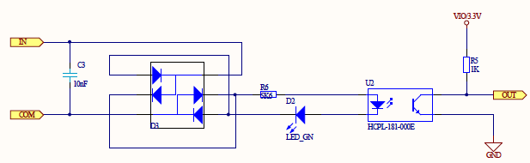Figure 6: schematic of the optocoupler input circuit

Relay
The relay inputs are working the same way then the digital inputs described chapter 1.1.6.1. Digital on page 7, which means that in fact they consist of the optocoupler circuit shown in figure 6. The only difference to the digital inputs mentioned before is the circuit on the testee, which not drives only 24 V to an output but switches an incoming signal, so that it has no power consumption of this action. Because of that, every relay-input got its own 24 V output signal, that should be switched by the testee. In addition, the incoming signal must not refer to 24 V, which is just the maximum the relais is able to switch. A certain range of voltages between X and Y can be switched.

Analogue
The analogue in-and output circuits are the most complex circuit parts in the design. This is mainly caused by three specific requirements to these circuits. Firstly, the internal converters of the central processor should not be used due to their insufficient accurateness which causes external devices inclusive their required wirings. Secondly, the in- and outputs should be able to read both voltage and current, which requires a special circuit combination, because converters are only able to read voltages. Lastly and due to debugging, the values from the converters should be accessible with a measure device, which causes an additional pin-row to grip the signals. Eight analogue inputs and six analogue outputs are needed. As on all in- and outputs, at least a few of the signals must be switchable to a alternative connector. In case of the analogue connections, all channels are involved, which requires two four-way multiplexers per port.
On the analogue inputs, the multiplexers are the first devices involved into the circuit. This is mainly to reduce the further needed components and based on the principle that all channels are switched at the same time. Also based on this is the connection to the pin-grid (see figure 7). It is wired that way that is possible to grip voltage as well as current. For this, each of the eight channels is wired to one input pin on the grid and one output pin. With this, a current measure device can be connected in series to the circuit as well as a voltage measure device can grip the voltage parallel between on both pins shorted (for instance with a jumper) and GND. Afterwards, The signal is led to a special circuit that allows the detection of either voltage or current, which is shown in figure 8. This is basically realised with a MOSFET transistor (Q1) and a series power resistor (R2) in front of four-way operation amplifier (U1A), on which each one channel uses one amplifier. The MOSFET is controlled by an output (CURRENT_IN_A) from the LPC. When inactive, the signal is led directly to the amplifier. When the control line becomes HIGH, the transistor connects the power resistor to GND and so terminates the current throughput. This causes a voltage drop on the amplifier, which is linear to the current though the resistor.
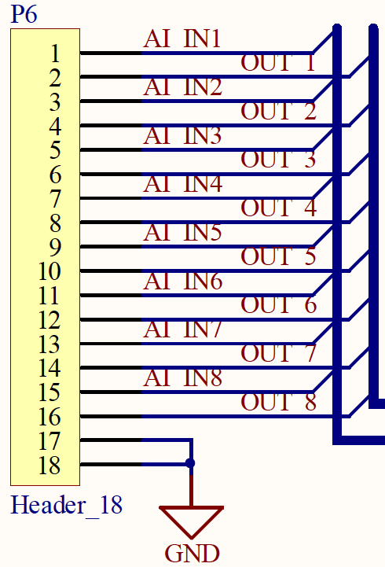Figure 7: Pin-grid example
The applied converter works with a accurateness of twelve bits and is connected to processor via the Serial Peripheral Interface (SPI). It contains eight individual analogue-digital converting channels, so that only one device is needed. To reduce the measurement inaccuracy, a high precision, low power reference device stabilises the reference voltage of the converter.
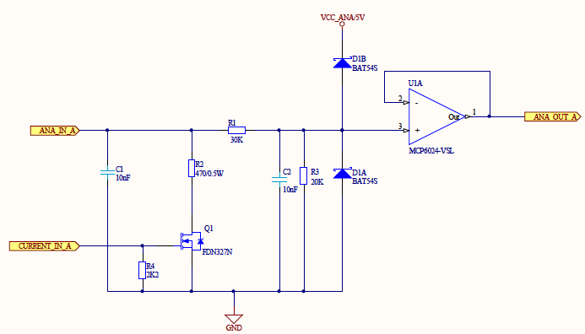Figure 8: Analogue input frontend with current detection
The analogue outputs work the inverse way of the inputs with the difference, that three two-way digital-analogue converters are needed and because of that three CHIP-ENABLE (CE) connections are required to be able to control every converter individually. The converters are also connected to the SPI, so that except for the CE-wired no further connections to the processor is needed. As well as the analogue-digital converter, a high precision reference device stabilises the reference voltage. The outlet of the converters are connected to the specific analogue out circuit allowing to differ between voltage and current output, which is partly shown in figure 9. It consists of two divided circuits based on a two-way operation amplifier (U3) where one of these simply amplifies the incoming voltage and the other controls a power transistor (T1) which realises a current flow depending on the output of the amplifier. Both circuits are brought together in a two-way multiplexer (U4) where both channels are controlled by only one connection from the processor (CONFIG). This is because one of the two switches in inverted and so only one of both amplifying circuits becomes active.
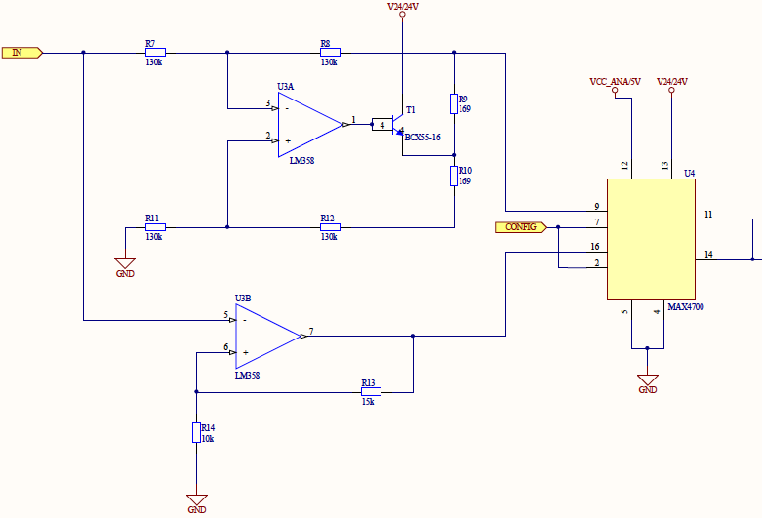Figure 9: Analogue output backend with both operation amplifier circuits and switch
As well as on the analogue inputs, the signals should be accessible on a pin-grid for measuring with the same connection principle. Afterwards, the six signals are connected to two multiplexers to be able to switch them between two connectors.

Communication

RS 232
The Recommended Standard 232 (RS 232) interface is the most used communication interface on the design. It will be both used to control the program flow of the processor and to write program code into the processor-internal memory.
The Recommended Standard 232 describes the level and way of connection of a certain serial interface. RS 232 is the most common used serial interface an realisable with a LPC-intern universal asynchronous receiver transmitter (UART) and a RS 232 certified level changer. To communicate with the processor, these two connections (TX: transmit; RX: receive) are sufficient. The Standard prescribes more connectivities, for instance flow-control mechanisms to communicate with modems and the like, which are not necessary in the actual context. The two connections should be filtered with a CLC filter to reduce high-frequency noise. The values of this CLC part should be chosen carefully, because the filter limits the transfer rate of the connection due to the buffer-effect of the capacitors.
In order to be able to write program code into the processor-internal memory, the serial connection must be switched in some way. To prevent the processor of unintended reprogramming, this change must be done by the user manually with a jumper. With that, the global RESET signal can be pulled to GND with a reset signal from the programming device (e.g. a PC) which in turn resets the processor to the starting address. On another line the programming device then can start programming the processor via the In-System Programming Interface (ISP). The RS 232 connection with the attached ISP interface is shown in figure 10. On the RS 232 connector (J1), the lines 2 and 3 are for the serial communication with the processor, where line 2 represents RX and line 3 TX. The figure also shows the manual accessible jumper (P1) to enable the ISP interface. At least, the whole board is reset-able via a switch (S1) that pulls down the RESET signal to GND.
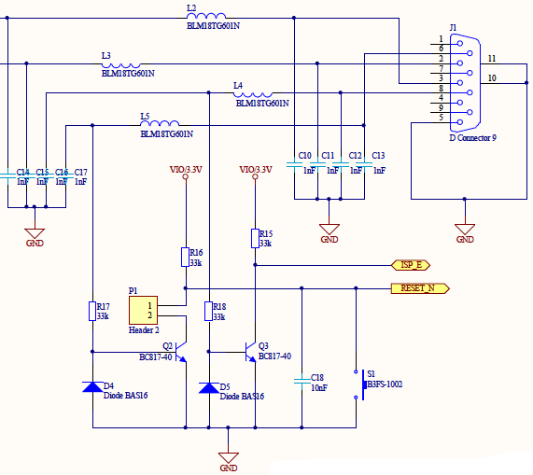Figure 10: RS 232 interface with attached In-System Programming interface

RS 485
The Recommended Standard 485 as well as the 232 describes the level and way of connection of a serial interface. In difference to the 232 standard, the levels on the 485 are higher so that both interfaces are not directly connectable. The principle behind both interfaces is similar, so that also the RS 485 is supplied by a LPC-internal UART with an attached level changer.
On the actual design, the RS 485 connections are used to create a parallel bus structure. This means that the whole bus consists in fact of two wires, on that several devices can be attached parallel. This principle is also shown in figure 11.
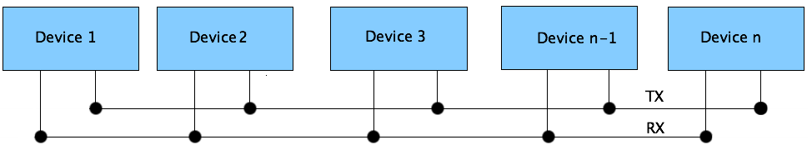Figure 11: Scheme of a parallel bus structure
The actual design contains two RS 485 interfaces and two external connectors to attach them, so that two individual bus structures are possible. Both connectors contain both interfaces, so that the connectors are not bound to one bus. Normally, a device within the bus requires two connectors to be build into the existing structure, because on both sides other members are available. The only exceptions are the master device at the beginning and the last slave device at the end of the bus. The actual design can represent both one device within the bus or up to two devices on one the two ends. Also, the device is able to be attached to both busses at the same time.

Ethernet
The ethernet connection is based on the multilayer principle of the OSI-model. The specific layers are designed in two different hardware devices, firstly the Physical Layer (PHY) and secondly the Media Access Control (MAC) .
The PHY is responsible for the physical connection between the outside network and the central processor. It is as far as possible automated and only contains a few registers to be configured. The physical layer is the first, bottom layer of the OSI-model. The MAC as second, next layer is the data link layer and responsible for a reliable, as far as possible error-free data transfer. On the LPC, the MAC is integrated as a hardware interface and communicates with the PHY with a special interface called Reduced Media Independent Interface (RMII). This interface is designated to the communication between these two OSI layers and can either be in full transfer mode with four bits parallel (MII) or in reduced mode with two bits parallel (RMII).
The ethernet layers are supplied by an own crystal and the PHY is partly supplied by an special power supply of 2.5 V.

CAN
The Controller Area Network (CAN) is a common used bus in industrial or automotive vicinities. The LPC 2388 processor contains two independent CAN interfaces, which both consists of each a receive and transmit line. To access a CAN bus with the processor, a external CAN receiver transmitter device is required to change the receive and transmit lines to the specified levels. Depending on the transfer speed, the number of connected devices and the distance to the bus, a 120 Ω resistor is required to terminate the bus between its high and low signal wires. The complete CAN connections circuit is shown in figure 12, where P14 represents a jumper to manually terminate the bus connection as mentioned above if necessary.
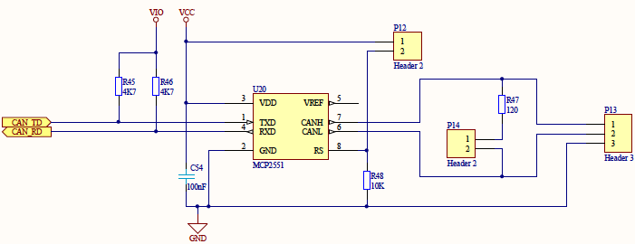Figure 12: CAN connection circuit

Memory

EEPROM
The Electrically Erasable Programmable Read-Only Memory (EEPROM or E²PROM) is accessed via SPI by the processor. To warrant low latency, the memory is attached to an own serial interface on which no other devices are connected. Due to its properties as a non volatile memory, it is used to store important variables or data concerning the device or a special part of a program, that belongs to this device and should be accessible even if the original program code in the processor is updated or changed. The advantage of this memory is the fact that it is accessible byte-by-byte, which allows a comfortable and fast access and storage of single variables or smaller arrays. In difference to that, most memories are accessed in a certain page-size which demands to read or write always a whole block, mostly of 512 bytes, which is more comfortable on working with bigger data sizes, which is not given in this case.
The EEPROM is used to store board-specific data like serial numbers, certain MAC-address spaces or special values like calibration multipliers. Because these data belongs to the device and not to the specific program running on it, it is more comfortable to store them externally. To attach the memory device to the processor, no further devices like level changers are needed. It is directly connected to the first SPI of the LPC.

MCI
The Memory Card Interface (MCI) is used to attach removable memory to the processor. It can either work with Multimedia Cards (MMC) or Secure Disks (SD). The LPC contains a implemented MCI, that can be set up with just a few registers. It works with a certain set of commands, that mostly fit to both kind of cards. Only one command on the initialisation and a few commands for multiple access to the card differs. With the initialisation difference it is possible to scan which kind of card is inserted to the card. In hardware, the MMC is only reachable with one data line, where a SD can be attached either to one or four data lines parallel, which allows a much higher transfer rate up to 5 MB/s. Due to interoperability, all four data connection will be realised. In addition to that, the MCI contains one clock line and one command line. Furthermore, two switches allow scans whether a card is inserted and if its write-protected (SD only). This protection is based on a mechanical switch build to the SD card, which can easily be overridden by software. It will be implemented and used as a kind of notification to prevent of accidentally overwriting.
The data lines all need to be pulled up to 3.3 V as well as the both switch lines. A own power line (MCI_PWR) from the MCI is used to switch the power supply of the card. This line is automatically controlled by the interface. The power status becomes visible with an included LED. This supply control circuit is shown in figure 13.
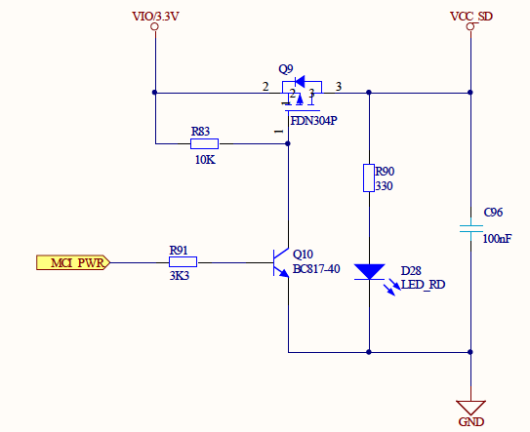Figure 13: Power supply and control of the MCI

Printed circuit board design
The design of a printed circuit board is the more complex part of the hardware development. Although there is hardly research action left to do, there are a lot of possible errors in this step of development.

General information on the printed circuit board design
Printed circuit boards are common devices available and used almost everywhere in normal life, from the coffee machine up to the mobile phone or the notebook. A board is not only used to support electrical connections between components but also to hold them. So aside from electrical attributes, also the mechanical and even thermal properties are important for the design. In some cases, a board holds bigger and heavier components or is used to conduct lost heat from components like processors or integrated power circuits. These an probably several more issues must be considered on a PCB design before the first connection is drawn.
The starting point of a prototype board like the actual design differs from a commercial, maybe massed-produced product. The first difference is given with the size of the board, which is mostly prescribed on commercial products by the used enclosure. In most cases also the positions of some special components like switches or LEDs are given due to their accessibility. These specifications decreases the possibilities of the designer, which may be a advantage in the beginning but can also be turned to a drawback at the last connections. On a prototype development with no specifications about positions and sizes like the actual design, the first step normally is to chose positions for attachable components like connectors, interfaces, LEDs and switches. Also it is common to place the central processor in the middle of the board in order to reach it from every side. The size of the board is at first chosen a bit bigger than necessary and is firstly fitted to a possible size when the mentioned positioning is done. Many further positions and design parts of components and circuits result from this. The last decision before the designing process is the definition of the used layers. Normally, the designer chose between a one, two or a multilayer design. The difference between these is mainly given in the power supply and the costs. PCBs with inner layers are more expensive but allows inner power and GND plains, which permits a low-impedance power supply at every position of the board without getting problems to route the signal layers. Smaller design are normally designed on two or even just one layer. On larger or more complex designs, usually a multilayer design is chosen, because the advantage of easier routing and the lower impedance outweighs the higher costs. Multilayer PCBs must always contain an even number. It is common to start with four layers and add more signal layers only if necessary. Normally, the inner layers are used for GND and power and the outer layers for the signal routing. This is mainly caused by the fact that all components are mounted on the outer layers and must be attached on them. Also it is advisable to route the signals of both layers 90° staggered to prevent of crossed connections on one layer.
The different layers are connected to each other by so-called vias, which are small, metallised holes, that establishes a connection between at least two layers. A via can be build on two ways, where the first is a fully metallised hole through the complete board that connects every layer. The second kind only contains conducting material between the layers that should be connected to each other. The first possibility requires an isolating area around the via on every layer, that should not be connected to the signal. The second method only involves the layers that should be connected to each other but is more complex in production and because of that more expensive than the full metallised via.
The not-used areas on the signal layers can either be left free or filled with plains connected to GND. Filling reduces the impedance and saves vias to the GND layer. It also reduces noise and interaction between signal lines and can cause a more stable system.

Designators, values and synonyms in PCB designs
The designators, values and synonyms already described in 1.1.3. Designators, values and synonyms in schematics on page 2 are also used in the PCB design. It is common to just write the designator next to the component on the board surface. The reason why values are normally not added to the board is that values are usually mentioned on the component by the manufacturer. The designators are helpful additions to the design both for the person that places the components on the board and also for the designer on checking and eventually debugging the design. It is advisable to keep one or at most two different writing directions on the board and also to place the designators as near as possible to the component. Only if a lack of space occurs, designators should be left out.

Component positioning
A complete overview on the layout of the PCB with the positions of every component is shown in figure 14.
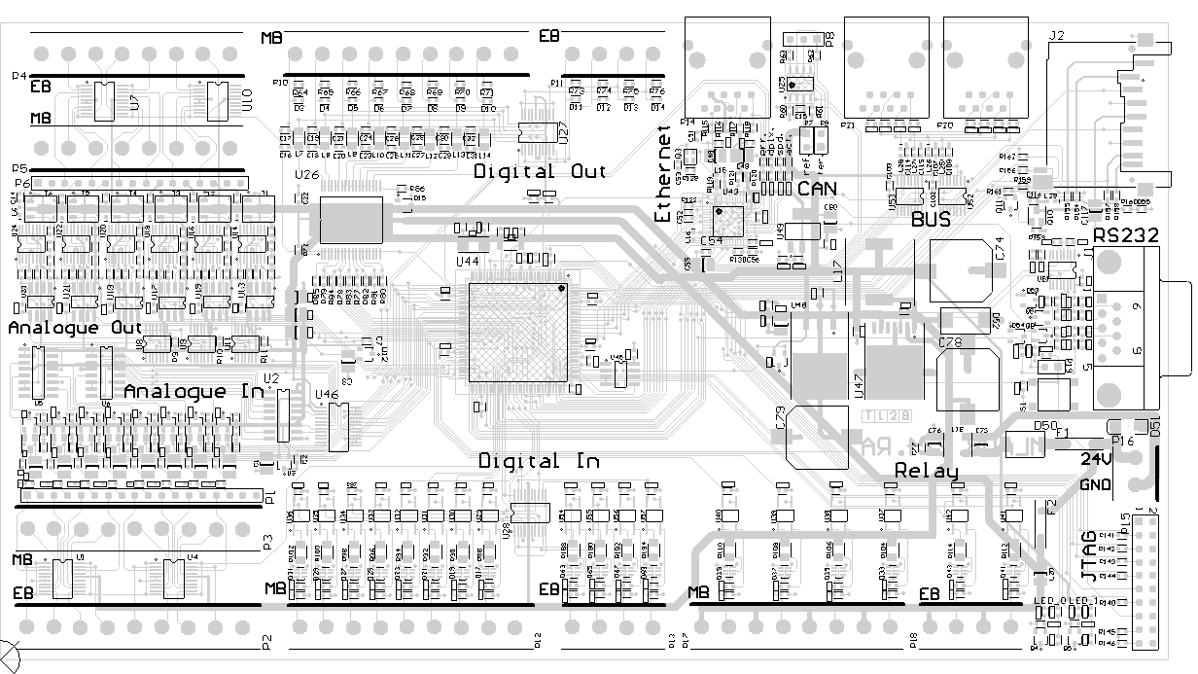Figure 14: Overview of the component positions
As shown, both the analogue as also the digital in- and outputs are routed to a adversed, similar design. The outputs are all located at the top edge and the inputs at the bottom edge of the board. This is mainly caused by a better overview and to minimise the risk of wrong connections. All these in- and outputs sections and in addition to that the relay inputs insist of two connectors, where one is routed to the basic settings and the second one can be used instead of at least several of the basic channels. In case of the analogue circuits, all channels are switches either between the main board (MB) or the extension board (EB) connector. On the digital circuits, only four of the eight existing channels are switched. These are the first four channels from the left on the main board connector. The last four channels are applicable in both modes. On the relay inputs, all channels are reachable without a switch in between. The analogue circuit connectors are placed in a special way with the pin-grid, where the pin wired to the connector (Xi) is always routed in a row to its corresponding pin on the connector, and the other pin of the grid wired to the converter circuits (Xo) is placed in the gap between two connector pins. This placement is exemplary shown in figure 15 by the connectors of the analogue outputs.
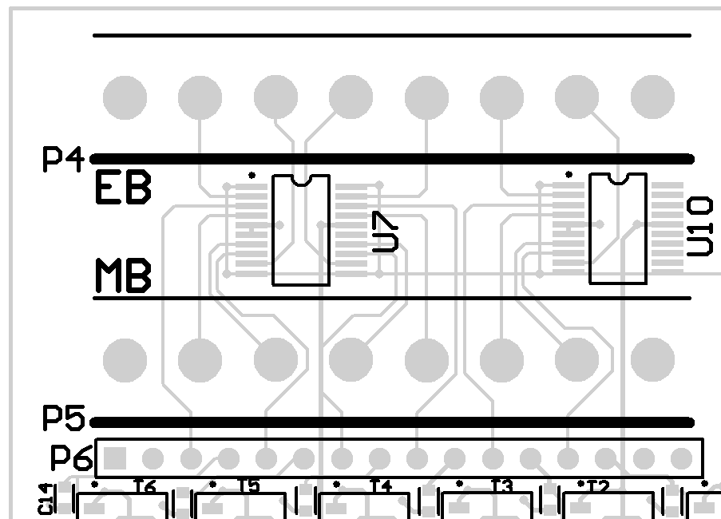Figure 15: Pin-grid placement of the analogue outputs (numbers added manually)
On the top edge next to the outputs, all circuits concerning the communication with the testee are located. This affects the complete ethernet circuit including the PHY, the CAN circuit and the RS 485 bus assembly. To reduce impedance, the last step-down voltage regulator stage for the ethernet circuit is located directly next to the PHY.
Figure 16 shows the layout of the communication circuits. Because the ethernet and the bus assembly both use the same connector, they are separated from each other with the CAN interface to reduce the risk of wrong connections which may harm the RS 485 level changer or the ethernet PHY. Also shown with this figure is the possibility to manually add text strings to the board. This is advisable on some components like jumpers or special LEDs. In case of the PHY, the four available LEDs show different stats of the actual ethernet connection, which are rather readable with their logical meaning than just with their designators. Same is for the two jumpers of the CAN interface, where one of them activates the bus termination and the other one disables the transceiver.
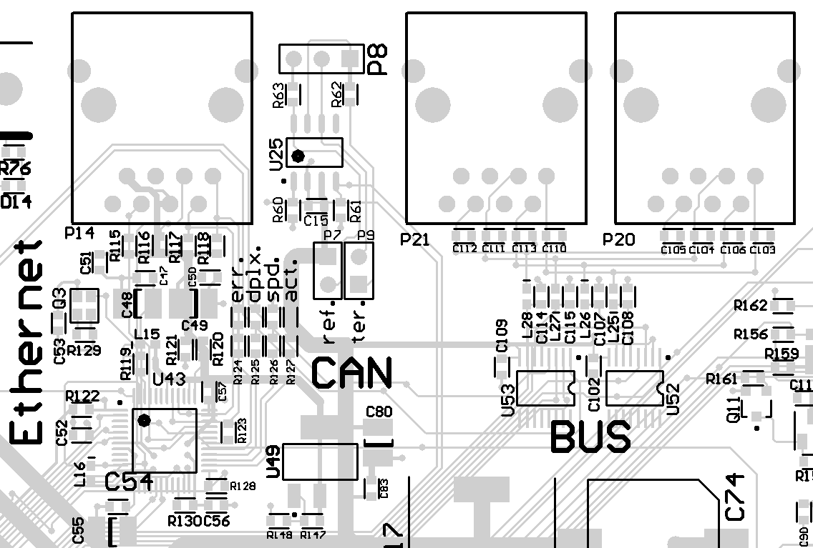Figure 16: Communication circuits (ethernet, CAN, bus)
On the right edge of the board, the more user-specific components are placed. This mostly concerns the RS 232 and the JTAG interfaces, with which the user controls the board. Also, the power connector, the reset switch and the MCI cardholder are placed in this area. This is chosen this way, because the surrounding circuits (bus, CAN, ethernet at the top, relay inputs at the bottom) leave much free space to place the relatively big power circuit components like step-down regulators or capacitors. To reduce the impedance of the supply circuits, the lengths of the wires between them should be kept as short as possible, which is easiest done in this free area of the board. Figure 17 and 18 show the impedance-relevant connections on the power supply circuits in the schematic (figure 17) and in the PCB (figure 18) with red highlights.

Figure 17: Impedance-relevant connections on power supply in schematics
Figure 18: Impedance-relevant connections in PCB
At least, two free usable LEDs are located at the bottom right of the board. They are designated to show the actual status of the processor, for instance a normal running mode with a blinking LED and an active procedure with a permanent illuminated LED.

