Used software on this thesis
During this thesis, several programs, packages and software are used. The frequently used and/or special software will be shown and explained in this chapter.

Altium Designer package
The Altium Designer package is a powerful and for commercial and industrial purpose created software package. It contains special subprograms for every step of the hardware development and is furthermore able to be comfortably used in network vicinities by one or more designers. It is a commercial software and needs to be licensed by the user.

Altium schematic editor
The schematic editor allows the creation and development of electrical circuits. It can be used just to draw circuits (for instance for documentation) but is commonly for creating a library base for the PCB design. The user is able to develop circuits from every available or self-composed component on multiple sheets. Furthermore, the components can be marked as driving sources, power supplies, inputs, outputs and the like, with which the drawn schematics can be simulated as a electric circuit. Also, a very detailed rule-management allows a complete schematic rule check for almost every possible error or carelessness like open pins, short-lines and much more. A special advantage of the schematic editor is the multi-sheet ability. It is possible to insert already drawn circuits from the actual or older projects as a component and so save development and drawing time. Also, the documentation gets smaller with this. Furthermore, the editor is able to annotate the component designators. This function allows to automatically order and rename the components, so that during the development process every sheet can contain a number one of every kind of component but afterwards the components are all named and numbered unique.
When the schematics are finished and free of errors, the complete schematic hierarchy can be compiled. With this, the drawn components and connections are split into a component list, a pin list and a netlist, which are then used by the PCB design editor.

Altium PCB editor
The PCB editor is for the development and design of (multilayer-) PCBs and is normally based on the lists composed by the schematic editor before. From this, normally the PCB is created by exporting all available circuits to a new PCB. After setting the properties of the board (e.g. number of layers, size), all used components from the schematic are added to the PCB design including their connections to each other.
The PCB editor is a powerful tool mainly based on extensive graphics. Nevertheless it is also usable on older PCs, although with lower performance. Its advantage lies in many additional graphical or organisational functions and routines, which allows to keep an overview over the design even on big multilayer design with less processor stressing. Also, the graphic engine is completely adjustable, so that every layer and component can be set to every colour and almost every behaviour. For control, the design editor is based on the same rule engine like the schematic editor, which allows to set different priorities and warning or error levels for certain rule violations. The PCB design rules mostly contain isolator spaces, distances between nets, widths of wires and the like. They are adjustable for general use or also for certain nets or components.
The design is all time update-able. This means that if changes in the schematics are necessary after the design process already started and components or nets are added or deleted, the PCB designer can easily be updated from the new compiled schematic component- and netlists. Even changes in the inverse directions are possible. Figure 1 shows the PCB design editor window with focus on the central processor of the tester board, where red wires are on the bottom and blue wires are on the top signal layer.
Figure 1: Altium PCB Designer with focus on the processor routing on all layers

Altium component editor
Although the Altium package already contains several thousand common components like resistors, capacitors, standard ICs, processors, diodes, LEDs connectors and the like, it will be necessary to create or update components within the design process. For this, Altium created an own component editor, which allows to create schematic and layout symbols and combine them.
A schematic symbol is an abstract drawn component which contains every used pin. Furthermore it should contain important internal connections and a logical structure for the pin order (for instance power pins above, input pins left, output pins right, GND pins below). The symbol is combined with a library containing additional information like the manufacturer name, order codes, datasheets and more. At least, it is possible to attach one or more layout symbols to it. These so-called footprints are exact mechanical and graphical descriptions of the component and displays every mechanical existence on every used layer. Mostly this concerns the pins of a component on the top-layer, component names and drawn shapes on the overlay (or text) layer and on throughole components also the hole with its corresponding drill. Most footprints are normed to certain sizes and already included in Altium Desinger, so that in most cases, just a new schematic symbol needs to be created and then combined with an existing footprint.
Figures 2 and 3 show examples of schematic and PCB symbols, both created with the component editor. They both stand for the same component, which is a LM2678 step-down voltage regulator. In figure 2 the logical pin order mentioned above is visible. The footprint in figure 3 comply with the TO-263 footprint standard.
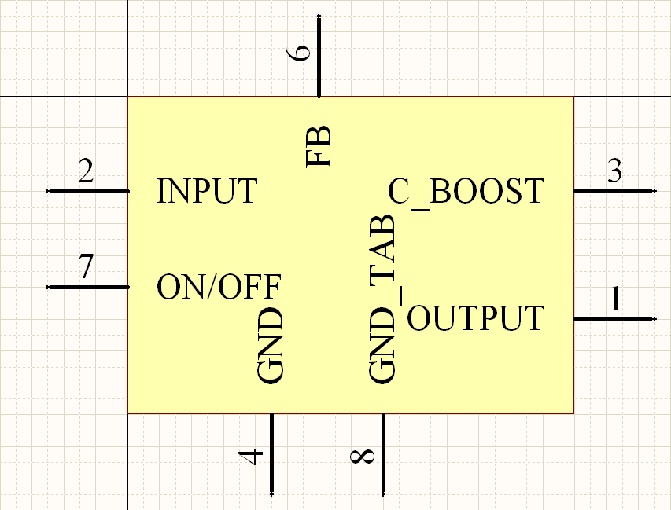Figure 2: Schematic symbol example
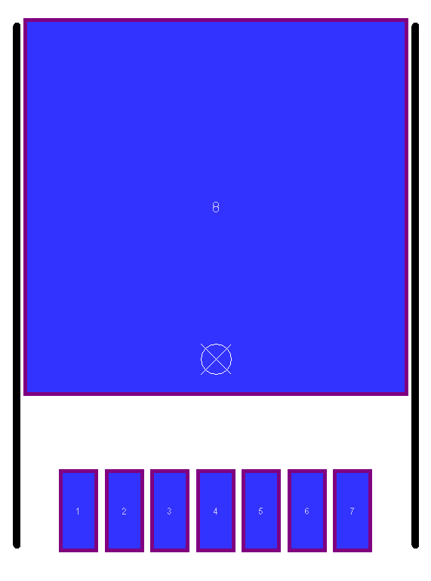Figure 3: PCB symbol example (TO-263)

YAGARTO GNU-ARM Eclipse toolchain
YAGARTO stands for Yet Another GNU ARM toolchain. The term GNU is from 1984 and stands for an Unix-like software project and is a recursive acronym for GNU is not Unix. The idea behind this project was a free and open source operating system similar to Unix. From that the GNU-Manifest and later on the GNU-licence have raised. The basic idea of this is to involve as much programmers and other helpers as possible to support a certain software project. Every software under the GNU-licence is open source and free for usage, handing and changing in private use. All rights remain at the developer. In case of commercial use, special agreements or limitations are to be arranged.
A toolchain is composed of a number of single programs that are forced into a project to work with each other. Usually it is hardly possible to combine different software when it is not supposed for that. In prebuild toolchains, the developer already did all the combination work.
The YAGARTO toolchain contains:
- the IDE Eclipse (open source)
- the GNU-licenced GCC
- the OpenOCD (OCD: On Chip Debugger)
- some small support programs

Eclipse IDE
Eclipse is a IDE based on JAVA and originally just supposed for JAVA development as well. Within the last years, Eclipse became the number one open source IDE because of its quality to be easily extended with plugins. In this way it is for example now possible to use Eclipse also for development of software in C and C++. This great popularity could be ascribed to Eclipses possibilities of handling big projects, work with more then one opened project once and combine a clear, structured surface with helpful additional functions like Auto-Complete or a Mouseover-Display. Moreover, Eclipse is unlike many other IDEs able to be setted up in almost every way the user wants it to. For example the text editor can be configured in many different ways of code style, just like the user or the corresponding company wants it to be.
Figure 4: Eclipse IDE with opened projects

Open OCD
The Open On-Chip Debugger (Open OCD) is a small tool that allows a comfortable debug communication with the processor via the JTAG interface. Required for this is a supported JTAG controller. The tool creates an environment that enables a connection to the board via a telnet connection and provides a UNIX-like API. With this vicinity, it is for instance possible to read or manipulate every available register or memory address. For every action, the processor must be halted. With this method, even one-time readable registers, which lose their content after reading in normal processing mode, are readable multiple times.

Visual Studio C# Express 2008
The Visual Studio package is a professional development environment created by the company Microsoft (MS). The full Studio package contains IDEs for the languages C, C++, C#, Virtual Basic and J++ and provides own compiler for each of them. The Visual Studio series is designed for software development for x86 systems, so usually personal computers and is hardly applied to embedded systems.
Microsoft provides two different versions of Visual Studio; either the complete package, which must me licensed, or single, limited versions of each IDE for free use, which are marked with the additional name “Express”. Although the used version of Visual Studio is limited to more basic interaction with the operating system, it is sufficient for the purpose of this thesis and does not require a new license on Visual Studio. The environment is used to create the window test application control.

Notepad++
Notepad++ is an easy-to-use open source text editor, published with the GPL. Its advantage is automated keyword- and text highlighting for different programming languages and a teachable behaviour. Some functions like auto-completion or mouseover-display are similar to the ones already mentioned with the Eclipse IDE (see chapter 2.2.1. Eclipse IDE on page 5), which makes it easier to switch between them or work with both programs at the same time. On this thesis, Notepad++ is mostly used to develop the linux applications for the testee, which can either be scripts or small C programs. A server-based version of the GCC is used to compile the C code written in Notepad++.

Putty
Putty is a open source terminal, ssh- and telnet client for Windows operating systems. It is used to establish almost every connection between the PC and the used boards, normally on the serial ports. The connection to the Open OCD is also established with Putty. It is multiple usable, which means that multiple instances of this application can be opened and used at the same time. Although the Windows operating systems contain an own terminal client called Hyperterm, Putty is preferred due to its smaller size and its better adjustability. The practical use showed also that Hyperterm is less reliable.

PCB: Printed circuit board
IDE: Integrated development environment
GCC: GNU compiler collection
JTAG: Joint Test Action Group
API: Application programming interface
GPL: General Public License

