Hardware development of the tester

Schematic development
The hardware development usually begins with the design of the schematics. These contain every electrical component and connection which should be prospectively available on the PCB. On projects with a higher amount of electrical devices and wirings, the schematic drawings are usually divided to contiguous circuits like the boards power supply, the input- and output section of the main processor and the like. Also, multiple used circuits or circuit parts should be split to an own schematic to prevent of repeated drawing.
In order of a better abridgement, the schematics for this project should also be divided as mentioned above.

General information for schematic designs
The schematic design represents the actual research part of the hardware development. Because of that, this activity usually takes a higher amount of time then the PCB design afterwards. Depending on the future purpose of the device, the designer is not only responsible for the pure electrical circuits but also for the compliance of (international) norms and/or the costs of the device. These topics are normally more important on mass produced and public-used products and force the designer to search and compare several and partial a lot of different devices to make the circuit fit as much as possible to the wanted target. But although the costs or norms are minor motivations on a prototype or single device development, the choice of the components takes some time. In addition to that, the use of non-common devices or ICs mostly forces the designer to create new component symbols in the design environment. Although in the schematics only a few different symbols are used, these components may differ on the further PCB in size (e.g. common resistors and power resistors, which both got the same schematic symbol but need size-different PCB symbols). On SMD devices, these symbols need to be very accurate. In a commercial facility, it is usual to supplement the components with the manufacturer name, the manufacturer code and order codes of the common used device distributors. Also alternatives are sometimes necessary.
These tasks rather concerning organisation parts are mostly important in commercial surroundings, where usually more then one designer design several PCBs and is commonly called “library care”. The more accurate these libraries are created and supported, the easier is the future use of it for all designers, who all then can access new libraries and/or components.

Introducing information
The schematic drawings will contain several components and circuits with different purpose, so the division of the schematic to more sheets is advisable. The following chapters are to explain the created circuits and their purpose.
ORGANISATION DES SCHEMATIC (TOP-SHEET, HIRACHIE; ETC)!!!

Power supply section
As mentioned in KAPITEL 2, ÜBERLEGUNGEN, the whole board will only be supplied with a constant power source of 24 Volts. Nowadays, this is the most common power supply available in development and industrial vicinities.
Although there are some circuits that are designed to work on 24 Volts supply, most of the circuits and components are to be supplied with a much lower voltage. It is advisable to chose the components that way that they fit as far as possible on the same voltage. In the actual schematic, seven different voltages are needed, which are mentioned in table 1 with their schematic names, values and main purpose.
Name | Value | Purpose
VIN | 24 V | - Unfiltered voltage from the external supply  - Supply of VIN_DIGI
V24 | 24 V | - Switching voltage of multiplexers  - Further transformation to VCC
VIN_DIGI | 24 V | - Reference voltage of digital in- and outputs
VCC | 5 V | - Supply of integrated circuits like level changer  - Supply of status LEDs  - Further transformation to VIO and VCC_ETH
VCC_ANA | 5 V | - Extra filtered 5 Volts supply for analogue in- and outputs
VIO | 3.3 V | - Supply of main processor  - Supply of integrated circuits  - Supply of JTAG interface
VCC_ETH | 2.5 V | - Supply of external ethernet PHY circuit
Table 1: Table of used voltages with schematic-used names, values and general purpose

As protection, the power supply circuit contains several special components. Directly parallel to the power supply connector (P19), a supressor diode (D26) protects the following circuits against overvoltage. In row-connection to the following circuits, a 1.35 A fuse (F1) protects the boards against high current flow e.g. caused by short lines and in connection to that a common diode (D25) prevents of fault connection on the main power supply connector. At least, a choke reduces possible noise of the supply. The protection part of the power supply circuit is shown in figure 1:
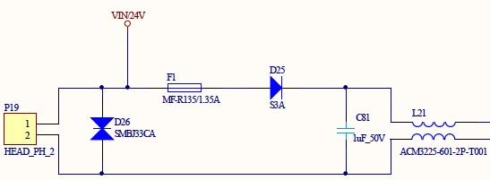Figure 1: Power protection circuit on power supply
The filtered 24 V behind the choke is used to supply the multiplexers with a high switching reference voltage as well as also supply further step-down regulators to lower voltages. The first of these step-down regulator takes voltage down to 5 V. This transform-stage is mainly responsible for the correct supply of the whole board, because it supplies several devices directly as well as it also drives a second step-down stage to 3.3 V and a third stage to 2.5 V. Because of this requirements, a high quality and stable step-down regulator with high current throughput is necessary. Since the possible high current, it is highly recommended to adhere the impedance of the regulator and its wiring. The second step-down stage to 3.3 V is directly driven by the first one and is mainly to supply the central processor as well as several internal devices like level changers and memory interfaces. These devices are all not highly sensitive against voltage-fluctuation, but nevertheless a regulator with high output should be chosen since otherwise a consumption peak may cause voltage drops, which in turn may cause a unmeant restart of the processor. The third, last stage only partly supplies the ethernet PHY and must not be chose as a high quality device due to the PHYs purpose.
As seen in table 1, the digital and analogue in- and outputs are supplied with an own voltage. This is mainly caused by their purpose. The supply for VIN_DIGI is gripped directly from the external supply in front of any filters or security components like fuses. In future use, this voltage supplies the digital outputs, which are mainly designed to drive optocoupler-circuits on a second, unknown device. Because the functionality of these inputs cannot be warranted and may be short-lined for any reason, they can cause a much higher current than the outputs are designed to drive. To prevent the whole board of the risk of damage, this supply voltage is separated and secured by an own fuse right in front of the main fuse of the board. This is shown in figure 2, where P19 is the connector for the external power supply (Pin 1: 24 V; Pin 2: GND).
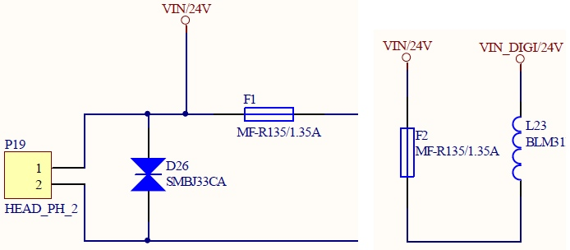Figure 2: Scheme of the separation of the digital output power supply

From the already to 5 Volts transformed voltage VCC, the additional supply VCC_ANA is split for the analogue in- and outputs. This is mainly caused by noise reduction on the power lines in order to achieve a more stable reference voltage on the analogue-digital (ADC) and digital-analogue (DAC) converters as less as possible influenced by the current consumption of all other VCC-supplied components. To achieve this, VCC_ANA is filtered and stabilised from VCC as shown in figure 3:
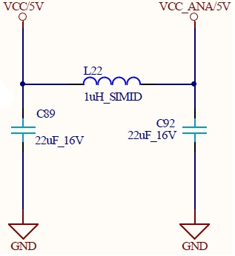Figure 3: Filtering of analogue supply voltage

Central and co processor
The central processor is, according to its name, one of the most important components in a digital circuit. Most common designs are based on only one central processor to do all work, where bigger or more complex designs divide several tasks like communications or special memory algorithms to so-called co processors, which are in turn controlled by one or more, to a cluster connected central processing unit(s). The actual design contains one central processor to do the whole work.
The LPC 2388 in the applied version with 144 pins causes a quite big schematic symbol. Due to the abridgement, this symbol should be divided to two or more single signs, which then can be split to several schematic drawings. It is advisable to split the symbol according to the purpose of the pins, e.g. GPIOs, power connection, the debug interface and the like. The processor is able to use most of its pins as a general in- or output, but also use them for instance as special communication or memory interfaces. In case of the LPC 2388, most of the pins support four different purposes. These different possible usages should be mentioned in the schematic symbol for each pin. Secondly, it must be decided, in which order the pins are printed. All applicable pins are grouped to five banks with up to 32 pins. These pins are not compulsorily consistent with the external pin number, which then allows a printout either according to the external pin numbering, which is more interesting for the further PCB design, or the logical bank order allowing a better overview for the software development. In this thesis, the second option will be used due to the design software which already contains a ready-to-use symbol for the LPC 2388 with the specified order. Figure 4 shows a partial pin printout. It shows the pins ten to 26 of the first pin bank (bank 0) with their different possible purposes. It is observable that the pins used for the digital inputs are setted to the general purpose where the pins concerning the MCI mostly are setted to a special interface function. Also, the figure shows the difference of the two ordering methods mentioned above where the external pin numbers are mentioned outside of the component above their corresponding pin.
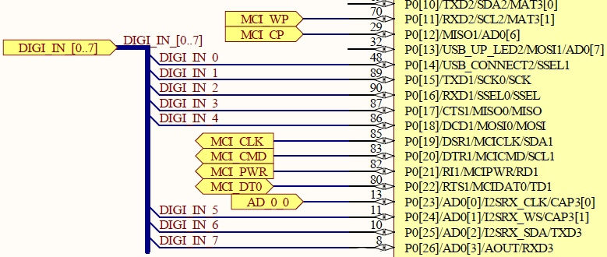Figure 4: Partial drawing of a pin bank of the central processor
Beside the adaptable pins, the LPC contains several more connections to the outside which are also grouped to four more schematic symbols. The first of these is the power connect block, which contains every pin used to supply the processor. Because the LPC contains several, independent interfaces, it is possible to supply some of them individually, for instance the build-in converters. Also, reference voltages can be connected separately. At least, the processor is able to be partly supplied with a battery. With this, the internal real-time clock (RTC) on a special part of the memory is still on power, so that for instance the clock does not need to be set up every time the processor is switched on. In the actual design, a battery supply is not designated, so that all of the supply pins are directly connected to the power supply of 3.3 V. Except for the battery supply pin, all power connections need to be buffered with an own blocking capacitor of 100 nF.
The next schematic symbol contains the crystal connections. The LPC 2388 must be driven at least by one crystal commonly with 12 MHz. Without this clock, the processor is not runnable. Although the internal circuits of the processor need different clock speeds, the whole component only needs to be supplied with one external crystal. The LPC contains special, individual clock divider registers for the interfaces and circuits that must be driven with different clock speeds. A second, much slower crystal with 32.768 kHz exclusively supplies the RTC. This is as mentioned above because the RTC is driven by an own supply-pin either on the normal power connection or on battery so that even in battery mode, the RTC crystal is supplied.
The fourth symbol contains the Joint Test Action Group (JTAG) debug interface connections. This interface allows comfortable debugging directly on the chip and is a powerful tool especially on prototype development. The interface connections are ready-to-use and only need to be added with pull-up resistors on the data and a pull-down resistor on the clock connection. Although the JTAG interface only contains six connections, it is common to use a 20 pin connector with 2 times ten pins in a row. This is because the JTAG controller outside the board (for instance a PC) gets also its power from the board via two pins and is able to act on some more pins with special actions. In the actual design, the JTAG controller can also drive the global RESET signal on the board.
The last symbol contains every not connected pin of the LPC. Although there are of course no connections to this symbol, it should be mentioned in the schematics to show which pins are not involved in the design.

In- and outputs
The design contains several kinds of in- and outputs with each several pins or channels. Because of this, this chapter will be split up to these different kinds.

Digital
The digital in-and output section is mainly designed to be connected to industrial sensors or devices. Digital means that each output contains two states, which are either HIGH or LOW. In industrial vicinities it is nowadays common to use 24 V logic, because electrical signals than can be carried on long distances. Also, each channel both of the in and outputs should contain an own LED that shows the actual state, where an illuminated LED means HIGH. Each eight digital in- and outputs are needed, from which each four must be switchable to an alternative connector.
To achieve in- and outputs fulfilling these requirements, on both ports some special circuits are necessary. On the outputs, the first step is to raise the LPC output level from 3.3 V to the required 24 V. For this, special so-called high-side switches are available. This device is designed to a certain input logic and raises this to a also certain output level. The high-side switch is supplied by the special secured digital 24 V voltage. The output signal from the switch is then filtered with a CLC low-pass to protect the output against chattering and reduce noise. At least, the signal is wired to a connector to be able to grip the signal externally. Before, the required LED is connected to the signal between the CLC and the connector with a series resistor to ground. A special component is the four-channel multiplexer that allows to switch four digital outputs between two connectors. It is controlled by only one line coming directly from the central processor. The signals the multiplexer should switch are gripped between the CLC filter and the LED connections.
The digital inputs are working the inverse way to the outputs. The only difference is the method to reduce the incoming voltage of 24 V to a level the processor can handle. This is done with a optocoupler circuit that also realises a complete electrical detachment between the incoming signal from a foreign device and the own board, which is shown in figure 5. The optocoupler is secured with a special diode (D3) component that prevents of misconnection and wired to a LED (D2) showing the actual signal status. The coupler (U2) output creates a inverted signal with a pull-up resistor (R5) pulling the output to HIGH when the coupler is not active and pulling down the signal to 0 V (LOW) when the coupler becomes active. This inversion must be considered in the software. Afterwards, eight of the input signals are wired to a multiplexer to use each four of them. The multiplexer is already known from the digital outputs.
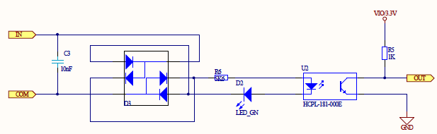Figure 5: schematic of the optocoupler input circuit

Relay
The relay inputs are working the same way then the digital inputs described chapter 1.1.5.1. Digital on page 6, which means that in fact they consist of the optocoupler circuit shown in figure 5. The only difference to the digital inputs mentioned before is the circuit on the testee, which not drives only 24 V to an output but switches an incoming signal, so that it has no power consumption of this action. Because of that, every relay-input got its own 24 V output signal, that should be switched by the testee. In addition, the incoming signal must not refer to 24 V, which is just the maximum the relais is able to switch. A certain range of voltages between X and Y can be switched.

Analogue
The analogue in-and output circuits are the most complex circuit parts in the design. This is mainly caused by three specific requirements to these circuits. Firstly, the internal converters of the central processor should not be used due to their insufficient accurateness which causes external devices inclusive their required wirings. Secondly, the in- and outputs should be able to read both voltage and current, which requires a special circuit combination, because converters are only able to read voltages. Lastly and due to debugging, the values from the converters should be accessible with a measure device, which causes an additional pin-row to grip the signals. Eight analogue inputs and six analogue outputs are needed. As on all in- and outputs, at least a few of the signals must be switchable to a alternative connector. In case of the analogue connections, all channels are involved, which requires two four-way multiplexers per port.
On the analogue inputs, the multiplexers are the first devices involved into the circuit. This is mainly to reduce the further needed components and based on the principle that all channels are switched at the same time. Also based on this is the connection to the pin-grid (see figure 6). It is wired that way that is possible to grip voltage as well as current. For this, each of the eight channels is wired to one input pin on the grid and one output pin. With this, a current measure device can be connected in series to the circuit as well as a voltage measure device can grip the voltage parallel between on both pins shorted (for instance with a jumper) and GND. Afterwards, The signal is led to a special circuit that allows the detection of either voltage or current, which is shown in figure 7. This is basically realised with a MOSFET transistor (Q1) and a series power resistor (R2) in front of four-way operation amplifier (U1A), on which each one channel uses one amplifier. The MOSFET is controlled by an output (CURRENT_IN_A) from the LPC. When inactive, the signal is led directly to the amplifier. When the control line becomes HIGH, the transistor connects the power resistor to GND and so terminates the current throughput. This causes a voltage drop on the amplifier, which is linear to the current though the resistor.
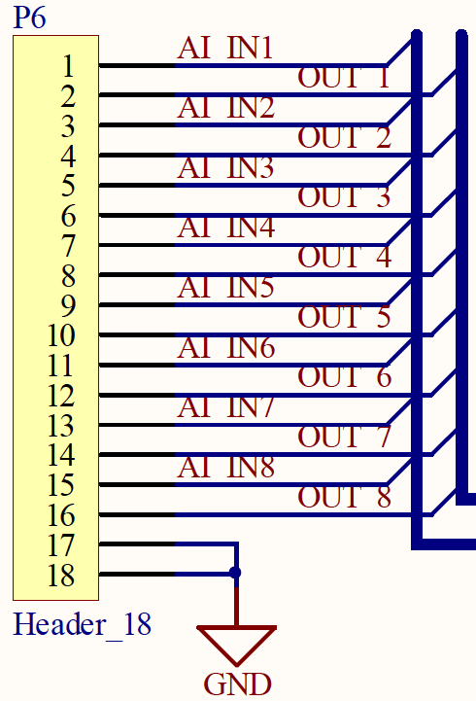Figure 6: Pin-grid example
The applied converter works with a accurateness of twelve bits and is connected to processor via the Serial Peripheral Interface (SPI). It contains eight individual analogue-digital converting channels, so that only one device is needed. To reduce the measurement inaccuracy, a high precision, low power reference device stabilises the reference voltage of the converter.
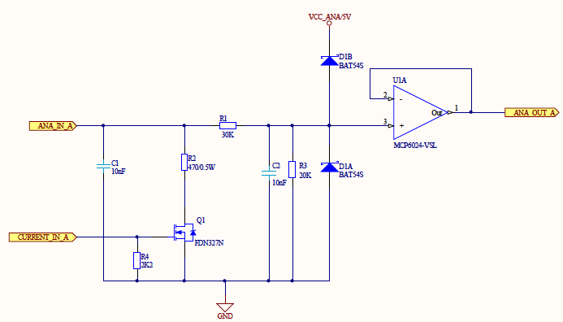Figure 7: Analogue input frontend with current detection
The analogue outputs work the inverse way of the inputs with the difference, that three two-way digital-analogue converters are needed and because of that three CHIP-ENABLE (CE) connections are required to be able to control every converter individually. The converters are also connected to the SPI, so that except for the CE-wired no further connections to the processor is needed. As well as the analogue-digital converter, a high precision reference device stabilises the reference voltage. The outlet of the converters are connected to the specific analogue out circuit allowing to differ between voltage and current output, which is partly shown in figure 8. It consists of two divided circuits based on a two-way operation amplifier (U3) where one of these simply amplifies the incoming voltage and the other controls a power transistor (T1) which realises a current flow depending on the output of the amplifier. Both circuits are brought together in a two-way multiplexer (U4) where both channels are controlled by only one connection from the processor (CONFIG). This is because one of the two switches in inverted and so only one of both amplifying circuits becomes active.
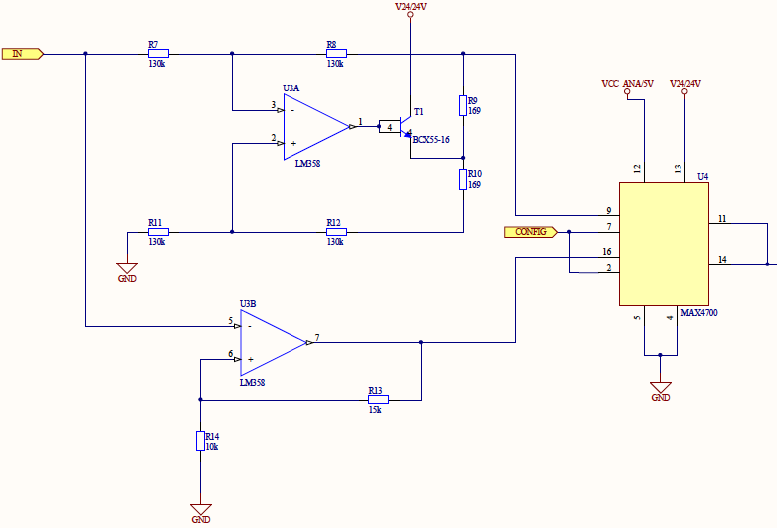Figure 8: Analogue output backend with both operation amplifier circuits and switch
As well as on the analogue inputs, the signals should be accessible on a pin-grid for measuring with the same connection principle. Afterwards, the six signals are connected to two multiplexers to be able to switch them between two connectors.

Communication

RS 232
The Recommended Standard 232 (RS 232) interface is the most used communication interface on the design. It will be both used to control the program flow of the processor and to write program code into the processor-internal memory.
The Recommended Standard 232 describes the level and way of connection of a certain serial interface. RS 232 is the most common used serial interface an realisable with a LPC-intern universal asynchronous receiver transmitter (UART) and a RS 232 certified level changer. To communicate with the processor, these two connections (TX: transmit; RX: receive) are sufficient. The Standard prescribes more connectivities, for instance flow-control mechanisms to communicate with modems and the like. The two connections should be filtered with a CLC filter to reduce low-frequency noise. The values of this CLC part should be chosen carefully, because the filter limits the transfer rate of the connection due to the buffer-effect of the capacitors.
In order to be able to write program code into the processor-internal memory, the serial connection must be switched in some way. To prevent the processor of unintended reprogramming, this change must be done by the user manually with a jumper. With that, the global RESET signal can be pulled to GND with a reset signal from the programming device (e.g. a PC) which in turn resets the processor to the starting address. On another line the programming device then can start programming the processor via the In-System Programming Interface (ISP). The RS 232 connection with the attached ISP interface is shown in figure X. On the RS 232 connector (J1), the lines 2 and 3 are for the serial communication with the processor, where line 2 represents RX and line 3 TX. The figure also shows the manual accessible jumper (P1) to enable the ISP interface. At least, the whole board is reset-able via a switch (S1) that pulls down the RESET signal to GND.
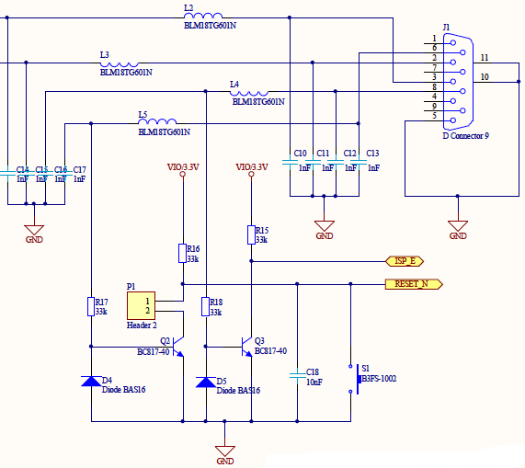Figure 9: RS 232 interface with attached In-System Programming interface

RS 485
The Recommended Standard 485 as well as the 232 describes the level and way of connection of a serial interface. In difference to the 232 standard, the levels on the 485 are higher, so that both interfaces are not directly connectable. The principle behind both interfaces is similar, so that also the RS 485 is supplied by a LPC-internal UART with an attached level changer.
On the actual design, the RS 485 connections are used to create a parallel bus structure. This means that the whole bus consists in fact of two wires, on that several devices can be attached parallel. This principle is also shown in figure 10.
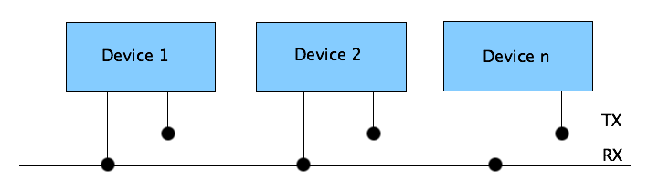Figure 10: Scheme of a parallel bus structure
The actual design contains two RS 485 interfaces and two external connectors to attach them, so that two individual bus structures are possible. Both connectors contain both interfaces, so that the connectors are not bound to one bus. Normally, a device within the bus requires two connectors to be build into the existing structure, because on both sides other members are available. The only exceptions are the master device at the beginning and the last slave device at the end of the bus. The actual design can both represent a device within the bus or one of the two ends.

