Photonis 0387 HSB MRTS
User Manual
Description:  User manual for HSB module repair test set | Doc No.: | PHO-0387-U0-3-1
Description:  User manual for HSB module repair test set | Revision: | 001
Description:  User manual for HSB module repair test set | Date: | 20-3-2018

 | Name | Date | Signature
Author | T. Lantinga | 20-3-2018
Reviewed
Approved

* The approval box may be extended as necessary.

No part of this document may be reproduced in any form or by any means, without the prior written permission of the respective owners.
All trademarks are property of their respective owners.
Document History
Version | Date | Status | Description
001 | 20-3-2018 | draft | Initial draft
Table of Contents
1 General 6
1.1 Symbol and warnings 6
1.2 Disposal of equipment 6
1.3 Intended usage 6
1.4 Safety 6
1.4.1 Safety notes 6
1.4.2 Responsibility of the operator 7
1.4.3 Responsibility of the administrator 7
1.5 Technical data 7
2 Installation 9
2.1 Placement 9
2.2 DUT connection 9
2.3 Auxiliary mains socket 9
3 Operation 10
3.1 Front panel control 10
3.2 Drawer control 10
3.3 Anode drawer 11
3.3.1 Start screen 11
3.3.2 Main menu 11
3.3.3 Opening the cover 11
3.3.4 Tube repair menu 11
3.3.4.1 Select preset menu 12
3.3.4.2 Preset preview screen 12
3.3.4.3 Start repair menu 13
3.3.4.3.1 Error messages based on safety 13
3.3.4.3.2 Repair in progress 13
3.3.4.3.3 Repair Finished 13
3.3.5 Repair pause 14
3.3.5.1 Repair paused 14
3.3.6 Administrator Menu 15
3.3.6.1 PIN protection 15
3.3.6.1.1 PIN insertion screen 15
3.3.6.1.2 PIN accepted 15
3.3.6.1.3 PIN denied 16
3.3.6.2 Administrator main menu 16
3.3.6.3 Change PIN menu 16
3.3.6.3.1 Insert new Pin 16
3.3.6.3.2 New Pin OK 17
3.3.6.3.3 New Pin failed 17
3.3.6.4 I/O control menu 18
3.3.6.4.1 Read interlock 18
3.3.6.4.2 Solenoids 18
3.3.6.4.3 Get voltage in 19
3.3.6.4.4 Set voltage out 19
3.3.6.5 Preset configuration 20
3.3.6.6 PID constants 22
3.3.6.7 Information and version screen 22
3.3.7 Calibration menu 22
3.3.7.1 PIN protection 22
3.3.7.1.1 PIN insertion screen 22
3.3.7.1.2 PIN accepted 23
3.3.7.1.3 PIN denied 23
3.3.7.2 Calibration main menu 23
3.3.7.3 Setpoint check menu 24
3.3.7.3.1 Low setpoint check screen 24
3.3.7.3.2 High setpoint check screen 25
3.4 Cathode / MCP drawer 25
3.4.1 Start screen 25
3.4.2 Main menu 25
3.4.3 Opening the cover 26
3.4.4 Tube repair menu 26
3.4.4.1 Select preset menu 27
3.4.4.2 Preset preview screen 27
3.4.4.3 Start repair menu 27
3.4.4.3.1 Error messages based on safety 27
3.4.4.3.2 Repair in progress 28
3.4.4.3.3 Repair Finished 28
3.4.5 Repair pause 29
3.4.5.1 Repair paused 29
3.4.6 Administrator Menu 30
3.4.6.1 PIN protection 30
3.4.6.1.1 PIN insertion screen 30
3.4.6.1.2 PIN accepted 30
3.4.6.1.3 PIN denied 30
3.4.6.2 Administrator main menu 31
3.4.6.3 Change PIN menu 31
3.4.6.3.1 Insert new Pin 31
3.4.6.3.2 New Pin OK 32
3.4.6.3.3 New Pin failed 32
3.4.6.4 I/O control menu 32
3.4.6.4.1 Read interlock 33
3.4.6.4.2 Solenoids 33
3.4.6.4.3 Get voltage in 33
3.4.6.4.4 Set voltage out 34
3.4.6.5 Preset configuration 35
3.4.6.6 PID Constants 37
3.4.6.7 37
3.4.6.8 Information and version screen 37
3.4.7 Calibration menu 37
3.4.7.1 PIN protection 37
3.4.7.1.1 PIN insertion screen 37
3.4.7.1.2 PIN accepted 38
3.4.7.1.3 PIN denied 38
3.4.7.2 Calibration main menu 38
3.4.7.3 Cathode/MCP selection menu 39
3.4.7.4 Setpoint check menu 39
3.4.7.4.1 Low setpoint check screen 40
3.4.7.4.2 High setpoint check screen 40
3.5 Tesla drawer 40
3.5.1 Start screen 40
3.5.2 Main menu 41
3.5.3 Opening the cover 41
3.5.4 Tube repair menu 41
3.5.4.1 Select preset menu 41
3.5.4.2 Preset preview screen 42
3.5.4.3 Start repair menu 42
3.5.4.3.1 Error messages based on safety 42
3.5.4.3.2 Repair in progress 42
3.5.4.3.3 Repair finished 43
3.5.5 Repair pause 44
3.5.5.1 Repair paused 44
3.5.6 Administrator Menu 44
3.5.6.1 PIN protection 44
3.5.6.1.1 PIN insertion screen 45
3.5.6.1.2 PIN accepted 45
3.5.6.1.3 PIN denied 45
3.5.6.2 Administrator main menu 45
3.5.6.3 Change PIN menu 46
3.5.6.3.1 Insert new Pin 46
3.5.6.3.2 New Pin OK 47
3.5.6.3.3 New Pin failed 47
3.5.6.4 I/O control menu 47
3.5.6.4.1 Read interlock 48
3.5.6.4.2 Solenoids 48
3.5.6.4.3 Get voltage in 48
3.5.6.4.4 Set voltage out 49
3.5.6.4.5 Teslagun relais 49
3.5.6.5 Preset configuration 49
3.5.6.6 PID constraints 51
3.5.6.7 Information and version screen 51
3.5.7 Calibration menu 51
3.5.7.1 PIN protection 51
3.5.7.1.1 PIN insertion screen 51
3.5.7.1.2 PIN accepted 52
3.5.7.1.3 PIN denied 52
3.5.7.2 Calibration main menu 52
3.5.7.2.1 Setpoint check menu 53
3.6 Error messages 54
3.6.1 Cover open 54
3.6.2 Error in row 54
3.6.3 Power loss 54
4 Contact and support 56
4.1 Maintenance and cleaning 56
4.2 Repairs 56
4.3 Replacing a defect mains fuse 56
4.4 Contact 56

General

Symbol and warnings

Symbol for general safety notices


Symbol for a life-threatening danger

On the drawer you can find the following warning stickers:

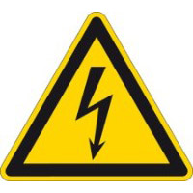

Warning for high voltage



Warning for possible hand injury

Disposal of equipment
A piece of equipment which is intended for disposal must, according to European laws and regulations (WEEE) be returned to Photonis for scrapping, unless the person operating the
piece of equipment or another, delegated person is conducting the disposal. Our equipment falls under these regulations and is accordingly marked with the following symbol:
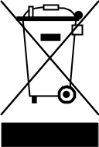

Intended usage
The equipment includes 3 repair drawers, each with a unique repair process.
The equipment is intended to be used only for repairing defective image intensifier tubes, in the corresponding repair drawer.
• Claims of any sort due to damage caused by non-intended usage will not be accepted.
• All damage caused by non-intended usage is solely the responsibility of the operator.

Safety

Safety notes
- The equipment must only be used as intended.
- Do not insert any object, particularly metallic, in the drawers.
- Avoid any use of liquids near the equipment. Protect the device from wet, damp and condensation.
- The Auxiliary mains socket is only to be used in conjunction with the Tesla drawer.

Danger for unqualified users
Improper operation can cause person or object damage.
To guarantee safety when using the device, it is essential that only persons operate the device who are fully acquainted and trained in the required safety measures to be taken when working with dangerous electrical voltages.

Responsibility of the operator
The operator has been properly instructed in their tasks and the attendant dangers. The operator is only allowed to execute the repair process.

Responsibility of the administrator
The administrator is able through training, knowledge and experience as well as knowledge of
the specific details to carry out all the required tasks, identify dangers and avoid personal and other risks.
The tasks of an administrator include:
- Executing repair process
- Access to administrator menu and thereby able to:
  - Change PIN
  - Control individual I/O
  - Change the preset configurations
  - Change the PID constants
- Access to calibration menu and execute calibration process

Technical data
General
Model number | 711564
Safety class | Class I
Operating temperature | 21 °C ± 2°C
Operating humidity | 45% ± 10%
Max. installation height | 2000 m
IP class | IP20

Mains supply
Rated voltage | 230VAC
Frequency | 50 Hz
Power dissipation | 80 Watt
Fuse rating | 3.15A
Fuse type | Slow

Auxiliary mains socket
Rated voltage | 230 VAC
Frequency | 50 Hz
Max. power consumption | 35 VA

DC output
Anode Drawer
 | Output voltage (per row) | 850 – 10000V
 | Output current (per row) | 50uA
Cathode /MCP Drawer
 | Output voltage (per row) | 170 – 2000V
 | Output current (per row) | 500uA
Tesla Drawer
 | Output voltage (per row) | 510 – 6000V
 | Output current (per row) | 167uA

Installation

Placement
Serious or fatal crushing injuries can occur from equipment tip-over. To prevent this equipment from tipping over it must be permanently fixed to the wall.

Use the included brackets to permanently secure the equipment to the wall. Fixing devices for the wall are not included since different wall materials require different types of fixing devices. Use fixing devices suitable for the wall.

The following picture shows how the equipment should be fixed to a wall.

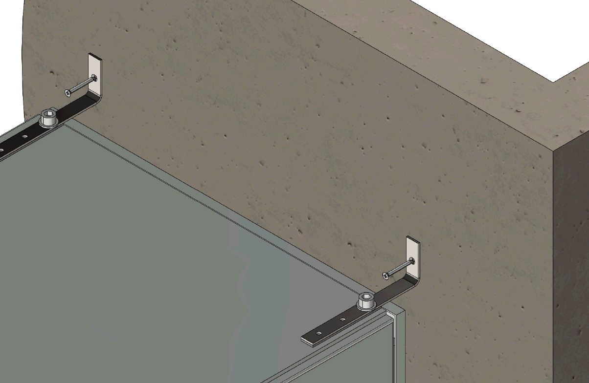
Figure 1: Placement of equipment

Placing the tubes

Open / close the bonnet
The bonnet of the drawer is locked by two solenoids. The bonnet can be opened or closed when the following criteria are met:
- Drawer is powered
- Main menu visible on display

To open the bonnet press and hold ‘0’ on the keypad. Open the bonnet and release the key.
Fully open the bonnet until you notice a resistance.

Closing the bonnet is the same procedure. Press and hold ‘0’ on the keypad and close the bonnet, then release the key.
Possible risk of hand injure when the bonnet is not fully opened. The bonnet can fall on your hands.

Tube connections
Place the image intensifier tubes in the drawer and connect the wires as shown in the following pictures. The wires of the tube can only be connected in one way.

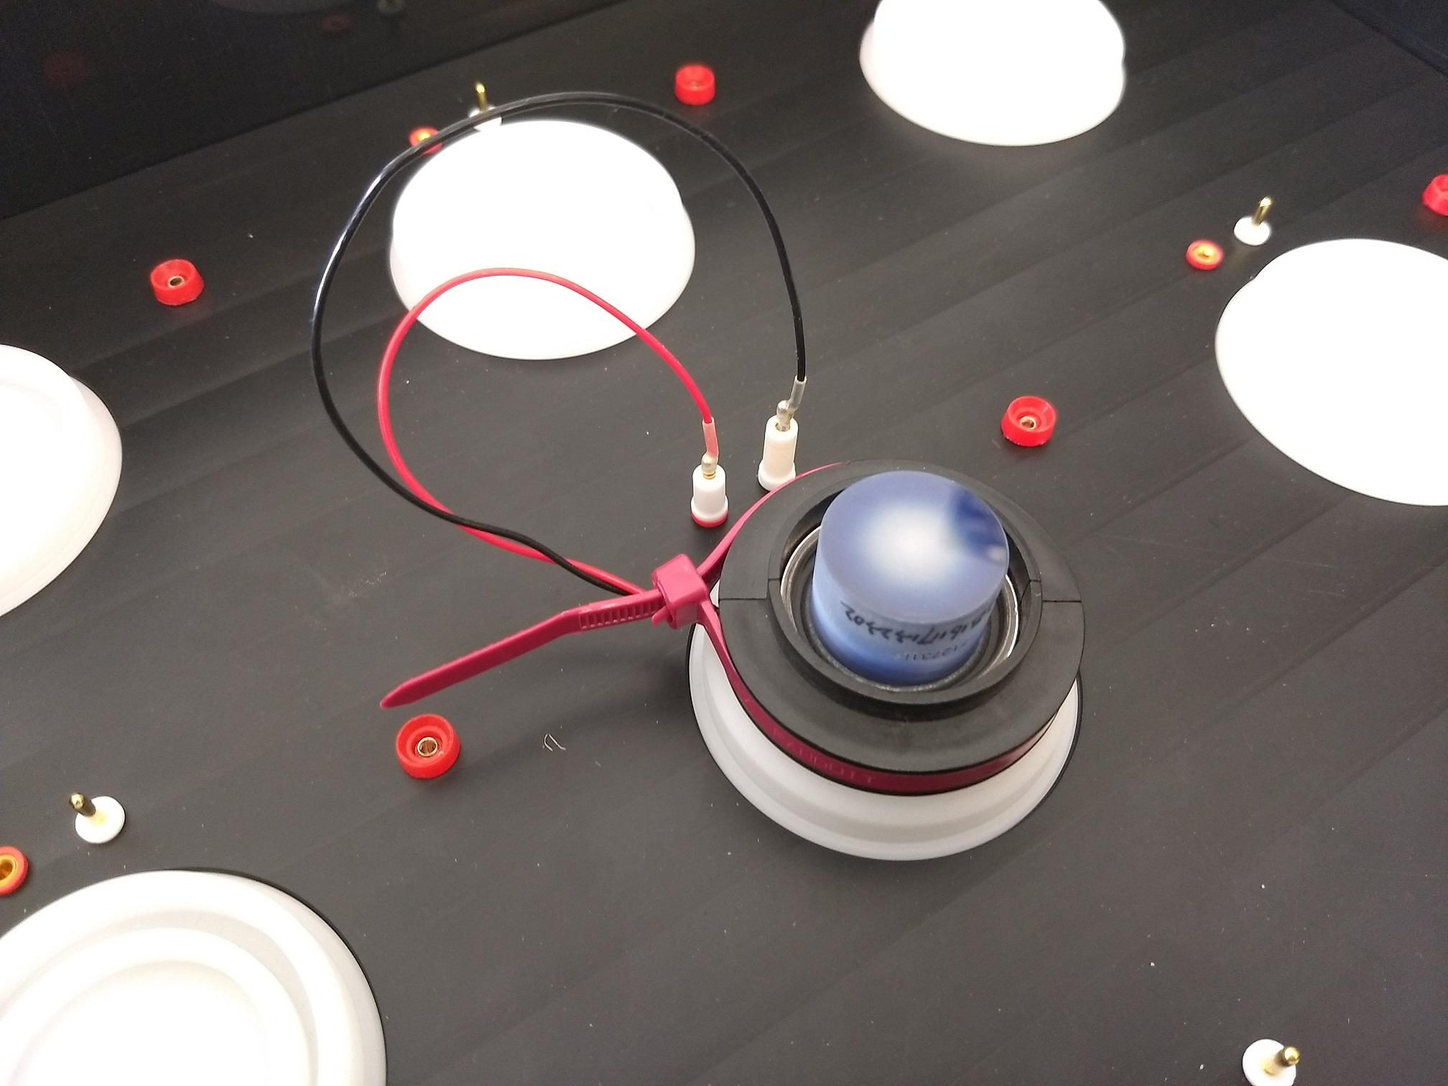
Figure 2: Tube connection

Place the ring on top of the tube and connect the wire as shown in the following picture.

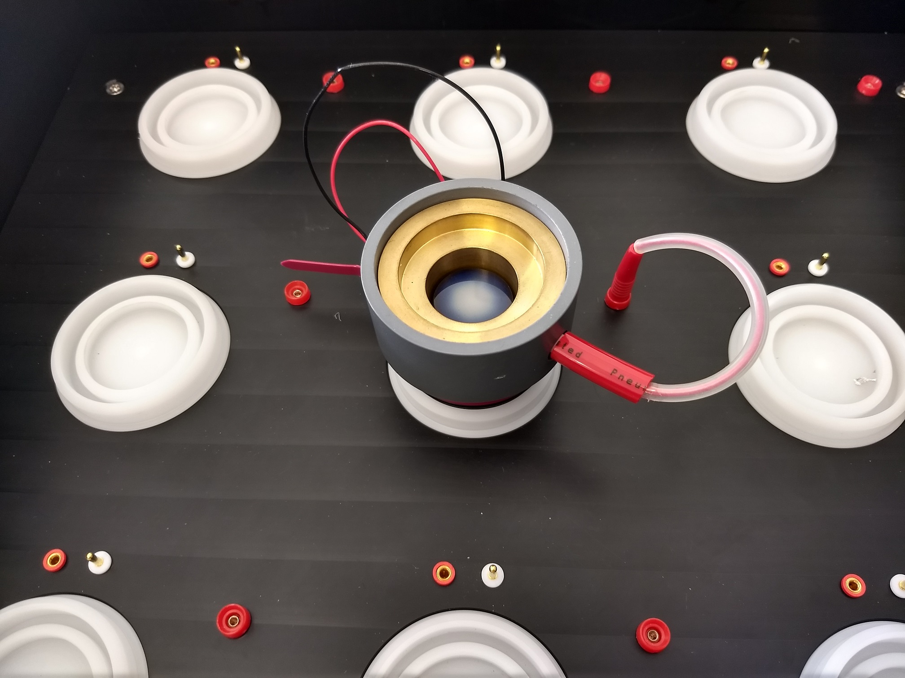
Figure 3: Ring connection

Auxiliary mains socket
The Auxiliary mains socket is used during the repair process in the Tesla drawer. It’s intended for a high voltage spark tester capable of generating an output voltage that is adjustable between at least 10kV to 55kV. The spark tester must not exceed the rating of the Auxiliary mains socket as mentioned in chapter 1.5 Technical data. The spark tester must comply with the applicable European laws and regulations, regarding safety and EMC.

Operation

Front panel control
On the front top side there is a Control panel. It has the following functions:
- Main switch
Use this switch to enable power to the device. All drawers are powered simultaneously with this switch.
- Main On
White indicator light, indicating if the equipment is connected to the mains supply.
- Emergency switch
In case of an emergency, press this switch to interrupt the mains power.
Pull and rotate the emergency switch to enable the mains power again.
- Auxiliary mains socket
Use the Auxiliary mains socket for a suitable spark tester, which will be used during the Tesla repair process.
- Auxiliary enable switch
During the Tesla repair process, press this switch to enable mains power to the Auxiliary mains socket. This switch is in series with a safety feature implemented in de Tesla drawer. The operator needs both hands to operate the spark tester; one hand on this enable switch and the other hand on the spark tester.

Drawer control
Interaction between user and system occurs via a display, a keypad and status led, which are situated at the front of each drawer. See following picture.
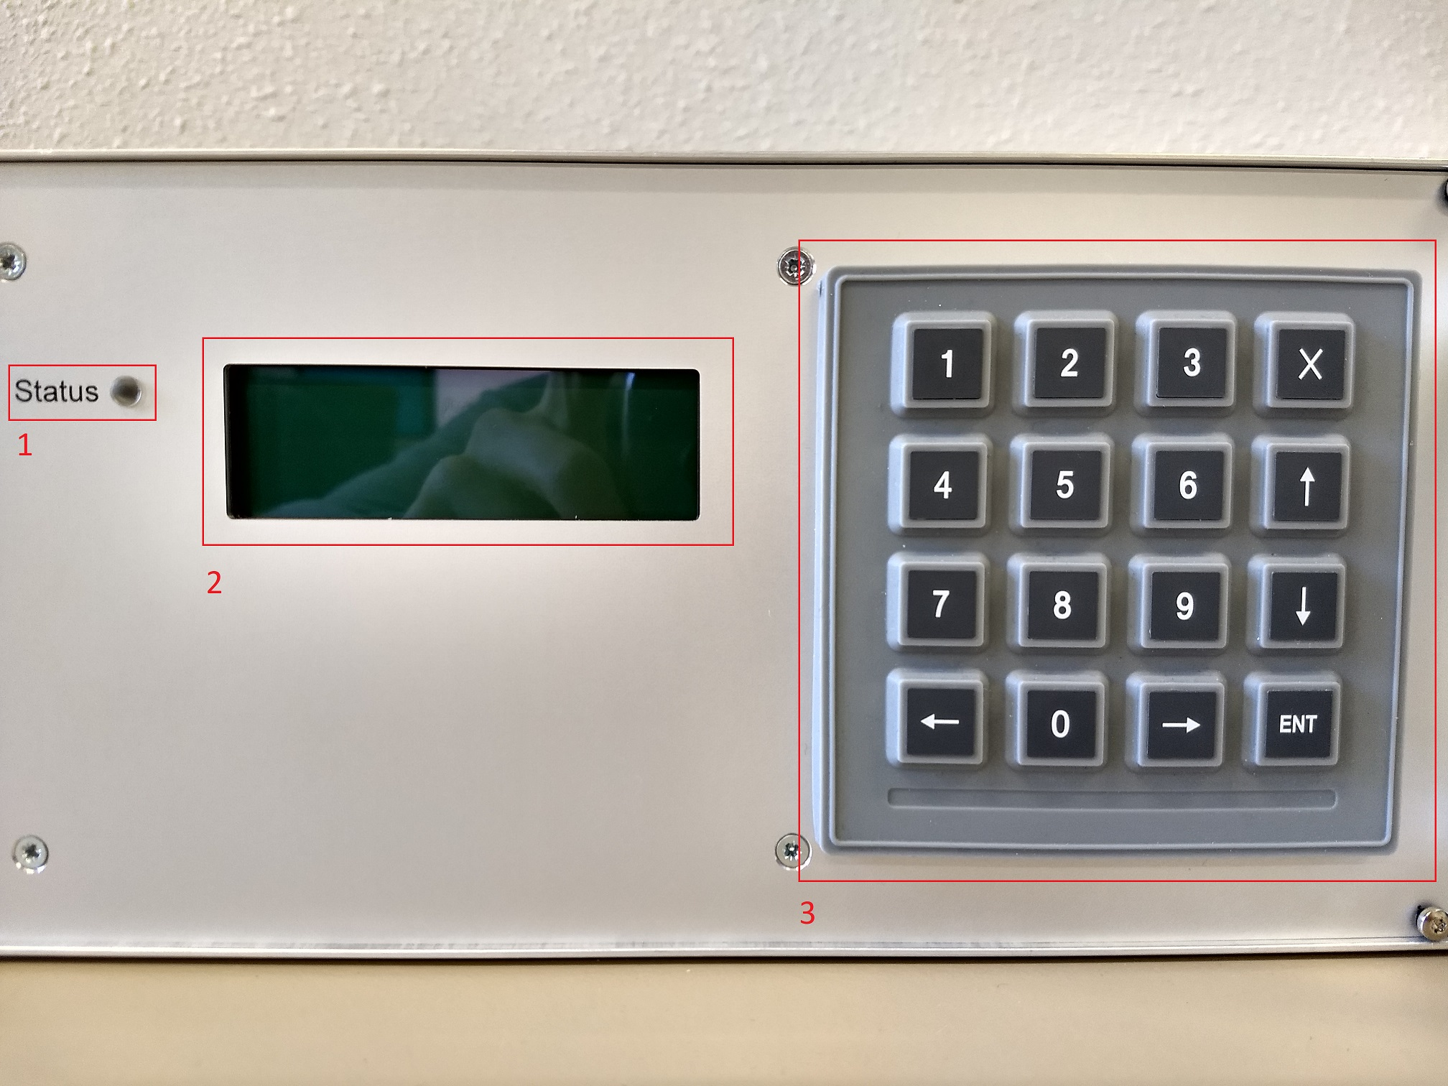

Item | Description
1 | Status LED
2 | Display
3 | Keypad
Within this document the display content is related to by a table. Below represents the display seen from left to right and up to down as a matrix of 4x20.

/ | 1 | 2 | 3 | 4 | 5 | 6 | 7 | 8 | 9 | 10 | 11 | 12 | 13 | 14 | 15 | 16 | 17 | 18 | 19 | 20
1
2
3
4

See the table below for an example.

/ | 1 | 2 | 3 | 4 | 5 | 6 | 7 | 8 | 9 | 10 | 11 | 12 | 13 | 14 | 15 | 16 | 17 | 18 | 19 | 20
1 | S | c | h | e | d | u | l | e | : |  | M | o | n | . | - |  | F | r | i | .
2 | O | p | t | i | o | n | s |  | P | r | e | s | e | t | : |  | A | 2 | 1
3 | A | u | t | o | - | o | f | f | : |  | N | O
4 | A | c | c | e | s | s | : |  | P | u | b | l | i | c

The system contains a keypad which represents the only possibility for the user to interact with the several functions of the system.

The keypad consists of a matrix of four by four keys, making it 16 keys totally. They are labelled as follows:

0-9 | Numeric keys 0 - 9
← | Arrow left
↑ | Arrow up
→ | Arrow right
↓ | Arrow down
ENT | Enter
X | Escape

Depending on the menu item, the keys have different functions. During each menu item the key functions are explained in a table like the one above.

Anode drawer

Start screen
After powering the system, the display will become active and print out a start message, containing the type of repair process and the software version number.

A full start message on display, containing the system version number, will look like:

/ | 1 | 2 | 3 | 4 | 5 | 6 | 7 | 8 | 9 | 10 | 11 | 12 | 13 | 14 | 15 | 16 | 17 | 18 | 19 | 20
1 | A | n | o | d | e |  | r | e | p | a | i | r
2
3 |  |  |  |  | S | W |  | V | . |  | 1 | . | 0 | . | 0 | . | 0
4

There is no user-action needed at this point – the system will switch to the main menu as soon as the system is fully booted and functional.

Main menu
After booting, the system switches to the main menu.

/ | 1 | 2 | 3 | 4 | 5 | 6 | 7 | 8 | 9 | 10 | 11 | 12 | 13 | 14 | 15 | 16 | 17 | 18 | 19 | 20
1 | A | n | o | d | e |  | r | e | p | a | i | r
2 | > |  | 1 | . | T | u | b | e |  | r | e | p | a | i | r
3 |  |  | 2 | . | A | d | m | i | n | i | s | t | r | a | t | o | r
4 |  |  | 3 | . | C | a | l | i | b | r | a | t | i | o | n

Note: The item 2 and 3 are only accessible for the administrator and therefor PIN protected.

1-3 | Select item 1-3 respectively
↑ | Move cursor up one line
↓ | Move cursor down one line
ENT | Select currently current item
0 | Release solenoids to open the cover
others | No function

Opening the cover
When the system is in main menu, press and hold the 0 key to unlock the cover lock.

Tube repair menu

/ | 1 | 2 | 3 | 4 | 5 | 6 | 7 | 8 | 9 | 10 | 11 | 12 | 13 | 14 | 15 | 16 | 17 | 18 | 19 | 20
1 | T | u | b | e |  | r | e | p | a | i | r
2 | > |  | 1 | . | S | e | l | e | c | t |  | p | r | e | s | e | t
3 |  |  | 2 | . | S | t | a | r | t
4

1-2 | Select item 1-2 respectively
↑ | Move cursor up one line
↓ | Move cursor down one line
ENT | Select currently current item
X | Leave current menu level and return to main menu
others | No function

Select preset menu
/ | 1 | 2 | 3 | 4 | 5 | 6 | 7 | 8 | 9 | 10 | 11 | 12 | 13 | 14 | 15 | 16 | 17 | 18 | 19 | 20
1 | S | e | l | e | c | t |  | p | r | e | s | e | t
2 | > |  | 1 | . | P | r | e | s | e | t |  | 1
3 |  |  | 2 | . | P | r | e | s | e | t |  | 2
4 |  |  | 3 | . | P | r | e | s | e | t |  | 3
There is a total of 9 presets.

1-9 | Select item 1-9 respectively and return to tube repair menu
↑ | Move cursor up one line
↓ | Move cursor down one line
→ | Go to preset preview menu of the current currently under the cursor
ENT | Select preset currently under the cursor and return to tube repair menu
X | Leave current menu level and return to tube repair menu
others | No function

Note: The system will always assume preset1 selected when no other selection is done.

Preset preview screen
/ | 1 | 2 | 3 | 4 | 5 | 6 | 7 | 8 | 9 | 10 | 11 | 12 | 13 | 14 | 15 | 16 | 17 | 18 | 19 | 20
1 | P | r | e | s | e | t |  | X |  | i | n | f | o
2 | S | t | a | r | t | : |  |  |  | 1 | 2 | 3 | m |  |  |  | 1 | 2 | 3 | m
3 | T | i | m | e | : |  |  |  |  | 1 | 2 | 3 | m |  |  |  | 1 | 2 | 3 | m
4 | V | o | l | t | : |  |  | - | 1 | 2 | 3 | 4 | m |  | - | 1 | 2 | 3 | 4 | m
Where ‘X’ is the number of the preset that has been selected for preview.

← | Go back to select preset menu
X | Go back to select preset menu
others | No function

Start repair menu

Error messages based on safety
Before starting the repair treatment, it will be verified that the cover of the drawer is closed correctly. For safety reason the cover must be closed before the repair treatment can be started.

/ | 1 | 2 | 3 | 4 | 5 | 6 | 7 | 8 | 9 | 10 | 11 | 12 | 13 | 14 | 15 | 16 | 17 | 18 | 19 | 20
1 |  |  |  |  |  | ! | ! | E | R | R | O | R | ! | !
2 |  |  |  |  | C | O | V | E | R |  | O | P | E | N
3
4 |  |  | H | i | t |  | X |  | t | o |  | c | o | n | t | i | n | u | e

X | Acknowledge error and return to main menu
others | No function

Note: it is not sufficient to close the cover. The system will only react to the X key and return to the main menu. Closing the cover is, however, mandatory before starting a new repair.

Repair in progress
When all conditions are met, the repair treatment starts. The display now acts as feedback.

/ | 1 | 2 | 3 | 4 | 5 | 6 | 7 | 8 | 9 | 10 | 11 | 12 | 13 | 14 | 15 | 16 | 17 | 18 | 19 | 20
1 | X |  |  | h | h | : | m | m | : | s | s |  | t | o | t | a | l
2 |  |  |  | h | h | : | m | m | : | s | s |  | r | e | m | a | i | n
3 |  |  | R | 1 |  |  |  |  |  | R | 2 |  |  |  |  |  | R | 3
4 | - | 1 | 2 | 3 | 4 | V |  | - | 1 | 2 | 3 | 4 | V |  | - | 1 | 2 | 3 | 4 | V

The number in row1/column1 represents the selected preset number.
X | Pause the current repair action
others | No function

Repair Finished
The standard screen as soon as the repair process finishes looks like:

/ | 1 | 2 | 3 | 4 | 5 | 6 | 7 | 8 | 9 | 10 | 11 | 12 | 13 | 14 | 15 | 16 | 17 | 18 | 19 | 20
1 |  |  |  | R | E | P | A | I | R |  | F | I | N | I | S | H | E | D
2
3
4 |  | H | i | t |  | E | N | T |  | t | o |  | c | o | n | t | i | n | u | E

ENT | Return to main menu
others | No function

In case that one or more errors occurred, the following screen will be shown indicating the failing row number(s).
/ | 1 | 2 | 3 | 4 | 5 | 6 | 7 | 8 | 9 | 10 | 11 | 12 | 13 | 14 | 15 | 16 | 17 | 18 | 19 | 20
1 |  |  |  | R | E | P | A | I | R |  | F | I | N | I | S | H | E | D
2 |  |  |  |  | E | r | r | o | r |  | i | n |  | r | o | w
3 |  |  |  |  |  |  |  | 1 |  | 2 |  | 3
4 |  | H | i | t |  | E | N | T |  | t | o |  | c | o | n | t | i | n | u | E

Where the numbers in third row show the row(s) that failed.

ENT | Return to main menu
others | No function

Repair pause

Repair paused
/ | 1 | 2 | 3 | 4 | 5 | 6 | 7 | 8 | 9 | 10 | 11 | 12 | 13 | 14 | 15 | 16 | 17 | 18 | 19 | 20
1
2 |  |  |  |  |  | R | E | P | A | I | R |  | B | U | S | Y
3 |  |  | H | i | t |  |  | X |  |  | t | o |  | P | A | U | S | E
4

When X is hit during an active repair, the screen above appears. This is to suppress accidental keyboard actions. If a pause is requested the user must press X a second time. This screen will remain on display for one second. If the X-button is not pressed within this time, the system will return to the “repair in progress” screen.

X | Pause the current repair action
others | No function

Pausing the repair process automatically turns down the voltage output of all rows to 0 volts. It can take some time to unload all capacities on the rows, so the system will keep waiting until the voltage of all rows is decreased to a safe level. The display will notify about this waiting time with the following screen:

/ | 1 | 2 | 3 | 4 | 5 | 6 | 7 | 8 | 9 | 10 | 11 | 12 | 13 | 14 | 15 | 16 | 17 | 18 | 19 | 20
1
2
3 |  |  |  |  | W | A | I | T | I | N | G |  | F | O | R
4 |  |  |  |  |  | P | O | W | E | R |  | D | O | W | N

When treatment is paused, the display will change its output to:

/ | 1 | 2 | 3 | 4 | 5 | 6 | 7 | 8 | 9 | 10 | 11 | 12 | 13 | 14 | 15 | 16 | 17 | 18 | 19 | 20
1
2 |  |  |  |  |  | ! | ! | P | A | U | S | E | ! | !
3 |  | H | i | t |  | E | N | T |  | t | o |  | c | o | n | t | i | n | u | e
4 |  | H | i | t |  |  | X |  |  | t | o |  | R | E | S | E | T

ENT | Continue the current repair
X | Reset/quit the treatment and return to the tube repair menu
others | No function

After each pause the remaining repair time increases with 5 minutes.

Administrator Menu

PIN protection

PIN insertion screen
The operator menu is PIN protected. Prior to entering, the user must enter the PIN. The default PIN is 0123. It is advised that the administrator changes this PIN as soon as possible.

/ | 1 | 2 | 3 | 4 | 5 | 6 | 7 | 8 | 9 | 10 | 11 | 12 | 13 | 14 | 15 | 16 | 17 | 18 | 19 | 20
1
2
3 |  |  |  |  |  | I | n | s | e | r | t |  | P | I | N
4 |  |  |  |  |  |  |  |  | - | - | - | -

0-9 | Insert number
← | Backspace – delete last entered digit
ENT | Confirm inserted PIN
X | Return to main menu
others | No function

PIN accepted

/ | 1 | 2 | 3 | 4 | 5 | 6 | 7 | 8 | 9 | 10 | 11 | 12 | 13 | 14 | 15 | 16 | 17 | 18 | 19 | 20
1
2
3 |  |  |  |  |  |  |  | P | I | N |  | O | K
4

others | No function

No action required. The screen will be left after three seconds and the operator menu will be entered.

PIN denied

/ | 1 | 2 | 3 | 4 | 5 | 6 | 7 | 8 | 9 | 10 | 11 | 12 | 13 | 14 | 15 | 16 | 17 | 18 | 19 | 20
1
2
3 |  |  |  |  |  | P | I | N |  | D | E | N | I | E | D
4

others | No function

No action required. The screen will be left after one second and the system will return to the main menu.

Administrator main menu
/ | 1 | 2 | 3 | 4 | 5 | 6 | 7 | 8 | 9 | 10 | 11 | 12 | 13 | 14 | 15 | 16 | 17 | 18 | 19 | 20
1 | A | d | m | i | n | i | s | t | r | a | t | i | o | n
2 | > |  | 1 | . | C | h | a | n | g | e |  | P | I | N
3 |  |  | 2 | . | I | / | O |  | c | o | n | t | r | o | l
4 |  |  | 3 | . | P | r | e | s | e | t |  | c | o | n | f | i | g

/ | 1 | 2 | 3 | 4 | 5 | 6 | 7 | 8 | 9 | 10 | 11 | 12 | 13 | 14 | 15 | 16 | 17 | 18 | 19 | 20
 |  |  | 4 | . | P | I | D |  | c | o | n | s | t | a | n | t | S
 |  |  | 5 | . | I | n | f | o |  | & |  | V | e | r | s | i | o | n

1-5 | Select item 1-5 respectively
↑ | Move cursor up one line
↓ | Move cursor down one line
ENT | Select currently current item
X | Leave current menu level and return to main menu
others | No function

Change PIN menu

Insert new Pin
/ |  | 1 | 2 | 3 | 4 | 5 | 6 | 7 | 8 | 9 | 10 | 11 | 12 | 13 | 14 | 15 | 16 | 17 | 18 | 19 | 20
1 | C | h | a | n | g | e |  | P | I | N
2
3 |  |  |  |  | N | e | w |  | P | I | N | : |  |  |  | - | - | - | -
4

X | Leave current menu level and return to administrator menu without changing the PIN
← | Backspace – delete last entered digit
ENT | Confirm inserted PIN
0-9 | Insert number
others | No function

When the 4-digit PIN has been entered, the screen automatically changes to:

/ |  | 1 | 2 | 3 | 4 | 5 | 6 | 7 | 8 | 9 | 10 | 11 | 12 | 13 | 14 | 15 | 16 | 17 | 18 | 19 | 20
1 | C | h | a | n | g | e |  | P | I | N
2
3 |  |  |  |  | N | e | w |  | P | I | N | : |  |  |  | * | * | * | *
4 |  | R | e | p | e | a | t |  | P | I | N | : |  |  |  | - | - | - | -

X | Leave current menu level and return to administrator main menu without changing the PIN
← | Backspace – delete last entered digit
ENT | Confirm inserted PIN
0-9 | Insert number
others | No function

When the 4-digit has been entered a second time, the system will verify that both entered PINs are equal.

New Pin OK
/ |  | 1 | 2 | 3 | 4 | 5 | 6 | 7 | 8 | 9 | 10 | 11 | 12 | 13 | 14 | 15 | 16 | 17 | 18 | 19 | 20
1
2
3 |  |  | N | e | w |  | P | I | N |  | a | c | c | e | p | t | e | d
4

others | No function

No action required. The screen will be left after three seconds and the administrator main menu will appear again.

New Pin failed
/ |  | 1 | 2 | 3 | 4 | 5 | 6 | 7 | 8 | 9 | 10 | 11 | 12 | 13 | 14 | 15 | 16 | 17 | 18 | 19 | 20
1
2
3 |  |  |  | N | e | w |  | P | I | N |  | d | e | n | i | e | d
4

others | No function

No action required. The screen will be left after three seconds and the administrator main menu will appear again.

I/O control menu
/ | 1 | 2 | 3 | 4 | 5 | 6 | 7 | 8 | 9 | 10 | 11 | 12 | 13 | 14 | 15 | 16 | 17 | 18 | 19 | 20
1 | I | / | O |  | c | o | n | t | r | o | l
2 | > |  | 1 | . | R | e | a | d |  | i | n | t | e | r | l | o | c | k
3 |  |  | 2 | . | S | o | l | e | n | o | i | d | S
4 |  |  | 3 | . | G | e | t |  | v | o | l | t | a | g | e |  | i | n

/ | 1 | 2 | 3 | 4 | 5 | 6 | 7 | 8 | 9 | 10 | 11 | 12 | 13 | 14 | 15 | 16 | 17 | 18 | 19 | 20
 |  |  | 4 | . | S | e | t |  | v | o | l | t | a | g | e |  | o | u | t

1-4 | Select item 1-4 respectively
↑ | Move cursor up one line
↓ | Move cursor down one line
ENT | Select currently current item
X | Leave current menu level and return to administrator menu
others | No function

Read interlock
Reading the interlock status is a constant action, meaning that the screen will immediately update its content with the interlock status.

/ | 1 | 2 | 3 | 4 | 5 | 6 | 7 | 8 | 9 | 10 | 11 | 12 | 13 | 14 | 15 | 16 | 17 | 18 | 19 | 20
1
2 |  | C | o | v | e | r |  | i | n | t | e | r | l | o | c | k |  | i | s
3
4

If interlock is open:
/ | 1 | 2 | 3 | 4 | 5 | 6 | 7 | 8 | 9 | 10 | 11 | 12 | 13 | 14 | 15 | 16 | 17 | 18 | 19 | 20
3 |  |  |  |  |  |  |  |  | o | p | e | n

If interlock is closed:
/ | 1 | 2 | 3 | 4 | 5 | 6 | 7 | 8 | 9 | 10 | 11 | 12 | 13 | 14 | 15 | 16 | 17 | 18 | 19 | 20
3 |  |  |  |  |  |  |  | c | l | o | s | e | d

X | Leave current menu level and return to administrator I/O menu
others | No function

Solenoids

/ | 1 | 2 | 3 |  | 4 | 5 | 6 | 7 | 8 | 9 | 10 | 11 | 12 | 13 | 14 | 15 | 16 | 17 | 18 | 19 | 20
1 | S | o | l |  | e | n | o | i | d | s
2 |  |  | H |  | o | l | d |  | 0 |  | t | o |  | t | o | g | g | l | e
3
4
0 |  |  |  | Press: activate solenoids (open cover)  Release: de-activate solenoids (seal cover)
X |  |  |  | Leave current menu level and return to administrator I/O menu
others |  |  |  | No function

Get voltage in
The screen to read the voltage input is a read-only screen, meaning that no user action is accepted (other than leaving the menu).
The screen shows the currently read voltage on all three rows in both voltage (left value) and the corresponding hexadecimal value of the DA converter.

/ | 1 | 2 | 3 | 4 | 5 | 6 | 7 | 8 | 9 | 10 | 11 | 12 | 13 | 14 | 15 | 16 | 17 | 18 | 19 | 20
1 | G | e | t |  | v | o | l | t | a | g | e |  | i | n
2 | R | o | w | 1 | : |  | 1 | 2 | 3 | 4 | 5 | V | | |  | A | B | C | D | x
3 | R | o | w | 2 | : |  | 1 | 2 | 3 | 4 | 5 | V | | |  | A | B | C | D | x
4 | R | o | w | 3 | : |  | 1 | 2 | 3 | 4 | 5 | V | | |  | A | B | C | D | x

X | Leave screen and return to administrator I/O menu
others | No function

Set voltage out
The screen to set the voltage output enables the administrator to apply a voltage to the three rows.
The cursor is put at the first row when entering the menu.
The screen shows two values per row. The left value is the value that the administrator inserts and applies to the DA converter of that specific row. The right value of that row is the actual value that is read back from the AD converter of that same row.

/ | 1 | 2 | 3 | 4 | 5 | 6 | 7 | 8 | 9 | 10 | 11 | 12 | 13 | 14 | 15 | 16 | 17 | 18 | 19 | 20
1 | S | e | t |  | v | o | l | t | a | g | e |  | o | u | t
2 | R | o | w | 1 | : |  | 1 | 2 | 3 | 4 | 5 | V | | |  | 1 | 2 | 3 | 4 | 5 | V
3 | R | o | w | 2 | : |  | 1 | 2 | 3 | 4 | 5 | V | | |  | 1 | 2 | 3 | 4 | 5 | V
4 | R | o | w | 3 | : |  | 1 | 2 | 3 | 4 | 5 | V | | |  | 1 | 2 | 3 | 4 | 5 | V

0-9 | Used for value insertion
↑ | Move cursor up one row
↓ | Move cursor down one row
← | Backspace – delete last entered digit
ENT | Accept inserted value and apply to DA converter of that row
X | Leave screen and return to administrator I/O menu
others | No function

Leaving the set voltage out menu causes the following screen to appear.

/ | 1 | 2 | 3 | 4 | 5 | 6 | 7 | 8 | 9 | 10 | 11 | 12 | 13 | 14 | 15 | 16 | 17 | 18 | 19 | 20
1
2
3 | A | l | l |  | r | o | w | s |  | r | e | s | e | t |  | t | o |  | 0 | V
4 |  | P | r | e | s | s |  | X |  | t | o |  | c | o | n | t | i | n | u | e

X | Leave screen and return to administrator I/O menu
others | No function

Preset configuration
The repair process follows a configurable preset. There are two types of presets, a one-stage and a two-stage repair preset. See the following images for an explanation of the presets.
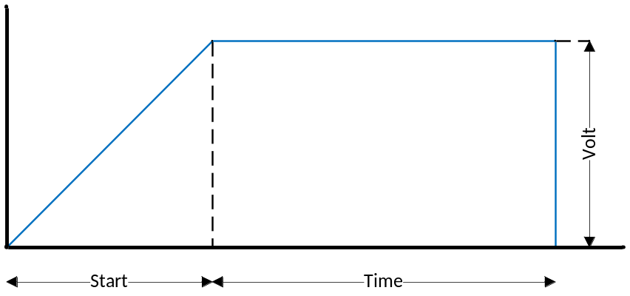
Figure 4: One stage repair preset

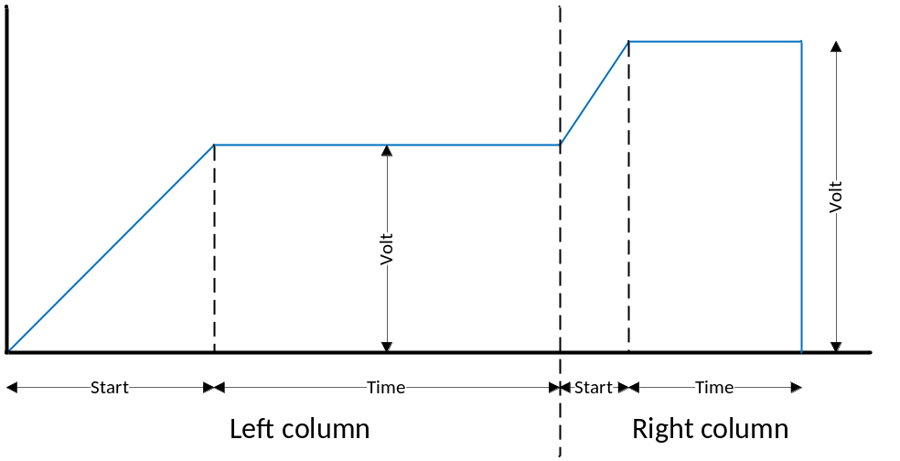
Figure 5: Two-stage repair preset

Parameter | Description
Start | Ramp-up time (minutes)
Time | Repair duration (minutes)
Volt | Repair voltage (Volt)

Select a preset to configure.

/ | 1 | 2 | 3 | 4 | 5 | 6 | 7 | 8 | 9 | 10 | 11 | 12 | 13 | 14 | 15 | 16 | 17 | 18 | 19 | 20
1 | P | r | e | s | e | t |  | c | o | n | f | i | g
2 |  |  | 1 | . | P | r | e | s | e | t |  | 1 |  | c | o | n | f | i | g
3 |  |  | 2 | . | P | r | e | s | e | t |  | 2 |  | c | o | n | f | i | g
4 |  |  | 3 | . | P | r | e | s | e | t |  | 3 |  | c | o | n | f | i | g

The screen continues until item “9.Preset 9 config”.

1-9 | Select item 1-9 respectively
↑ | Move cursor up one row
↓ | Move cursor down one row
ENT | Select current preset under the cursor
X | Leave screen and return to Cathode/MCP selection menu
others | No function

The first six presets only contain one stage, while preset seven, eight and nine contain two repair stages. The screen underneath represents a preset with two stages. For a single-stage preset, the second column with values is not available.
When entering this screen, the cursor is put to the start value of the first stage. The value can be updated/modified. Button ‘ENT’ accepts the value and sets the cursor to the next value. When the last value has been reached, ‘ENT’ will cause the system to save the modified preset to system memory and leave the preset configuration screen, returning to the preset selection overview.

/ | 1 | 2 | 3 | 4 | 5 | 6 | 7 | 8 | 9 | 10 | 11 | 12 | 13 | 14 | 15 | 16 | 17 | 18 | 19 | 20
1 | P | r | e | s | e | t |  | X |  | c | o | n | f | i | g
2 | S | t | a | r | t | : |  |  |  | 1 | 2 | 3 | m |  |  |  | 1 | 2 | 3 | m
3 | T | i | m | e | : |  |  |  |  | 1 | 2 | 3 | m |  |  |  | 1 | 2 | 3 | m
4 | V | o | l | t | : |  |  | 1 | 2 | 3 | 4 | 5 | V |  | 1 | 2 | 3 | 4 | 5 | V
Where ‘X’ is the number of the currently configurated preset.

0-9 | Digit insertion
← | Backspace – delete last entered digit
ENT | Accept inserted value and continue. When last value is reached, ENT will save the modified preset and return to the preset selection overview.
X | Leave screen and return to preset config menu without saving
others | No function

When a preset is modified and saved, the system will confirm this action with an additional screen that appears only temporary:

/ | 1 | 2 | 3 | 4 | 5 | 6 | 7 | 8 | 9 | 10 | 11 | 12 | 13 | 14 | 15 | 16 | 17 | 18 | 19 | 20
1
2
3 |  |  |  |  | P | r | e | s | e | t |  | s | a | v | e | d
4
This screen will disappear after one second and the preset selection overview will be shown.

PID constants
When entering this screen, the cursor is put to the Kp value. The value can be updated/modified. Button ‘ENT’ accepts the value and sets the cursor to the next value. When the last value has been reached, ‘ENT’ will cause the system to save the modified PID constants to system memory and leave the PID constants screen, returning to the administration menu.

/ | 1 | 2 | 3 | 4 | 5 | 6 | 7 | 8 | 9 | 10 | 11 | 12 | 13 | 14 | 15 | 16 | 17 | 18 | 19 | 20
1 | P | I | D |  | c | o | n | s | t | a | n | t | s
2 | K | p | : |  |  | 3 | 0 | 0 | 0
3 | K | i | : |  |  | 2 | 0 | 0 | 0
4 | K | d | : |  |  |  |  |  | 0

0-9 | Digit insertion
← | Backspace – delete last entered digit
ENT | Accept inserted value and continue. When last value is reached, ENT will save the modified preset and return to the preset selection overview.
X | Leave screen and return to preset config menu without saving
others | No function

Information and version screen
The full screen on display, containing the system version number, will look like:

/ | 1 | 2 | 3 | 4 | 5 | 6 | 7 | 8 | 9 | 10 | 11 | 12 | 13 | 14 | 15 | 16 | 17 | 18 | 19 | 20
1 | A | n | o | d | e |  | r | e | p | a | i | r
2
3 |  |  |  |  | S | W |  | V | . |  | 1 | . | 0 | . | 0 | . | 0
4

X | Leave screen and return to administrator menu
others | No function

Calibration menu

PIN protection

PIN insertion screen
The calibration menu is PIN protected. Prior to entering, the administrator must enter the PIN:

/ | 1 | 2 | 3 | 4 | 5 | 6 | 7 | 8 | 9 | 10 | 11 | 12 | 13 | 14 | 15 | 16 | 17 | 18 | 19 | 20
1 |  |  | C | a | l | i | b | r | a | t | i | o | n |  | m | e | n | u
2
3 |  |  |  |  |  | I | n | s | e | r | t |  | P | I | N
4 |  |  |  |  |  |  |  |  | - | - | - | -

0-9 | Insert number
← | Backspace – delete last entered digit
ENT | Confirm inserted PIN
X | Return to main menu
others | No function

PIN accepted
/ | 1 | 2 | 3 | 4 | 5 | 6 | 7 | 8 | 9 | 10 | 11 | 12 | 13 | 14 | 15 | 16 | 17 | 18 | 19 | 20
1 |  |  | C | a | l | i | b | r | a | t | i | o | n |  | m | e | n | u
2
3 |  |  |  |  |  |  |  | P | I | N |  | O | K
4

others | No function

No action required. The screen will be left after 3 seconds and the calibration main menu will be entered.

PIN denied
/ | 1 | 2 | 3 | 4 | 5 | 6 | 7 | 8 | 9 | 10 | 11 | 12 | 13 | 14 | 15 | 16 | 17 | 18 | 19 | 20
1 |  |  | C | a | l | i | b | r | a | t | i | o | n |  | m | e | n | u
2
3 |  |  |  |  |  | P | I | N |  | D | E | N | I | E | D
4

others | No function

No action required. The screen will be left after 3 seconds and the PIN insertion screen will appear again.

Calibration main menu
/ | 1 | 2 | 3 | 4 | 5 | 6 | 7 | 8 | 9 | 10 | 11 | 12 | 13 | 14 | 15 | 16 | 17 | 18 | 19 | 20
1 | C | a | l | i | b | r | a | t | i | o | n |  | m | e | n | u
2 | > |  | 1 | . | S | e | t | p | o | i | n | t |  | c | h | e | c | k
3
4

↑ | Move cursor up one line
↓ | Move cursor down one line
ENT | Select currently current item
X | Leave current menu level and return to main menu
others | No function

The only calibration option now is the verification of setpoint voltages

The following setpoints will be loaded:
Repair mode | Low setpoint | High setpoint
Anode | 6000V | 10000V

The next screen will be the setpoint check menu in both cases.

Setpoint check menu
/ | 1 | 2 | 3 | 4 | 5 | 6 | 7 | 8 | 9 | 10 | 11 | 12 | 13 | 14 | 15 | 16 | 17 | 18 | 19 | 20
1 | S | e | t | p | o | i | n | t |  | c | h | e | c | k
2 | > |  | 1 | . | L | o | w |  | s | e | t | p | o | i | n | t
3 |  |  | 2 | . | H | i | g | h |  | s | e | t | p | o | i | n | t
4

↑ | Move cursor up one line
↓ | Move cursor down one line
ENT | Select currently current item
X | Leave current menu level and return to Cathode/MCP selection menu
others | No function

Danger for unqualified users
Calibration should only be performed by an administrator.
Calibration can only be executed with the lid open. This means that the interlock safety switch should be bypassed. The safety features are now disabled during calibration.

Electrocution hazard
Calibration must be executed while the lid is open. This means the user can access the DUT connections while the high voltage is still present.

Low setpoint check screen

/ | 1 | 2 | 3 | 4 | 5 | 6 | 7 | 8 | 9 | 10 | 11 | 12 | 13 | 14 | 15 | 16 | 17 | 18 | 19 | 20
1 | L | o | w |  | s | e | t | p | o | i | n | t
2 | R | o | w | 1 | : |  | - | 6 | 0 | 0 | 0 | V | | |  | - | 1 | 2 | 3 | 4 | V
3 | R | o | w | 2 | : |  | - | 6 | 0 | 0 | 0 | V | | |  | - | 1 | 2 | 3 | 4 | V
4 | R | o | w | 3 | : |  | - | 6 | 0 | 0 | 0 | V | | |  | - | 1 | 2 | 3 | 4 | V

Where the left value is the low setpoint for the specific selection and the right value is the directly read-back value from the ADC for comparison.

The low setpoint voltage is applied to the outputs automatically as soon as this menu is entered, and a voltage of 0 V is applied to the outputs automatically when this menu is left again.

X | Leave calibration procedure and return to setpoint check menu
others | No function

High setpoint check screen

/ | 1 | 2 | 3 | 4 | 5 | 6 | 7 | 8 | 9 | 10 | 11 | 12 | 13 | 14 | 15 | 16 | 17 | 18 | 19 | 20
1 | H | i | g | h |  | s | e | t | p | o | i | n | t
2 | R | o | w | 1 | : |  | 1 | 0 | 0 | 0 | 0 | V | | |  | 1 | 2 | 3 | 4 | 5 | V
3 | R | o | w | 2 | : |  | 1 | 0 | 0 | 0 | 0 | V | | |  | 1 | 2 | 3 | 4 | 5 | V
4 | R | o | w | 3 | : |  | 1 | 0 | 0 | 0 | 0 | V | | |  | 1 | 2 | 3 | 4 | 5 | V

Where the left value is the high setpoint for the specific selection and the right value is the directly read-back value from the ADC for comparison.

The high setpoint voltage is applied to the outputs automatically as soon as this menu is entered, and a voltage of 0 V is applied to the outputs automatically when this menu is left again.

X | Leave calibration procedure and return to setpoint check menu

Cathode / MCP drawer

Start screen
After powering the system, the display will become active and print out a start message, containing the type of repair process and the software version number.
A full start message on display, containing the system version number, will look like:

/ | 1 | 2 | 3 | 4 | 5 | 6 | 7 | 8 | 9 | 10 | 11 | 12 | 13 | 14 | 15 | 16 | 17 | 18 | 19 | 20
1 | C | a | t | h | o | d | e | / | M | C | P |  | r | e | p | a | i | r
2
3 |  |  |  |  | S | W |  | V | . |  | 1 | . | 0 | . | 0 | . | 0
4
There is no user-action needed at this point – the system will switch to the main menu as soon as the system is fully booted and functional.

Main menu
After booting, the system switches to the main menu.

/ | 1 | 2 | 3 | 4 | 5 | 6 | 7 | 8 | 9 | 10 | 11 | 12 | 13 | 14 | 15 | 16 | 17 | 18 | 19 | 20
1 | C | a | t | h | o | d | e | / | M | C | P |  | r | e | p | a | i | r
2 | > |  | 1 | . | T | u | b | e |  | r | e | p | a | i | r
3 |  |  | 2 | . | A | d | m | i | n | i | s | t | r | a | t | o | r
4 |  |  | 3 | . | C | a | l | i | b | r | a | t | i | o | n

Note: The item 2 and 3 are only accessible for the administrator and therefor PIN protected.

1-3 | Select item 1-3 respectively
↑ | Move cursor up one line
↓ | Move cursor down one line
ENT | Select currently current item
others | No function

Opening the cover
When the system is in main menu, press and hold the 0 key to unlock the cover lock.

Tube repair menu
Prior to entering the tube repair menu, a selection screen allows to choose between the Cathode and MCP repair process.

/ | 1 | 2 | 3 | 4 | 5 | 6 | 7 | 8 | 9 | 10 | 11 | 12 | 13 | 14 | 15 | 16 | 17 | 18 | 19 | 20
1 | T | u | b | e |  | r | e | p | a | i | r
2 | > |  | 1 | . | C | a | t | h | o | d | e |  | r | e | p | a | i | r
3 |  |  | 2 | . | M | C | P |  | r | e | p | a | i | r
4

1-2 | Select item 1-2 respectively
↑ | Move cursor up one line
↓ | Move cursor down one line
ENT | Select currently current item
X | Leave current menu level and return to main menu
others | No function

By choosing either of the two options, the corresponding presets will be loaded. The next screen will be the tube repair menu in both cases.

/ | 1 | 2 | 3 | 4 | 5 | 6 | 7 | 8 | 9 | 10 | 11 | 12 | 13 | 14 | 15 | 16 | 17 | 18 | 19 | 20
1 | T | u | b | e |  | r | e | p | a | i | r
2 | > |  | 1 | . | S | e | l | e | c | t |  | p | r | e | s | e | t
3 |  |  | 2 | . | S | t | a | r | t
4

1-2 | Select item 1-2 respectively
↑ | Move cursor up one line
↓ | Move cursor down one line
ENT | Select currently current item
X | Leave current menu level and return to Cathode/MCP selection menu
others | No function

Select preset menu
/ | 1 | 2 | 3 | 4 | 5 | 6 | 7 | 8 | 9 | 10 | 11 | 12 | 13 | 14 | 15 | 16 | 17 | 18 | 19 | 20
1 | S | e | l | e | c | t |  | p | r | e | s | e | t
2 | > |  | 1 | . | P | r | e | s | e | t |  | 1
3 |  |  | 2 | . | P | r | e | s | e | t |  | 2
4 |  |  | 3 | . | P | r | e | s | e | t |  | 3

There is a total of 9 presets.

1-9 | Select item 1-9 respectively and return to tube repair menu
↑ | Move cursor up one line
↓ | Move cursor down one line
→ | Go to preset preview menu of the current currently under the cursor
ENT | Select preset currently under the cursor and return to tube repair menu
X | Leave current menu level and return to tube repair menu
others | No function

Note: The system will always assume preset1 selected when no other selection is done.

Preset preview screen
/ | 1 | 2 | 3 | 4 | 5 | 6 | 7 | 8 | 9 | 10 | 11 | 12 | 13 | 14 | 15 | 16 | 17 | 18 | 19 | 20
1 | P | r | e | s | e | t |  | X |  | i | n | f | o
2 | S | t | a | r | t | : |  |  |  | 1 | 2 | 3 | m |  |  |  | 1 | 2 | 3 | m
3 | T | i | m | e | : |  |  |  |  | 1 | 2 | 3 | m |  |  |  | 1 | 2 | 3 | m
4 | V | o | l | t | : |  |  | - | 1 | 2 | 3 | 4 | m |  | - | 1 | 2 | 3 | 4 | m

Where ‘X’ is the number of the preset that has been selected for preview.

← | Go back select preset menu
X | Go back select preset menu
others | No function

Start repair menu

Error messages based on safety
Before starting the repair treatment, it will be verified that the cover of the drawer is closed correctly. For safety reason the cover must be closed before the repair treatment can be started.

/ | 1 | 2 | 3 | 4 | 5 | 6 | 7 | 8 | 9 | 10 | 11 | 12 | 13 | 14 | 15 | 16 | 17 | 18 | 19 | 20
1 |  |  |  |  |  | ! | ! | E | R | R | O | R | ! | !
2 |  |  |  |  | C | O | V | E | R |  | O | P | E | N
3
4 |  |  | H | i | t |  | X |  | t | o |  | c | o | n | t | i | n | u | e

X | Acknowledge error and return to main menu
others | No function
Note: it is not sufficient to close the cover. The system will only react to the X key and return to the main menu. Closing the cover is, however, mandatory before starting a new repair.

Repair in progress
When all conditions are met, the repair treatment starts. The display now acts as feedback

/ | 1 | 2 | 3 | 4 | 5 | 6 | 7 | 8 | 9 | 10 | 11 | 12 | 13 | 14 | 15 | 16 | 17 | 18 | 19 | 20
1 | X |  |  | h | h | : | m | m | : | s | s |  | t | o | t | a | l
2 |  |  |  | h | h | : | m | m | : | s | s |  | r | e | m | a | i | n
3 |  |  | R | 1 |  |  |  |  |  | R | 2 |  |  |  |  |  | R | 3
4 | - | 1 | 2 | 3 | 4 | V |  | - | 1 | 2 | 3 | 4 | V |  | - | 1 | 2 | 3 | 4 | V

The number in row1/column1 represents the selected preset number.
X | Pause the current repair action
others | No function

Repair Finished
The standard screen as soon as the repair process finishes looks like

/ | 1 | 2 | 3 | 4 | 5 | 6 | 7 | 8 | 9 | 10 | 11 | 12 | 13 | 14 | 15 | 16 | 17 | 18 | 19 | 20
1 |  |  |  | R | E | P | A | I | R |  | F | I | N | I | S | H | E | D
2
3
4 |  | H | i | t |  | E | N | T |  | t | o |  | c | o | n | t | i | n | u | E

ENT | Return to main menu
others | No function

In case that one or more errors occurred, the following screen will be shown indicating the failing row number(s).
/ | 1 | 2 | 3 | 4 | 5 | 6 | 7 | 8 | 9 | 10 | 11 | 12 | 13 | 14 | 15 | 16 | 17 | 18 | 19 | 20
1 |  |  |  | R | E | P | A | I | R |  | F | I | N | I | S | H | E | D
2 |  |  |  |  | E | r | r | o | r |  | i | n |  | r | o | w
3 |  |  |  |  |  |  |  | 1 |  | 2 |  | 3
4 |  | H | i | t |  | E | N | T |  | t | o |  | c | o | n | t | i | n | u | E

Where the numbers in third row show the row(s) that failed.

ENT | Return to main menu
others | No function

Repair pause

Repair paused
/ | 1 | 2 | 3 | 4 | 5 | 6 | 7 | 8 | 9 | 10 | 11 | 12 | 13 | 14 | 15 | 16 | 17 | 18 | 19 | 20
1
2 |  |  |  |  |  | R | E | P | A | I | R |  | B | U | S | Y
3 |  |  | H | i | t |  |  | X |  |  | t | o |  | P | A | U | S | E
4

When X is hit during an active repair, the screen above appears. This is to suppress accidental keyboard actions. If a pause is requested the user must press X a second time. This screen will remain on display for one second. If the X-button is not pressed within this time, the system will return to the “repair in progress” screen.

X | Pause the current repair action
others | No function

Pausing the repair process automatically turns down the voltage output of all rows to 0 volts. It can take some time to unload all capacities on the rows, so the system will keep waiting until the voltage of all rows is decreased to a safe level. The display will notify about this waiting time with the following screen:

/ | 1 | 2 | 3 | 4 | 5 | 6 | 7 | 8 | 9 | 10 | 11 | 12 | 13 | 14 | 15 | 16 | 17 | 18 | 19 | 20
1
2
3 |  |  |  |  | W | A | I | T | I | N | G |  | F | O | R
4 |  |  |  |  |  | P | O | W | E | R |  | D | O | W | N

When treatment is paused, the display will change its output to:

/ | 1 | 2 | 3 | 4 | 5 | 6 | 7 | 8 | 9 | 10 | 11 | 12 | 13 | 14 | 15 | 16 | 17 | 18 | 19 | 20
1
2 |  |  |  |  |  | ! | ! | P | A | U | S | E | ! | !
3 |  | H | i | t |  | E | N | T |  | t | o |  | c | o | n | t | i | n | u | e
4 |  | H | i | t |  |  | X |  |  | t | o |  | R | E | S | E | T

ENT | Continue the current repair
X | Reset/quit the treatment and return to the tube repair menu
others | No function

After each pause the remaining repair time increases with 5 minutes.

Administrator Menu

PIN protection

PIN insertion screen
The operator menu is PIN protected. Prior to entering, the user must enter the PIN. The default PIN is 0123. It is advised that the administrator changes this PIN as soon as possible.

/ | 1 | 2 | 3 | 4 | 5 | 6 | 7 | 8 | 9 | 10 | 11 | 12 | 13 | 14 | 15 | 16 | 17 | 18 | 19 | 20
1
2
3 |  |  |  |  |  | I | n | s | e | r | t |  | P | I | N
4 |  |  |  |  |  |  |  |  | - | - | - | -

0-9 | Insert number
← | Backspace – delete last entered digit
ENT | Confirm inserted PIN
X | Return to main menu
others | No function

PIN accepted
/ | 1 | 2 | 3 | 4 | 5 | 6 | 7 | 8 | 9 | 10 | 11 | 12 | 13 | 14 | 15 | 16 | 17 | 18 | 19 | 20
1
2
3 |  |  |  |  |  |  |  | P | I | N |  | O | K
4

others | No function

No action required. The screen will be left after three seconds and the operator menu will be entered.

PIN denied
/ | 1 | 2 | 3 | 4 | 5 | 6 | 7 | 8 | 9 | 10 | 11 | 12 | 13 | 14 | 15 | 16 | 17 | 18 | 19 | 20
1
2
3 |  |  |  |  |  | P | I | N |  | D | E | N | I | E | D
4

others | No function

No action required. The screen will be left after one second and the system will return to the main menu.

Administrator main menu
/ | 1 | 2 | 3 | 4 | 5 | 6 | 7 | 8 | 9 | 10 | 11 | 12 | 13 | 14 | 15 | 16 | 17 | 18 | 19 | 20
1 | A | d | m | i | n | i | s | t | r | a | t | i | o | n
2 | > |  | 1 | . | C | h | a | n | g | e |  | P | I | N
3 |  |  | 2 | . | I | / | O |  | c | o | n | t | r | o | l
4 |  |  | 3 | . | P | r | e | s | e | t |  | c | o | n | f | i | g

/ | 1 | 2 | 3 | 4 | 5 | 6 | 7 | 8 | 9 | 10 | 11 | 12 | 13 | 14 | 15 | 16 | 17 | 18 | 19 | 20
 |  |  | 4 | . | P | I | D |  | c | o | n | s | t | a | n | t | S
 |  |  | 5 | . | I | n | f | o |  | & |  | V | e | r | s | i | o | n

1-5 | Select item 1-5 respectively
↑ | Move cursor up one line
↓ | Move cursor down one line
ENT | Select currently current item
X | Leave current menu level and return to main menu
others | No function

Change PIN menu

Insert new Pin
/ |  | 1 | 2 | 3 | 4 | 5 | 6 | 7 | 8 | 9 | 10 | 11 | 12 | 13 | 14 | 15 | 16 | 17 | 18 | 19 | 20
1 | C | h | a | n | g | e |  | P | I | N
2
3 |  |  |  |  | N | e | w |  | P | I | N | : |  |  |  | - | - | - | -
4

X | Leave current menu level and return to administrator menu without changing the PIN
← | Backspace – delete last entered digit
ENT | Confirm inserted PIN
0-9 | Insert number
others | No function

When the 4-digit PIN has been entered, the screen automatically changes to:

/ |  | 1 | 2 | 3 | 4 | 5 | 6 | 7 | 8 | 9 | 10 | 11 | 12 | 13 | 14 | 15 | 16 | 17 | 18 | 19 | 20
1 | C | h | a | n | g | e |  | P | I | N
2
3 |  |  |  |  | N | e | w |  | P | I | N | : |  |  |  | * | * | * | *
4 |  | R | e | p | e | a | t |  | P | I | N | : |  |  |  | - | - | - | -

X | Leave current menu level and return to administrator main menu without changing the PIN
← | Backspace – delete last entered digit
ENT | Confirm inserted PIN
0-9 | Insert number
others | No function

When the 4-digit has been entered a second time, the system will verify that both entered PINs are equal.

New Pin OK
/ |  | 1 | 2 | 3 | 4 | 5 | 6 | 7 | 8 | 9 | 10 | 11 | 12 | 13 | 14 | 15 | 16 | 17 | 18 | 19 | 20
1
2
3 |  |  | N | e | w |  | P | I | N |  | a | c | c | e | p | t | e | d
4

others | No function

No action required. The screen will be left after three seconds and the administrator main menu will appear again.

New Pin failed
/ |  | 1 | 2 | 3 | 4 | 5 | 6 | 7 | 8 | 9 | 10 | 11 | 12 | 13 | 14 | 15 | 16 | 17 | 18 | 19 | 20
1
2
3 |  |  |  | N | e | w |  | P | I | N |  | d | e | n | i | e | d
4

others | No function

No action required. The screen will be left after three seconds and the administrator main menu will appear again.

I/O control menu
/ | 1 | 2 | 3 | 4 | 5 | 6 | 7 | 8 | 9 | 10 | 11 | 12 | 13 | 14 | 15 | 16 | 17 | 18 | 19 | 20
1 | I | / | O |  | c | o | n | t | r | o | l
2 | > |  | 1 | . | R | e | a | d |  | i | n | t | e | r | l | o | c | k
3 |  |  | 2 | . | S | o | l | e | n | o | i | d | S
4 |  |  | 3 | . | G | e | t |  | v | o | l | t | a | g | e |  | i | n

/ | 1 | 2 | 3 | 4 | 5 | 6 | 7 | 8 | 9 | 10 | 11 | 12 | 13 | 14 | 15 | 16 | 17 | 18 | 19 | 20
 |  |  | 4 | . | S | e | t |  | v | o | l | t | a | g | e |  | o | u | t

1-4 | Select item 1-4 respectively
↑ | Move cursor up one line
↓ | Move cursor down one line
ENT | Select currently current item
X | Leave current menu level and return to administrator menu
others | No function

Read interlock
Reading the interlock status is a constant action, meaning that the screen will immediately update its content with the interlock status.

/ | 1 | 2 | 3 | 4 | 5 | 6 | 7 | 8 | 9 | 10 | 11 | 12 | 13 | 14 | 15 | 16 | 17 | 18 | 19 | 20
1
2 |  | C | o | v | e | r |  | i | n | t | e | r | l | o | c | k |  | i | s
3
4

If interlock is open:
/ | 1 | 2 | 3 | 4 | 5 | 6 | 7 | 8 | 9 | 10 | 11 | 12 | 13 | 14 | 15 | 16 | 17 | 18 | 19 | 20
3 |  |  |  |  |  |  |  |  | o | p | e | n

If interlock is closed:
/ | 1 | 2 | 3 | 4 | 5 | 6 | 7 | 8 | 9 | 10 | 11 | 12 | 13 | 14 | 15 | 16 | 17 | 18 | 19 | 20
3 |  |  |  |  |  |  |  | c | l | o | s | e | d

X | Leave current menu level and return to administrator I/O menu
others | No function

Solenoids

/ | 1 | 2 | 3 | 4 | 5 | 6 | 7 | 8 | 9 | 10 | 11 | 12 | 13 | 14 | 15 | 16 | 17 | 18 | 19 | 20
1 | S | o | l | e | n | o | i | d | s
2 |  |  | H | o | l | d |  | 0 |  | t | o |  | t | o | g | g | l | e
3
4

0 | Press: activate solenoids (open cover)  Release: de-activate solenoids (seal cover)
X | Leave current menu level and return to administrator I/O menu
others | No function

Get voltage in
The screen to read the voltage input is a read-only screen, meaning that no user action is accepted (other than leaving the menu).
The screen shows the currently read voltage on all three rows in both voltage (left value) and the corresponding hexadecimal value of the DA converter.

/ | 1 | 2 | 3 | 4 | 5 | 6 | 7 | 8 | 9 | 10 | 11 | 12 | 13 | 14 | 15 | 16 | 17 | 18 | 19 | 20
1 | G | e | t |  | v | o | l | t | a | g | e |  | i | n
2 | R | o | w | 1 | : |  | - | 1 | 2 | 3 | 4 | V | | |  | A | B | C | D | x
3 | R | o | w | 2 | : |  | - | 1 | 2 | 3 | 4 | V | | |  | A | B | C | D | x
4 | R | o | w | 3 | : |  | - | 1 | 2 | 3 | 4 | V | | |  | A | B | C | D | x

X | Leave screen and return to administrator I/O menu
others | No function

Set voltage out
The screen to set the voltage output enables the administrator to apply a voltage to the three rows.
The cursor is put at the first row when entering the menu.
The screen shows two values per row. The left value is the value that the administrator inserts and applies to the DA converter of that specific row. The right value of that row is the actual value that is read back from the AD converter of that same row.

/ | 1 | 2 | 3 | 4 | 5 | 6 | 7 | 8 | 9 | 10 | 11 | 12 | 13 | 14 | 15 | 16 | 17 | 18 | 19 | 20
1 | G | e | t |  | v | o | l | t | a | g | e |  | i | n
2 | R | o | w | 1 | : |  | - | 1 | 2 | 3 | 4 | V | | |  | - | 1 | 2 | 3 | 4 | V
3 | R | o | w | 2 | : |  | - | 1 | 2 | 3 | 4 | V | | |  | - | 1 | 2 | 3 | 4 | V
4 | R | o | w | 3 | : |  | - | 1 | 2 | 3 | 4 | V | | |  | - | 1 | 2 | 3 | 4 | V

0-9 | Used for value insertion
↑ | Move cursor up one row
↓ | Move cursor down one row
← | Backspace – delete last entered digit
ENT | Accept inserted value and apply to DA converter of that row
X | Leave screen and return to administrator I/O menu
others | No function

Leaving the set voltage out menu causes the following screen to appear.
/ | 1 | 2 | 3 | 4 | 5 | 6 | 7 | 8 | 9 | 10 | 11 | 12 | 13 | 14 | 15 | 16 | 17 | 18 | 19 | 20
1
2
3 | A | l | l |  | r | o | w | s |  | r | e | s | e | t |  | t | o |  | 0 | V
4 |  | P | r | e | s | s |  | X |  | t | o |  | c | o | n | t | i | n | u | e

X | Leave screen and return to administrator I/O menu
others | No function

Preset configuration
The repair process follows a configurable preset. There are two types of presets, a one-stage and a two-stage repair preset. See the following images for an explanation of the presets.
Figure 6: One-stage repair preset

Figure 7: Two-stage repair preset

Parameter | Description
Start | Ramp-up time (minutes)
Time | Repair duration (minutes)
Volt | Repair voltage (Volt)

Select a preset to configure:

/ | 1 | 2 | 3 | 4 | 5 | 6 | 7 | 8 | 9 | 10 | 11 | 12 | 13 | 14 | 15 | 16 | 17 | 18 | 19 | 20
1 | T | u | b | e |  | r | e | p | a | i | r
2 | > |  | 1 | . | C | a | t | h | o | d | e |  | r | e | p | a | i | r
3 |  |  | 2 | . | M | C | P |  | r | e | p | a | i | r
4

1-2 | Select item 1-2 respectively
↑ | Move cursor up one line
↓ | Move cursor down one line
ENT | Select currently current item
X | Leave current menu level and return to administrator menu
others | No function

By choosing either of the two options, the corresponding presets will be loaded. The next screen will be the preset configuration menu in both cases.

Select a preset to configure:

/ | 1 | 2 | 3 | 4 | 5 | 6 | 7 | 8 | 9 | 10 | 11 | 12 | 13 | 14 | 15 | 16 | 17 | 18 | 19 | 20
1 | P | r | e | s | e | t |  | c | o | n | f | i | g
2 |  |  | 1 | . | P | r | e | s | e | t |  | 1 |  | c | o | n | f | i | g
3 |  |  | 2 | . | P | r | e | s | e | t |  | 2 |  | c | o | n | f | i | g
4 |  |  | 3 | . | P | r | e | s | e | t |  | 3 |  | c | o | n | f | i | g

The screen continues until item “9.Preset 9 config”.

1-9 | Select item 1-9 respectively
↑ | Move cursor up one row
↓ | Move cursor down one row
ENT | Select current preset under the cursor
X | Leave screen and return to Cathode/MCP selection menu
others | No function
The first six presets only contain one stage, while preset seven, eight and nine contain two repair stages. The screen underneath represents a preset with two stages. For a single-stage preset, the second column with values is not available.
When entering this screen, the cursor is put to the start value of the first stage. The value can be updated/modified. Button ‘ENT’ accepts the value and sets the cursor to the next value. When the last value has been reached, ‘ENT’ will cause the system to save the modified preset to system memory and leave the preset configuration screen, returning to the preset selection overview.

/ | 1 | 2 | 3 | 4 | 5 | 6 | 7 | 8 | 9 | 10 | 11 | 12 | 13 | 14 | 15 | 16 | 17 | 18 | 19 | 20
1 | P | r | e | s | e | t |  | X |  | c | o | n | f | i | g
2 | S | t | a | r | t | : |  |  |  | 1 | 2 | 3 | m |  |  |  | 1 | 2 | 3 | m
3 | T | i | m | e | : |  |  |  |  | 1 | 2 | 3 | m |  |  |  | 1 | 2 | 3 | m
4 | V | o | l | t | : |  |  | - | 1 | 2 | 3 | 4 | V |  | - | 1 | 2 | 3 | 4 | V

Where ‘X’ is the number of the currently configurated preset.

0-9 | Digit insertion
← | Backspace – delete last entered digit
ENT | Accept inserted value and continue. When last value is reached, ENT will save the modified preset and return to the preset selection overview.
X | Leave screen and return to preset config menu without saving
others | No function

When a preset is modified and saved, the system will confirm this action with an additional screen that appears only temporary.

/ | 1 | 2 | 3 | 4 | 5 | 6 | 7 | 8 | 9 | 10 | 11 | 12 | 13 | 14 | 15 | 16 | 17 | 18 | 19 | 20
1
2
3 |  |  |  |  | P | r | e | s | e | t |  | s | a | v | e | d
4

This screen will disappear after one second and the preset selection overview will be shown.

PID Constants
When entering this screen, the cursor is put to the Kp value. The value can be updated/modified. Button ‘ENT’ accepts the value and sets the cursor to the next value. When the last value has been reached, ‘ENT’ will cause the system to save the modified PID constants to system memory and leave the PID constants screen, returning to the administration menu.

/ | 1 | 2 | 3 | 4 | 5 | 6 | 7 | 8 | 9 | 10 | 11 | 12 | 13 | 14 | 15 | 16 | 17 | 18 | 19 | 20
1 | P | I | D |  | c | o | n | s | t | a | n | t | s
2 | K | p | : |  |  | 3 | 0 | 0 | 0
3 | K | i | : |  |  | 2 | 0 | 0 | 0
4 | K | d | : |  |  |  |  |  | 0

0-9 | Digit insertion
← | Backspace – delete last entered digit
ENT | Accept inserted value and continue. When last value is reached, ENT will save the modified preset and return to the preset selection overview.
X | Leave screen and return to preset config menu without saving
others | No function

Information and version screen
The full screen on display, containing the system version number, will look like:

/ | 1 | 2 | 3 | 4 | 5 | 6 | 7 | 8 | 9 | 10 | 11 | 12 | 13 | 14 | 15 | 16 | 17 | 18 | 19 | 20
1 | C | a | t | h | o | d | e | / | M | C | P |  | r | e | p | a | i | r
2
3 |  |  |  |  | S | W |  | V | . |  | 1 | . | 0 | . | 0 | . | 0
4

X | Leave screen and return to administrator menu
others | No function

Calibration menu

PIN protection

PIN insertion screen
The calibration menu is PIN protected. Prior to entering, the administrator must enter the PIN.

/ | 1 | 2 | 3 | 4 | 5 | 6 | 7 | 8 | 9 | 10 | 11 | 12 | 13 | 14 | 15 | 16 | 17 | 18 | 19 | 20
1 |  |  | C | a | l | i | b | r | a | t | i | o | n |  | m | e | n | u
2
3 |  |  |  |  |  | I | n | s | e | r | t |  | P | I | N
4 |  |  |  |  |  |  |  |  | - | - | - | -

0-9 | Insert number
← | Backspace – delete last entered digit
ENT | Confirm inserted PIN
X | Return to main menu
others | No function

PIN accepted
/ | 1 | 2 | 3 | 4 | 5 | 6 | 7 | 8 | 9 | 10 | 11 | 12 | 13 | 14 | 15 | 16 | 17 | 18 | 19 | 20
1 |  |  | C | a | l | i | b | r | a | t | i | o | n |  | m | e | n | u
2
3 |  |  |  |  |  |  |  | P | I | N |  | O | K
4

others | No function

No action required. The screen will be left after 3 seconds and the calibration main menu will be entered.

PIN denied
/ | 1 | 2 | 3 | 4 | 5 | 6 | 7 | 8 | 9 | 10 | 11 | 12 | 13 | 14 | 15 | 16 | 17 | 18 | 19 | 20
1 |  |  | C | a | l | i | b | r | a | t | i | o | n |  | m | e | n | u
2
3 |  |  |  |  |  | P | I | N |  | D | E | N | I | E | D
4

others | No function

No action required. The screen will be left after 3 seconds and the PIN insertion screen will appear again.

Calibration main menu
/ | 1 | 2 | 3 | 4 | 5 | 6 | 7 | 8 | 9 | 10 | 11 | 12 | 13 | 14 | 15 | 16 | 17 | 18 | 19 | 20
1 | C | a | l | i | b | r | a | t | i | o | n |  | m | e | n | u
2 | > |  | 1 | . | S | e | t | p | o | i | n | t |  | c | h | e | c | k
3
4

↑ | Move cursor up one line (currently not implemented)
↓ | Move cursor down one line (currently not implemented)
ENT | Select currently current item
X | Leave current menu level and return to main menu
others | No function

The only calibration option now is the verification of setpoint voltages

Cathode/MCP selection menu
Prior to entering the setpoint check menu, a selection screen allows to differ between cathode and MCP.

/ | 1 | 2 | 3 | 4 | 5 | 6 | 7 | 8 | 9 | 10 | 11 | 12 | 13 | 14 | 15 | 16 | 17 | 18 | 19 | 20
1 | T | u | b | e |  | r | e | p | a | i | r
2 | > |  | 1 | . | C | a | t | h | o | d | e |  | r | e | p | a | i | r
3 |  |  | 2 | . | M | C | P |  | r | e | p | a | i | r
4

1-2 | Select item 1-2 respectively
↑ | Move cursor up one line
↓ | Move cursor down one line
ENT | Select currently current item
X | Leave current menu level and return to calibration menu
others | No function

By choosing either of the two options, the corresponding setpoints will be loaded, which are:
Repair mode | Low setpoint | High setpoint
Cathode | -200 V | -1000 V
MCP | -500 V | -2000 V

The next screen will be the setpoint check menu in both cases.

Setpoint check menu
/ | 1 | 2 | 3 | 4 | 5 | 6 | 7 | 8 | 9 | 10 | 11 | 12 | 13 | 14 | 15 | 16 | 17 | 18 | 19 | 20
1 | S | e | t | p | o | i | n | t |  | c | h | e | c | k
2 | > |  | 1 | . | L | o | w |  | s | e | t | p | o | i | n | t
3 |  |  | 2 | . | H | i | g | h |  | s | e | t | p | o | i | n | t
4

↑ | Move cursor up one line
↓ | Move cursor down one line
ENT | Select currently current item
X | Leave current menu level and return to Cathode/MCP selection menu
others | No function

Danger for unqualified users
Calibration should only be performed by an administrator.
Calibration can only be executed with the lid open. This means that the interlock safety switch should be bypassed. The safety features are now disabled during calibration.

Electrocution hazard
Calibration must be executed while the lid is open. This means the user can access the DUT connections while the high voltage is still present.

Low setpoint check screen

/ | 1 | 2 | 3 | 4 | 5 | 6 | 7 | 8 | 9 | 10 | 11 | 12 | 13 | 14 | 15 | 16 | 17 | 18 | 19 | 20
1 | L | o | w |  | s | e | t | p | o | i | n | t
2 | R | o | w | 1 | : |  | - | 1 | 2 | 3 | 4 | V | | |  | - | 1 | 2 | 3 | 4 | V
3 | R | o | w | 2 | : |  | - | 1 | 2 | 3 | 4 | V | | |  | - | 1 | 2 | 3 | 4 | V
4 | R | o | w | 3 | : |  | - | 1 | 2 | 3 | 4 | V | | |  | - | 1 | 2 | 3 | 4 | V

Where the left value is the low setpoint for the specific selection and the right value is the directly read-back value from the ADC for comparison.
The low setpoint voltage is applied to the outputs automatically as soon as this menu is entered, and a voltage of 0 V is applied to the outputs automatically when this menu is left again.

X | Leave calibration procedure and return to setpoint check menu
others | No function

High setpoint check screen

/ | 1 | 2 | 3 | 4 | 5 | 6 | 7 | 8 | 9 | 10 | 11 | 12 | 13 | 14 | 15 | 16 | 17 | 18 | 19 | 20
1 | H | i | g | h |  | s | e | t | p | o | i | n | t
2 | R | o | w | 1 | : |  | - | 1 | 2 | 3 | 4 | V | | |  | - | 1 | 2 | 3 | 4 | V
3 | R | o | w | 2 | : |  | - | 1 | 2 | 3 | 4 | V | | |  | - | 1 | 2 | 3 | 4 | V
4 | R | o | w | 3 | : |  | - | 1 | 2 | 3 | 4 | V | | |  | - | 1 | 2 | 3 | 4 | V

Where the left value is the high setpoint for the specific selection and the right value is the directly read-back value from the ADC for comparison.

The high setpoint voltage is applied to the outputs automatically as soon as this menu is entered, and a voltage of 0 V is applied to the outputs automatically when this menu is left again.

X | Leave calibration procedure and return to setpoint check menu
others | No function

Tesla drawer

Start screen
After powering the system, the display will become active and print out a start message, containing the type of repair process and the software version number.

A full start message on display, containing the system version number, will look like:

/ | 1 | 2 | 3 | 4 | 5 | 6 | 7 | 8 | 9 | 10 | 11 | 12 | 13 | 14 | 15 | 16 | 17 | 18 | 19 | 20
1 | T | e | s | l | a |  | r | e | p | a | i | r
2
3 |  |  |  |  | S | W |  | V | . |  | 1 | . | 0 | . | 0 | . | 0
4
There is no user-action needed at this point – the system will switch to the main menu as soon as the system is fully booted and functional.

Main menu
After booting, the system switches to the main menu.

/ | 1 | 2 | 3 | 4 | 5 | 6 | 7 | 8 | 9 | 10 | 11 | 12 | 13 | 14 | 15 | 16 | 17 | 18 | 19 | 20
1 | T | e | s | l | a |  | r | e | p | a | i | r
2 | > |  | 1 | . | T | u | b | e |  | r | e | p | a | i | r
3 |  |  | 2 | . | A | d | m | i | n | i | s | t | r | a | t | o | r
4 |  |  | 3 | . | C | a | l | i | b | r | a | t | i | o | n

Note: The item 2 and 3 are only accessible for the administrator and therefor PIN protected.

1-3 | Select item 1-3 respectively
↑ | Move cursor up one line
↓ | Move cursor down one line
ENT | Select currently current item
others | No function

Opening the cover
When the system is in main menu, press and hold the 0 key to unlock the cover lock.

Tube repair menu
/ | 1 | 2 | 3 | 4 | 5 | 6 | 7 | 8 | 9 | 10 | 11 | 12 | 13 | 14 | 15 | 16 | 17 | 18 | 19 | 20
1 | T | u | b | e |  | r | e | p | a | i | r
2 | > |  | 1 | . | S | e | l | e | c | t |  | p | r | e | s | e | t
3 |  |  | 2 | . | S | t | a | r | t
4

1-2 | Select item 1-2 respectively
↑ | Move cursor up one line
↓ | Move cursor down one line
ENT | Select currently current item
X | Leave current menu level and return to main menu
others | No function

Select preset menu
/ | 1 | 2 | 3 | 4 | 5 | 6 | 7 | 8 | 9 | 10 | 11 | 12 | 13 | 14 | 15 | 16 | 17 | 18 | 19 | 20
1 | S | e | l | e | c | t |  | p | r | e | s | e | t
2 | > |  | 1 | . | P | r | e | s | e | t |  | 1
3 |  |  | 2 | . | P | r | e | s | e | t |  | 2
4 |  |  | 3 | . | P | r | e | s | e | t |  | 3

The screen continues to item “9.Preset 9”.

1-9 | Select item 1-9 respectively and return to tube repair menu
↑ | Move cursor up one line
↓ | Move cursor down one line
→ | Go to preset preview menu of the current currently under the cursor
ENT | Select preset currently under the cursor and return to tube repair menu
X | Leave current menu level and return to tube repair menu
others | No function

Note: The system will always assume preset1 selected when no other selection is done.

Preset preview screen
/ | 1 | 2 | 3 | 4 | 5 | 6 | 7 | 8 | 9 | 10 | 11 | 12 | 13 | 14 | 15 | 16 | 17 | 18 | 19 | 20
1 | P | r | e | s | e | t |  | X |  | i | n | f | o
2 | S | t | a | r | t | : |  |  |  | 1 | 2 | 3 | m |  |  |  | 1 | 2 | 3 | m
3 | T | i | m | e | : |  |  |  |  | 1 | 2 | 3 | m |  |  |  | 1 | 2 | 3 | m
4 | V | o | l | t | : |  |  | 1 | 2 | 3 | 4 | 5 | m |  | 1 | 2 | 3 | 4 | 5 | m

Where ‘X’ is the number of the preset that has been selected for preview.

← | Go back select preset menu
X | Go back select preset menu
others | No function

Start repair menu

Error messages based on safety
Before starting the repair treatment, it will be verified that the cover of the drawer is closed correctly. For safety reason the cover must be closed before the repair treatment can be started.

/ | 1 | 2 | 3 | 4 | 5 | 6 | 7 | 8 | 9 | 10 | 11 | 12 | 13 | 14 | 15 | 16 | 17 | 18 | 19 | 20
1 |  |  |  |  |  | ! | ! | E | R | R | O | R | ! | !
2 |  |  |  |  | C | O | V | E | R |  | O | P | E | N
3
4 |  |  | H | i | t |  | X |  | t | o |  | c | o | n | t | i | n | u | e

X | Acknowledge error and return to main menu
others | No function

Note: it is not sufficient to close the cover. The system will only react to the X key and return to the main menu. Closing the cover is, however, mandatory before starting a new repair.

Repair in progress
When all conditions are met, the repair treatment starts. The display now acts as feedback.

/ | 1 | 2 | 3 | 4 | 5 | 6 | 7 | 8 | 9 | 10 | 11 | 12 | 13 | 14 | 15 | 16 | 17 | 18 | 19 | 20
1 | X |  |  | h | h | : | m | m | : | s | s |  | t | o | t | a | l
2 |  |  |  | h | h | : | m | m | : | s | s |  | r | e | m | a | i | n
3 |  |  |  |  |  |  |  |  |  | R | 2
4 |  |  |  |  |  |  |  |  | 1 | 2 | 3 | 4 | V

The number in row1/column1 represents the selected preset number.
X | Pause the current repair action
others | No function

Repair finished
The standard screen as soon as the repair process finishes looks like

/ | 1 | 2 | 3 | 4 | 5 | 6 | 7 | 8 | 9 | 10 | 11 | 12 | 13 | 14 | 15 | 16 | 17 | 18 | 19 | 20
1 |  |  |  | R | E | P | A | I | R |  | F | I | N | I | S | H | E | D
2
3
4 |  | H | i | t |  | E | N | T |  | t | o |  | c | o | n | t | i | n | u | E

ENT | Return to main menu
others | No function

In case that one or more errors occurred, the following screen will be shown indicating the failing row number(s).

/ | 1 | 2 | 3 | 4 | 5 | 6 | 7 | 8 | 9 | 10 | 11 | 12 | 13 | 14 | 15 | 16 | 17 | 18 | 19 | 20
1 |  |  |  | R | E | P | A | I | R |  | F | I | N | I | S | H | E | D
2 |  |  |  |  | E | r | r | o | r |  | i | n |  | r | o | w
3 |  |  |  |  |  |  |  | 1 |  | 2 |  | 3
4 |  | H | i | t |  | E | N | T |  | t | o |  | c | o | n | t | i | n | u | E

Where the numbers in third row show the row(s) that failed.

ENT | Return to main menu
others | No function

Repair pause

Repair paused
/ | 1 | 2 | 3 | 4 | 5 | 6 | 7 | 8 | 9 | 10 | 11 | 12 | 13 | 14 | 15 | 16 | 17 | 18 | 19 | 20
1
2 |  |  |  |  |  | R | E | P | A | I | R |  | B | U | S | Y
3 |  |  | H | i | t |  |  | X |  |  | t | o |  | P | A | U | S | E
4

When X is hit during an active repair, the screen above appears. This is to suppress accidental keyboard actions. If a pause is requested the user must press X a second time. This screen will remain on display for one second. If the X-button is not pressed within this time, the system will return to the “repair in progress” screen.

X | Pause the current repair action
others | No function

Pausing the repair process automatically turns down the voltage output of all rows to 0 volts. It can take some time to unload all capacities on the rows, so the system will keep waiting until the voltage of all rows is decreased to a safe level. The display will notify about this waiting time with the following screen:

/ | 1 | 2 | 3 | 4 | 5 | 6 | 7 | 8 | 9 | 10 | 11 | 12 | 13 | 14 | 15 | 16 | 17 | 18 | 19 | 20
1
2
3 |  |  |  |  | W | A | I | T | I | N | G |  | F | O | R
4 |  |  |  |  |  | P | O | W | E | R |  | D | O | W | N

When treatment is paused, the display will change its output to:

/ | 1 | 2 | 3 | 4 | 5 | 6 | 7 | 8 | 9 | 10 | 11 | 12 | 13 | 14 | 15 | 16 | 17 | 18 | 19 | 20
1
2 |  |  |  |  |  | ! | ! | P | A | U | S | E | ! | !
3 |  | H | i | t |  | E | N | T |  | t | o |  | c | o | n | t | i | n | u | e
4 |  | H | i | t |  |  | X |  |  | t | o |  | R | E | S | E | T

ENT | Continue the current repair
X | Reset/quit the treatment and return to the tube repair menu
others | No function

After each pause the remaining repair time increases with 5 minutes.

Administrator Menu

PIN protection

PIN insertion screen
The operator menu is PIN protected. Prior to entering, the user must enter the PIN. The default PIN is 0123. It is advised that the administrator changes this PIN as soon as possible.

/ | 1 | 2 | 3 | 4 | 5 | 6 | 7 | 8 | 9 | 10 | 11 | 12 | 13 | 14 | 15 | 16 | 17 | 18 | 19 | 20
1
2
3 |  |  |  |  |  | I | n | s | e | r | t |  | P | I | N
4 |  |  |  |  |  |  |  |  | - | - | - | -

0-9 | Insert number
← | Backspace – delete last entered digit
ENT | Confirm inserted PIN
X | Return to main menu
others | No function

PIN accepted
/ | 1 | 2 | 3 | 4 | 5 | 6 | 7 | 8 | 9 | 10 | 11 | 12 | 13 | 14 | 15 | 16 | 17 | 18 | 19 | 20
1
2
3 |  |  |  |  |  |  |  | P | I | N |  | O | K
4

others | No function

No action required. The screen will be left after three seconds and the operator menu will be entered.

PIN denied
/ | 1 | 2 | 3 | 4 | 5 | 6 | 7 | 8 | 9 | 10 | 11 | 12 | 13 | 14 | 15 | 16 | 17 | 18 | 19 | 20
1
2
3 |  |  |  |  |  | P | I | N |  | D | E | N | I | E | D
4

others | No function

No action required. The screen will be left after one second and the system will return to the main menu.

Administrator main menu
/ | 1 | 2 | 3 | 4 | 5 | 6 | 7 | 8 | 9 | 10 | 11 | 12 | 13 | 14 | 15 | 16 | 17 | 18 | 19 | 20
1 | A | d | m | i | n | i | s | t | r | a | t | i | o | n
2 | > |  | 1 | . | C | h | a | n | g | e |  | P | I | N
3 |  |  | 2 | . | I | / | O |  | c | o | n | t | r | o | l
4 |  |  | 3 | . | P | r | e | s | e | t |  | c | o | n | f | i | g

/ | 1 | 2 | 3 | 4 | 5 | 6 | 7 | 8 | 9 | 10 | 11 | 12 | 13 | 14 | 15 | 16 | 17 | 18 | 19 | 20
 |  |  | 4 | . | P | I | D |  | c | o | n | s | t | a | n | t | S
 |  |  | 5 | . | I | n | f | o |  | & |  | V | e | r | s | i | o | n

1-5 | Select item 1-5 respectively
↑ | Move cursor up one line
↓ | Move cursor down one line
ENT | Select currently current item
X | Leave current menu level and return to main menu
others | No function

Change PIN menu

Insert new Pin
/ |  | 1 | 2 | 3 | 4 | 5 | 6 | 7 | 8 | 9 | 10 | 11 | 12 | 13 | 14 | 15 | 16 | 17 | 18 | 19 | 20
1 | C | h | a | n | g | e |  | P | I | N
2
3 |  |  |  |  | N | e | w |  | P | I | N | : |  |  |  | - | - | - | -
4

X | Leave current menu level and return to administrator menu without changing the PIN
← | Backspace – delete last entered digit
ENT | Confirm inserted PIN
0-9 | Insert number
others | No function

When the 4-digit PIN has been entered, the screen automatically changes to:

/ |  | 1 | 2 | 3 | 4 | 5 | 6 | 7 | 8 | 9 | 10 | 11 | 12 | 13 | 14 | 15 | 16 | 17 | 18 | 19 | 20
1 | C | h | a | n | g | e |  | P | I | N
2
3 |  |  |  |  | N | e | w |  | P | I | N | : |  |  |  | * | * | * | *
4 |  | R | e | p | e | a | t |  | P | I | N | : |  |  |  | - | - | - | -

X | Leave current menu level and return to administrator main menu without changing the PIN
← | Backspace – delete last entered digit
ENT | Confirm inserted PIN
0-9 | Insert number
others | No function

When the 4-digit has been entered a second time, the system will verify that both entered PINs are equal.

New Pin OK
/ |  | 1 | 2 | 3 | 4 | 5 | 6 | 7 | 8 | 9 | 10 | 11 | 12 | 13 | 14 | 15 | 16 | 17 | 18 | 19 | 20
1
2
3 |  |  | N | e | w |  | P | I | N |  | a | c | c | e | p | t | e | d
4

others | No function

No action required. The screen will be left after three seconds and the administrator main menu will appear again.

New Pin failed
/ |  | 1 | 2 | 3 | 4 | 5 | 6 | 7 | 8 | 9 | 10 | 11 | 12 | 13 | 14 | 15 | 16 | 17 | 18 | 19 | 20
1
2
3 |  |  |  | N | e | w |  | P | I | N |  | d | e | n | i | e | d
4

others | No function

No action required. The screen will be left after three seconds and the administrator main menu will appear again.

I/O control menu
/ | 1 | 2 | 3 | 4 | 5 | 6 | 7 | 8 | 9 | 10 | 11 | 12 | 13 | 14 | 15 | 16 | 17 | 18 | 19 | 20
1 | I | / | O |  | c | o | n | t | r | o | l
2 | > |  | 1 | . | R | e | a | d |  | i | n | t | e | r | l | o | c | k
3 |  |  | 2 | . | S | o | l | e | n | o | i | d | S
4 |  |  | 3 | . | G | e | t |  | v | o | l | t | a | g | e |  | i | n

/ | 1 | 2 | 3 | 4 | 5 | 6 | 7 | 8 | 9 | 10 | 11 | 12 | 13 | 14 | 15 | 16 | 17 | 18 | 19 | 20
 |  |  | 4 | . | S | e | t |  | v | o | l | t | a | g | e |  | o | u | t

1-4 | Select item 1-4 respectively
↑ | Move cursor up one line
↓ | Move cursor down one line
ENT | Select currently current item
X | Leave current menu level and return to administrator menu
others | No function

Read interlock
Reading the interlock status is a constant action, meaning that the screen will immediately update its content with the interlock status.
/ | 1 | 2 | 3 | 4 | 5 | 6 | 7 | 8 | 9 | 10 | 11 | 12 | 13 | 14 | 15 | 16 | 17 | 18 | 19 | 20
1
2 |  | C | o | v | e | r |  | i | n | t | e | r | l | o | c | k |  | i | s
3
4

If interlock is open:
/ | 1 | 2 | 3 | 4 | 5 | 6 | 7 | 8 | 9 | 10 | 11 | 12 | 13 | 14 | 15 | 16 | 17 | 18 | 19 | 20
3 |  |  |  |  |  |  |  |  | o | p | e | n

If interlock is closed:
/ | 1 | 2 | 3 | 4 | 5 | 6 | 7 | 8 | 9 | 10 | 11 | 12 | 13 | 14 | 15 | 16 | 17 | 18 | 19 | 20
3 |  |  |  |  |  |  |  | c | l | o | s | e | d

X | Leave current menu level and return to administrator I/O menu
others | No function

Solenoids

/ | 1 | 2 | 3 | 4 | 5 | 6 | 7 | 8 | 9 | 10 | 11 | 12 | 13 | 14 | 15 | 16 | 17 | 18 | 19 | 20
1 | S | o | l | e | n | o | i | d | s
2 |  |  | H | o | l | d |  | 0 |  | t | o |  | t | o | g | g | l | e
3
4

0 | Press: activate solenoids (open cover)  Release: de-activate solenoids (seal cover)
X | Leave current menu level and return to administrator I/O menu
others | No function

Get voltage in
The screen to read the voltage input is a read-only screen, meaning that no user action is accepted (other than leaving the menu).
The screen shows the currently read voltage on all three rows in both voltage (left value) and the corresponding hexadecimal value of the DA converter.

/ | 1 | 2 | 3 | 4 | 5 | 6 | 7 | 8 | 9 | 10 | 11 | 12 | 13 | 14 | 15 | 16 | 17 | 18 | 19 | 20
1 | G | e | t |  | v | o | l | t | a | g | e |  | i | n
2
3 | R | o | w | 2 | : |  |  | 1 | 2 | 3 | 4 | V | | |  | A | B | C | D | x
4

X | Leave screen and return to administrator I/O menu
others | No function

Set voltage out
The screen to set the voltage input is allows to apply a voltage to the three rows.
The screen shows two values per row. The left value is the value that the administrator inserts and applies to the DA converter of that specific row. The right value of that row is the actual value that is read back from the AD converter of that same row.

/ | 1 | 2 | 3 | 4 | 5 | 6 | 7 | 8 | 9 | 10 | 11 | 12 | 13 | 14 | 15 | 16 | 17 | 18 | 19 | 20
1 | S | e | t |  | v | o | l | t | a | g | e |  | o | u | t
2
3 | R | o | w | 2 | : |  |  | 1 | 2 | 3 | 4 | V | | |  |  | 1 | 2 | 3 | 4 | V
4

0-9 | Used for value insertion
← | Backspace – delete last entered digit
ENT | Accept inserted value and apply to DA converter of that row
X | Leave screen and return to administrator I/O menu
others | No function

Leaving the set voltage out menu causes the following screen to appear.
/ | 1 | 2 | 3 | 4 | 5 | 6 | 7 | 8 | 9 | 10 | 11 | 12 | 13 | 14 | 15 | 16 | 17 | 18 | 19 | 20
1
2
3 | A | l | l |  | r | o | w | s |  | r | e | s | e | t |  | t | o |  | 0 | V
4 |  | P | r | e | s | s |  | X |  | t | o |  | c | o | n | t | i | n | u | e

X | Leave screen and return to administrator I/O menu
others | No function

Teslagun relais

/ | 1 | 2 | 3 | 4 | 5 | 6 | 7 | 8 | 9 | 10 | 11 | 12 | 13 | 14 | 15 | 16 | 17 | 18 | 19 | 20
1 | T | e | s | l | a | g | u | n |  | r | e | l | a | i | s
2 |  |  | H | o | l | d |  | 0 |  | t | o |  | t | o | g | g | l | e
3
4

0 | Press: activate relais  Release: de-activate relais
X | Leave current menu level and return to administrator I/O menu
others | No function

Preset configuration
The repair process follows a configurable one-stage preset. See the following image for an explanation of the preset.
Figure 8: One stage repair preset

Parameter | Description
Start | Ramp-up time (minutes)
Time | Repair duration (minutes)
Volt | Repair voltage (Volt)

Select a preset to configure.

/ | 1 | 2 | 3 | 4 | 5 | 6 | 7 | 8 | 9 | 10 | 11 | 12 | 13 | 14 | 15 | 16 | 17 | 18 | 19 | 20
1 | P | r | e | s | e | t |  | c | o | n | f | i | g
2 |  |  | 1 | . | P | r | e | s | e | t |  | 1 |  | c | o | n | f | i | g
3 |  |  | 2 | . | P | r | e | s | e | t |  | 2 |  | c | o | n | f | i | g
4 |  |  | 3 | . | P | r | e | s | e | t |  | 3 |  | c | o | n | f | i | g

The screen continues until item “9.Preset 9 config”.

1-9 | Select item 1-9 respectively
↑ | Move cursor up one row
↓ | Move cursor down one row
ENT | Select current preset under the cursor
X | Leave screen and return to Cathode/MCP selection menu
others | No function

The screen underneath represents a preset with one stage.
When entering this screen, the cursor is put to the start value of the first stage. The value can be updated/modified. Button ‘ENT’ accepts the value and sets the cursor to the next value. When the last value has been reached, ‘ENT’ will cause the system to save the modified preset to system memory and leave the preset configuration screen, returning to the preset selection overview.

/ | 1 | 2 | 3 | 4 | 5 | 6 | 7 | 8 | 9 | 10 | 11 | 12 | 13 | 14 | 15 | 16 | 17 | 18 | 19 | 20
1 | P | r | e | s | e | t |  | X |  | c | o | n | f | i | g
2 | S | t | a | r | t | : |  |  |  | 1 | 2 | 3 | m
3 | T | i | m | e | : |  |  |  |  | 1 | 2 | 3 | m
4 | V | o | l | t | : |  |  |  | 1 | 2 | 3 | 4 | V

Where ‘X’ is the number of the currently configurated preset.

0-9 | Digit insertion
← | Backspace – delete last entered digit
ENT | Accept inserted value and continue. When last value is reached, ENT will save the modified preset and return to the preset selection overview.
X | Leave screen and return to preset config menu without saving
others | No function

When a preset is modified and saved, the system will confirm this action with an additional screen that appears only temporary.

/ | 1 | 2 | 3 | 4 | 5 | 6 | 7 | 8 | 9 | 10 | 11 | 12 | 13 | 14 | 15 | 16 | 17 | 18 | 19 | 20
1
2
3 |  |  |  |  | P | r | e | s | e | t |  | s | a | v | e | d
4

This screen will disappear after one second and the preset selection overview will be shown.

PID constraints
When entering this screen, the cursor is put to the Kp value. The value can be updated/modified. Button ‘ENT’ accepts the value and sets the cursor to the next value. When the last value has been reached, ‘ENT’ will cause the system to save the modified PID constants to system memory and leave the PID constants screen, returning to the administration menu.

/ | 1 | 2 | 3 | 4 | 5 | 6 | 7 | 8 | 9 | 10 | 11 | 12 | 13 | 14 | 15 | 16 | 17 | 18 | 19 | 20
1 | P | I | D |  | c | o | n | s | t | a | n | t | s
2 | K | p | : |  |  | 3 | 0 | 0 | 0
3 | K | i | : |  |  | 2 | 0 | 0 | 0
4 | K | d | : |  |  |  |  |  | 0

0-9 | Digit insertion
← | Backspace – delete last entered digit
ENT | Accept inserted value and continue. When last value is reached, ENT will save the modified preset and return to the preset selection overview.
X | Leave screen and return to preset config menu without saving
others | No function

Information and version screen
The full screen on display, containing the system version number, will look like:

/ | 1 | 2 | 3 | 4 | 5 | 6 | 7 | 8 | 9 | 10 | 11 | 12 | 13 | 14 | 15 | 16 | 17 | 18 | 19 | 20
1 | T | e | s | l | a |  | r | e | p | a | i | r
2
3 |  |  |  |  | S | W |  | V | . |  | 1 | . | 0 | . | 0 | . | 0
4

X | Leave screen and return to administrator menu
others | No function

Calibration menu

PIN protection

PIN insertion screen
The calibration menu is PIN protected. Prior to entering, the user must enter the PIN:

/ | 1 | 2 | 3 | 4 | 5 | 6 | 7 | 8 | 9 | 10 | 11 | 12 | 13 | 14 | 15 | 16 | 17 | 18 | 19 | 20
1 |  |  | C | a | l | i | b | r | a | t | i | o | n |  | m | e | n | u
2
3 |  |  |  |  |  | I | n | s | e | r | t |  | P | I | N
4 |  |  |  |  |  |  |  |  | - | - | - | -

0-9 | Insert number
← | Backspace – delete last entered digit
ENT | Confirm inserted PIN
X | Return to main menu
others | No function

PIN accepted
/ | 1 | 2 | 3 | 4 | 5 | 6 | 7 | 8 | 9 | 10 | 11 | 12 | 13 | 14 | 15 | 16 | 17 | 18 | 19 | 20
1 |  |  | C | a | l | i | b | r | a | t | i | o | n |  | m | e | n | u
2
3 |  |  |  |  |  |  |  | P | I | N |  | O | K
4

others | No function

No action required. The screen will be left after 3 seconds and the calibration main menu will be entered.

PIN denied
/ | 1 | 2 | 3 | 4 | 5 | 6 | 7 | 8 | 9 | 10 | 11 | 12 | 13 | 14 | 15 | 16 | 17 | 18 | 19 | 20
1 |  |  | C | a | l | i | b | r | a | t | i | o | n |  | m | e | n | u
2
3 |  |  |  |  |  | P | I | N |  | D | E | N | I | E | D
4

others | No function

No action required. The screen will be left after 3 seconds and the PIN insertion screen will appear again.

Calibration main menu
/ | 1 | 2 | 3 | 4 | 5 | 6 | 7 | 8 | 9 | 10 | 11 | 12 | 13 | 14 | 15 | 16 | 17 | 18 | 19 | 20
1 | C | a | l | i | b | r | a | t | i | o | n |  | m | e | n | u
2 | > |  | 1 | . | S | e | t | p | o | i | n | t |  | c | h | e | c | k
3
4

↑ | Move cursor up one line (currently not implemented)
↓ | Move cursor down one line (currently not implemented)
ENT | Select currently current item
X | Leave current menu level and return to main menu
others | No function

The only calibration option now is the verification of setpoint voltages

Setpoint check menu
/ | 1 | 2 | 3 | 4 | 5 | 6 | 7 | 8 | 9 | 10 | 11 | 12 | 13 | 14 | 15 | 16 | 17 | 18 | 19 | 20
1 | S | e | t | p | o | i | n | t |  | c | h | e | c | k
2 | > |  | 1 | . | L | o | w |  | s | e | t | p | o | i | n | t
3 |  |  | 2 | . | H | i | g | h |  | s | e | t | p | o | i | n | t
4

↑ | Move cursor up one line
↓ | Move cursor down one line
ENT | Select currently current item
X | Leave current menu level and return to Cathode/MCP selection menu
others | No function

Danger for unqualified users
Calibration should only be performed by an administrator.
Calibration can only be executed with the lid open. This means that the interlock safety switch should be bypassed. The safety features are now disabled during calibration.

Electrocution hazard
Calibration must be executed while the lid is open. This means the user can access the DUT connections while the high voltage is still present.

Low setpoint check screen

/ | 1 | 2 | 3 | 4 | 5 | 6 | 7 | 8 | 9 | 10 | 11 | 12 | 13 | 14 | 15 | 16 | 17 | 18 | 19 | 20
1 | L | o | w |  | s | e | t | p | o | i | n | t
2
3 | R | o | w | 2 | : |  |  | 3 | 0 | 0 | 0 | V | | |  |  | 1 | 2 | 3 | 4 | V
4

Where the left value is the low setpoint and the right value is the directly read-back value from the ADC for comparison.
The low setpoint voltage is applied to the outputs automatically as soon as this menu is entered, and a voltage of 0 V is applied to the outputs automatically when this menu is left again.

X | Leave calibration procedure and return to setpoint check menu
others | No function

High setpoint check screen

/ | 1 | 2 | 3 | 4 | 5 | 6 | 7 | 8 | 9 | 10 | 11 | 12 | 13 | 14 | 15 | 16 | 17 | 18 | 19 | 20
1 | H | i | g | h |  | s | e | t | p | o | i | n | t
2
3 | R | o | w | 2 | : |  |  | 6 | 0 | 0 | 0 | V | | |  |  | 1 | 2 | 3 | 4 | V
4

Where the left value is the high setpoint and the right value is the directly read-back value from the ADC for comparison.

The high setpoint voltage is applied to the outputs automatically as soon as this menu is entered, and a voltage of 0 V is applied to the outputs automatically when this menu is left again.

X | Leave calibration procedure and return to setpoint check menu
others | No function

Error messages

Cover open
When the cover is not closed properly when the repair process is started, the following screen will be shown:

/ | 1 | 2 | 3 | 4 | 5 | 6 | 7 | 8 | 9 | 10 | 11 | 12 | 13 | 14 | 15 | 16 | 17 | 18 | 19 | 20
1 |  |  |  |  |  | ! | ! | E | R | R | O | R | ! | !
2 |  |  |  |  | C | O | V | E | R |  | O | P | E | N
3
4 |  |  | H | i | t |  | X |  | t | o |  | c | o | n | t | i | n | u | e

X | Acknowledge error and return to main menu
others | No function

Ensure that the cover is properly closed and both solenoids hold the cover in the closed position. Press the X key to return to the main menu and start the repair process again.

Error in row
When an error occurred during a repair process, the following screen will be shown after the repair has finished, indicating the failing row number(s):

/ | 1 | 2 | 3 | 4 | 5 | 6 | 7 | 8 | 9 | 10 | 11 | 12 | 13 | 14 | 15 | 16 | 17 | 18 | 19 | 20
1 |  |  |  | R | E | P | A | I | R |  | F | I | N | I | S | H | E | D
2 |  |  |  |  | E | r | r | o | r |  | i | n |  | r | o | w
3 |  |  |  |  |  |  |  | 1 |  | 2 |  | 3
4 |  | H | i | t |  | E | N | T |  | t | o |  | c | o | n | t | i | n | u | E

Where the numbers in third row show the row(s) that failed.

ENT | Return to main menu
others | No function

Power loss
When the mains supply is interrupted during a repair process, the following screen will be shown when the mains supply is back again:

/ | 1 | 2 | 3 | 4 | 5 | 6 | 7 | 8 | 9 | 10 | 11 | 12 | 13 | 14 | 15 | 16 | 17 | 18 | 19 | 20
1 |  |  |  |  |  | ! | ! | E | R | R | O | R | ! | !
2 |  | P | O | W | E | R | L | O | S | S |  | D | E | T | E | C | T | E | D
3
4 |  |  | H | i | t |  | X |  | t | o |  | c | o | n | t | i | n | u | e

X | Acknowledge error and return to main menu
others | No function

Contact and support

Maintenance and cleaning

The device needs no maintenance.
Cleaning:
- Disconnect the instrument from the mains net.
- Clean the external surfaces of the instrument with a soft cloth dampened with mild detergent or water.

Repairs

If the equipment suddenly performs in an unexpected way, which indicates a fault, or it has an obvious defect, this cannot and must not be repaired by the user. Contact the supplier in case of suspicion and elicit the steps to be taken.
It will then usually be necessary to return the device to Photonis. If a return for checking or repair is to be carried out, ensure that:
- The supplier has been contacted and it is clarified how and where the equipment should be sent.
- The device is in fully assembled state and in suitable transport packaging.
- A fault description in as much detail as possible is attached.
- If shipping destination is abroad, the necessary customs papers are attached.

Replacing a defect mains fuse

The device is protected by a fuse which is inside a fuse holder on the rear of the device. The fuse rating is printed on the identification label. Replace the fuse only with one of identical size and rating.

Contact

Questions or problems with operation of the device, use of optional components, with the documentation or software, can be addressed to technical support either by telephone or e-Mail.

Address | e-Mail | Telephone
Photonis Netherlands BV  Dwazziewegen 2  9301 ZR Roden  The Netherlands | info@nl.photonis.com | Switchboard: +31 50 501 8808

