Photonis 0387 HSB MRTS
Software User manual
Description:  User manual for HSB module repair test set | Doc No.: | PHO-0387-S0-2-0
Description:  User manual for HSB module repair test set | Revision: | 001
Description:  User manual for HSB module repair test set | Date: | 01-09-2017

 | Name | Date | Signature
Author | M. Mitscherlich | 01-09-2017
Reviewed
Approved

* The approval box may be extended as necessary.

No part of this document may be reproduced in any form or by any means, without the prior written permission of the respective owners.
All trademarks are property of their respective owners.
Document History
Version | Date | Status | Description
001 | 01-09-2017 | draft | Initial draft
Table of Contents

1 Introduction 4
1.1 Scope 4
1.2 References 4
1.3 Definitions 4
2 System overview 5
2.1 Display 5
2.2 Keypad 6
3 Service manual 7
3.1 Selection cursor 7
3.2 Start screen 7
3.3 Main menu 8
3.3.1 Anode repair - Tube repair menu 9
3.3.2 Cathode/MCP repair - Tube repair menu 13
3.3.3 Tesla repair 19
3.4 Operator Menu 20
3.4.1 Password protection 20
3.4.2 Operator main menu 21
3.5 Calibration menu 24
3.5.1 Password protection 24
3.5.2 Calibration main menu 25

Introduction

Scope
This document describes the end-user functionality of the Photonis HSB module repair test set. It gives detailed overview over the menu structure and explains the interactivity between user and device.

References
- Document somename, vvv
Micro-Key, dd-mm-yyyy

Definitions
TBD To Be Defined

System overview
Interaction between user and system occurs via two devices which are part of the HSB module repair test set.

Display
Visual feedback and information is provided to the user through a display. It contains four row with 20 characters each.
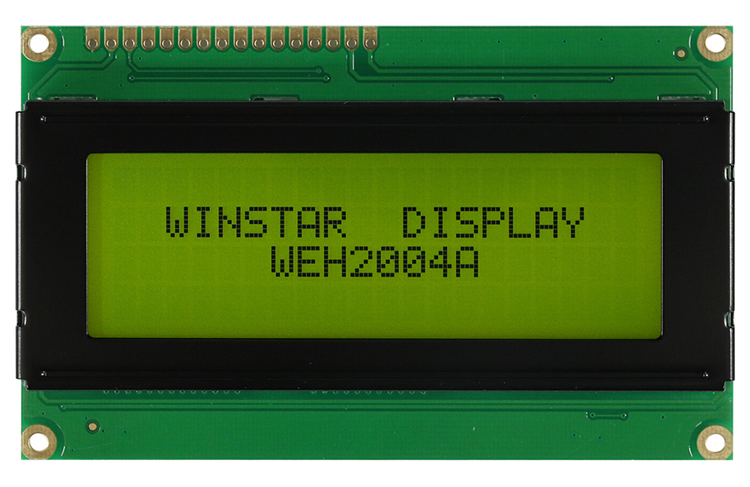
Figure 1: Winstar display

Within this document the display content is related to by a table. Below represents the display seen from left to right and up to down as a matrix of 4x20.
/ | 1 | 2 | 3 | 4 | 5 | 6 | 7 | 8 | 9 | 10 | 11 | 12 | 13 | 14 | 15 | 16 | 17 | 18 | 19 | 20
1
2
3
4

As example, the table below represents the same display content as in Figure 1.
/ | 1 | 2 | 3 | 4 | 5 | 6 | 7 | 8 | 9 | 10 | 11 | 12 | 13 | 14 | 15 | 16 | 17 | 18 | 19 | 20
1
2 |  |  | W | I | N | S | T | A | R |  | D | I | S | P | L | A | Y
3 |  |  |  |  |  |  | W | E | H | 2 | 0 | 0 | 4 | A
4

Keypad
The system contains a keypad which represents the only possibility for the user to interact with the several functions of the system.
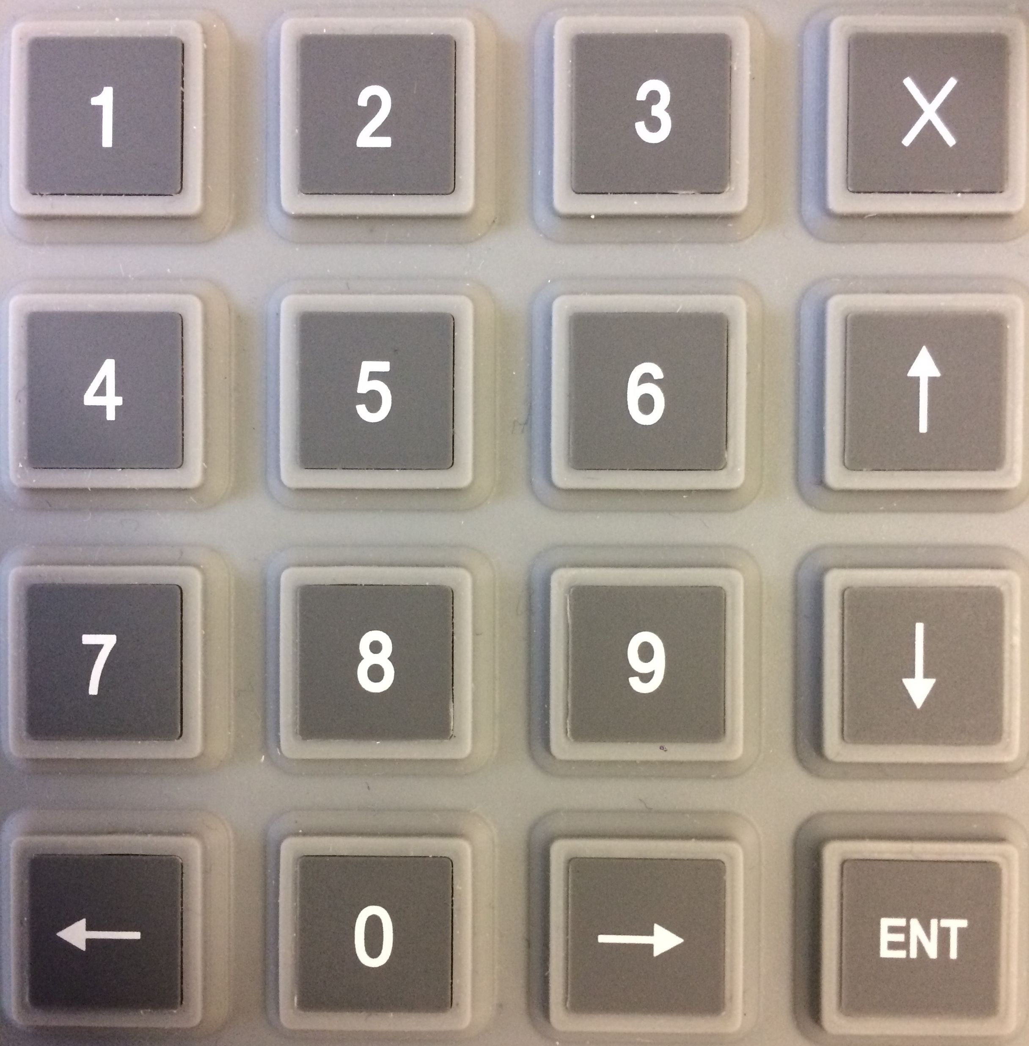
Figure 2: 16-key keypad

The keypad consists of a matrix of four by four keys, making it 16 keys totally. They are labelled as follows:
0-9 | Numeric keys
← | Arrow left
↑ | Arrow up
→ | Arrow right
↓ | Arrow down
ENTER | Enter
ESC | Escape

Service manual

Selection cursor
As soon as a menu with selectable items appears on the display there must be a cursor/selector to differ between the currently highlighted menu item and other items.
The cursor is character: >
The cursor is always in first position of the current row, followed by a blank (space character).
For example, the cursor active in third row with random text behind looks like:
/ | 1 | 2 | 3 | 4
1 | R | a | n | d
2 |  |  | 1 | .
3 | > |  | 2 | .
4 |  |  | 3 | .

Start screen
After powering the system, the display will become active and print out a start message, containing the type of assemblage and version number.
There are three different types of assemblages, which will be represented on the display as follows:
For anode repair repair set:
/ | 1 | 2 | 3 | 4 | 5 | 6 | 7 | 8 | 9 | 10 | 11 | 12 | 13 | 14 | 15 | 16 | 17 | 18 | 19 | 20
1 | A | n | o | d | e |  | R | e | p | a | i | r

For cathode and MCP repair set:
/ | 1 | 2 | 3 | 4 | 5 | 6 | 7 | 8 | 9 | 10 | 11 | 12 | 13 | 14 | 15 | 16 | 17 | 18 | 19 | 20
1 | C | a | t | h | o | d | e | / | M | C | P |  | r | e | p | a | i | r

For tesla repair set:
/ | 1 | 2 | 3 | 4 | 5 | 6 | 7 | 8 | 9 | 10 | 11 | 12 | 13 | 14 | 15 | 16 | 17 | 18 | 19 | 20
1 | T | e | s | l | a |  | r | e | p | a | i | r

A full start message on display, containing the system version number, will look like:
/ | 1 | 2 | 3 | 4 | 5 | 6 | 7 | 8 | 9 | 10 | 11 | 12 | 13 | 14 | 15 | 16 | 17 | 18 | 19 | 20
1 | A | n | o | d | e |  | r | e | p | a | i | r
2
3 |  |  |  |  |  | S | W |  | V | . |  | 1 | 0 | 0 | 0
4

There is no user-action needed at this point – the system will switch to the main menu as soon as the system is fully booted and functional.

Main menu
The main menu of the system is identical for all three assemblages and looks like:
/ | 1 | 2 | 3 | 4 | 5 | 6 | 7 | 8 | 9 | 10 | 11 | 12 | 13 | 14 | 15 | 16 | 17 | 18 | 19 | 20
1
2 |  |  | 1 | . | T | u | b | e |  | r | e | p | a | i | r |  | m | e | n | u
3 |  |  | 2 | . | O | p | e | r | a | t | o | r |  | m | e | n | u
4 |  |  | 3 | . | C | a | l | i | b | r | a | t | i | o | n |  | m | e | n | u

The only difference between the three assemblages will be that their identification string from the start screen will remain in first row. So, for the anode repair assemblage, the main menu looks like:

/ | 1 | 2 | 3 | 4 | 5 | 6 | 7 | 8 | 9 | 10 | 11 | 12 | 13 | 14 | 15 | 16 | 17 | 18 | 19 | 20
1 | A | n | o | d | e |  | r | e | p | a | i | r
2 | > |  | 1 | . | T | u | b | e |  | r | e | p | a | i | r |  | m | e | n | u
3 |  |  | 2 | . | O | p | e | r | a | t | o | r |  | m | e | n | u
4 |  |  | 3 | . | C | a | l | i | b | r | a | t | i | o | n |  | m | e | n | u

↑ | Move cursor up one line
↓ | Move cursor down one line
ENT | Select currently current item
others | No function

Anode repair - Tube repair menu
/ | 1 | 2 | 3 | 4 | 5 | 6 | 7 | 8 | 9 | 10 | 11 | 12 | 13 | 14 | 15 | 16 | 17 | 18 | 19 | 20
1 | T | u | b | e |  | r | e | p | a | i | r
2 | > |  | 1 | . |  | P | r | e | s | e | t | : |  | 8 |  | k | V
3 |  |  | 2 | . |  | T | i | m | e | r | : |  |  | 8 |  | h | r | s
4 |  |  | 3 | . |  | S | t | a | r | t |  | r | e | p | a | i | r

↑ | Move cursor up one line
↓ | Move cursor down one line
ENT | Select currently current item
ESC | Leave current menu level and return to main menu
others | No function

The pre-set and the timer menu item both show the current selection, which is always the first item available after each system (re)start.

Pre-set menu
/ | 1 | 2 | 3 | 4 | 5 | 6 | 7 | 8 | 9 | 10 | 11 | 12 | 13 | 14 | 15 | 16 | 17 | 18 | 19 | 20
1 | T | u | b | e |  | r | e | p | a | i | r |  | p | r | e | s | e | t | s
2 | > |  | 1 | . |  | P | r | e | s | e | t | 1 | : |  |  |  | 8 | k | V
3 |  |  | 2 | . |  | P | r | e | s | e | t | 2 | : |  |  | 1 | 0 | k | V
4 |  |  | 3 | . |  | V | a | r | i | a | b | l | e | : |  |  | 0 | k | V

↑ | Move cursor up one line
↓ | Move cursor down one line
ENT | Select current pre-set (see list below for more details)
ESC | Leave current menu level and return to tube repair menu without selecting a (new) pre-set
others | No function

Selecting defined pre-sets results in:
- Selection of the desired voltage for repair
- Return to tube repair menu, where the selected pre-set is mentioned.

Selecting the variable option results in:
- Enter variable voltage menu

Variable voltage menu
/ | 1 | 2 | 3 | 4 | 5 | 6 | 7 | 8 | 9 | 10 | 11 | 12 | 13 | 14 | 15 | 16 | 17 | 18 | 19 | 20
1 | T | u | b | e |  | r | e | p | a | i | r |  | p | r | e | s | e | t | s
2 | I | n | s | e | r | t |  | v | o | l | t | a | g | e |  | i | n |  | V | :
3
4 |  |  |  |  |  |  |  |  |  |  |  | 0 |  | V

This menu allows insertion of a desired voltage differently from the pre-defined presets. When entering this menu, the insertion cursor will appear and allow insertion of the desired value.
← | Move cursor to the left
→ | Move cursor to the right
ENT | Confirm inserted value, leave menu and return to tube repair menu
ESC | Leave current menu level and return to pre-set menu without entering a new value
0-9 | Value insertion
others | No function

Timer menu
/ | 1 | 2 | 3 | 4 | 5 | 6 | 7 | 8 | 9 | 10 | 11 | 12 | 13 | 14 | 15 | 16 | 17 | 18 | 19 | 20
1 | T | u | b | e |  | r | e | p | a | i | r |  | t | i | m | e | r
2 | > |  | 1 | . |  |  | 8 |  | h | o | u | r | s
3 |  |  | 2 | . |  | 1 | 6 |  | h | o | u | r | s
4

↑ | Move cursor up one line
↓ | Move cursor down one line
ENT | Select current timer and return to tube repair menu
ESC | Leave current menu level and return to tube repair menu without selecting a (new) timer
others | No function

Start repair menu

Error messages based on software
Starting the repair treatment does not lead to a new menu but to a totally different set of screens. A repair action must not be started unless several software conditions are met.
In Software, these conditions are:
- A voltage must be selected
- A timer must be selected

Error messages are defined and displayed in case one or both conditions are not met:
/ | 1 | 2 | 3 | 4 | 5 | 6 | 7 | 8 | 9 | 10 | 11 | 12 | 13 | 14 | 15 | 16 | 17 | 18 | 19 | 20
1 | S | t | a | r | t |  | r | e | p | a | i | r
2 |  |  |  |  |  | ! | ! | E | R | R | O | R | ! | !
3 | N | o |  | v | o | l | t | a | g | e |  | s | e | l | e | c | t | e | d
4 | N | o |  | t | i | m | e | r |  | s | e | l | e | c | t | e | d

The screen above shows both error messages, but only the appropriate message will be shown
ENT | Acknowledge error and return to main menu
others | No function

Error messages based on safety
Before starting the repair treatment, it is crucial to verify that the system enclosure drawer is properly closed. If that is not the case, an error message will be shown:
/ | 1 | 2 | 3 | 4 | 5 | 6 | 7 | 8 | 9 | 10 | 11 | 12 | 13 | 14 | 15 | 16 | 17 | 18 | 19 | 20
1 | S | t | a | r | t |  | r | e | p | a | i | r
2 |  |  |  |  |  | ! | ! | E | R | R | O | R | ! | !
3
4 |  |  |  |  | D | R | A | W | E | R |  | O | P | E | N | !

ENT | Acknowledge error and return to main menu
others | No function

Note: it is not sufficient to close the drawer. The system will only react to the ENT key and return to the main menu. Closing the drawer is, however, mandatory before starting a new repair.

Repair in progress
When all conditions are met, the repair treatment starts. The display now acts as feedback
/ | 1 | 2 | 3 | 4 | 5 | 6 | 7 | 8 | 9 | 10 | 11 | 12 | 13 | 14 | 15 | 16 | 17 | 18 | 19 | 20
1 |  |  | A | n | o | d | e |  | r | e | p | a | i | r |  | B | U | S | Y
2 | V | o | l | t | : |  | x | x | , | x | x |  | k | V
3 | T | i | m | e | : |  | h | h | : | m | m |  | ( | y | Z |  | h | r | s | )
4 |  | P | r | e | s | s |  | E | S | C |  | t | o |  | P | a | u | s | e

ESC | Pauze the current repair action
others | No function

Repair paused
When treatment is paused, the display will change its output to:
/ | 1 | 2 | 3 | 4 | 5 | 6 | 7 | 8 | 9 | 10 | 11 | 12 | 13 | 14 | 15 | 16 | 17 | 18 | 19 | 20
1 |  |  | A | n | o | d | e |  | r | e | p | a | i | r |  | B | U | S | Y
2 |  |  |  |  |  | ! | ! | P | A | U | S | E | D | ! | !
3 |  | P | r | e | s | s |  | E | N | T |  | t | o |  | s | t | a | r | t
4 |  | P | r | e | s | s |  | E | S | C |  | t | o |  | R | E | S | E | T

ENT | Continue the current repair
ESC | Reset/quit the treatment and return to the tube repair menu
others | No function

Cathode/MCP repair - Tube repair menu
/ | 1 | 2 | 3 | 4 | 5 | 6 | 7 | 8 | 9 | 10 | 11 | 12 | 13 | 14 | 15 | 16 | 17 | 18 | 19 | 20
1 | T | u | b | e |  | r | e | p | a | i | r
2 | > |  | 1 | . |  | M | C | P |  | r | e | p | a | i | r
3 |  |  | 2 | . |  | C | a | t | h | o | d | e |  | r | e | p | a | i | r
4

↑ | Move cursor up one line
↓ | Move cursor down one line
ENT | Select currently current item
others | No function

MCP repair menu
/ | 1 | 2 | 3 | 4 | 5 | 6 | 7 | 8 | 9 | 10 | 11 | 12 | 13 | 14 | 15 | 16 | 17 | 18 | 19 | 20
1 | M | C | P |  | r | e | p | a | i | r
2 | > |  | 1 | . |  | P | r | e | s | e | t | : |  | 1 | 8 | 0 | 0 |  | V
3 |  |  | 2 | . |  | T | i | m | e | r | : |  |  | 8 |  | h | r | s
4 |  |  | 3 | . |  | S | t | a | r | t |  | r | e | p | a | i | r

↑ | Move cursor up one line
↓ | Move cursor down one line
ENT | Select currently current item
ESC | Leave current menu level and return to main menu
others | No function

The pre-set and the timer menu item both show the current selection, which is always the first item available after each system (re)start.

Pre-set menu
/ | 1 | 2 | 3 | 4 | 5 | 6 | 7 | 8 | 9 | 10 | 11 | 12 | 13 | 14 | 15 | 16 | 17 | 18 | 19 | 20
1 | T | u | b | e |  | r | e | p | a | i | r |  | p | r | e | s | e | t | s
2 | > |  | 1 | . |  | P | r | e | s | e | t | 1 | : |  | 1 | 8 | 0 | 0 |  | V
3 |  |  | 2 | . |  | P | r | e | s | e | t | 2 | : |  | 2 | 0 | 0 | 0 |  | V
4 |  |  | 3 | . |  | V | a | r | i | a | b | l | e | : |  |  |  | 0 |  | V

↑ | Move cursor up one line
↓ | Move cursor down one line
ENT | Select current pre-set (see list below for more details)
ESC | Leave current menu level and return to tube repair menu without selecting a (new) pre-set
others | No function

Selecting defined pre-sets results in:
- Selection of the desired voltage for repair
- Return to tube repair menu, where the selected pre-set is mentioned.

Selecting the variable option results in:
- Enter variable voltage menu

Variable voltage menu
/ | 1 | 2 | 3 | 4 | 5 | 6 | 7 | 8 | 9 | 10 | 11 | 12 | 13 | 14 | 15 | 16 | 17 | 18 | 19 | 20
1 | M | C | P |  | r | e | p | a | i | r |  | p | r | e | s | e | t | s
2 | I | n | s | e | r | t |  | v | o | l | t | a | g | e |  | i | n |  | V | :
3
4 |  |  |  |  |  |  |  |  |  |  |  | 0 |  | V

This menu allows insertion of a desired voltage differently from the pre-defined presets. When entering this menu, the insertion cursor will appear and allow insertion of the desired value.
← | Move cursor to the left
→ | Move cursor to the right
ENT | Confirm inserted value, leave menu and return to tube repair menu
ESC | Leave current menu level and return to pre-set menu without entering a new value
0-9 | Value insertion
others | No function

Timer menu
/ | 1 | 2 | 3 | 4 | 5 | 6 | 7 | 8 | 9 | 10 | 11 | 12 | 13 | 14 | 15 | 16 | 17 | 18 | 19 | 20
1 | T | u | b | e |  | r | e | p | a | i | r |  | t | i | m | e | r
2 | > |  | 1 | . |  |  | 8 |  | h | o | u | r | s
3 |  |  | 2 | . |  | 1 | 6 |  | h | o | u | r | s
4

↑ | Move cursor up one line
↓ | Move cursor down one line
ENT | Select current timer and return to tube repair menu
ESC | Leave current menu level and return to tube repair menu without selecting a (new) timer
others | No function

Cathode repair menu
/ | 1 | 2 | 3 | 4 | 5 | 6 | 7 | 8 | 9 | 10 | 11 | 12 | 13 | 14 | 15 | 16 | 17 | 18 | 19 | 20
1 | C | a | t | h | o | d | e |  | r | e | p | a | i | r
2 | > |  | 1 | . |  | P | r | e | s | e | t | : |  | 6 | 0 | 0 |  | V
3 |  |  | 2 | . |  | T | i | m | e | r | : |  |  | 8 |  | h | r | s
4 |  |  | 3 | . |  | S | t | a | r | t |  | r | e | p | a | i | r

↑ | Move cursor up one line
↓ | Move cursor down one line
ENT | Select currently current item
ESC | Leave current menu level and return to main menu
others | No function

The pre-set and the timer menu item both show the current selection, which is always the first item available after each system (re)start.

Pre-set menu
/ | 1 | 2 | 3 | 4 | 5 | 6 | 7 | 8 | 9 | 10 | 11 | 12 | 13 | 14 | 15 | 16 | 17 | 18 | 19 | 20
1 | T | u | b | e |  | r | e | p | a | i | r |  | p | r | e | s | e | t | s
2 | > |  | 1 | . |  | P | r | e | s | e | t | 1 | : |  |  | 6 | 0 | 0 |  | V
3 |  |  | 2 | . |  | P | r | e | s | e | t | 2 | : |  |  | 8 | 0 | 0 |  | V
4 |  |  | 3 | . |  | V | a | r | i | a | b | l | e | : |  |  |  | 0 |  | V

↑ | Move cursor up one line
↓ | Move cursor down one line
ENT | Select current pre-set (see list below for more details)
ESC | Leave current menu level and return to tube repair menu without selecting a (new) pre-set
others | No function

Selecting defined pre-sets results in:
- Selection of the desired voltage for repair
- Return to tube repair menu, where the selected pre-set is mentioned.

Selecting the variable option results in:
- Enter variable voltage menu

Variable voltage menu
/ | 1 | 2 | 3 | 4 | 5 | 6 | 7 | 8 | 9 | 10 | 11 | 12 | 13 | 14 | 15 | 16 | 17 | 18 | 19 | 20
1 | T | u | b | e |  | r | e | p | a | i | r |  | p | r | e | s | e | t | s
2 | I | n | s | e | r | t |  | v | o | l | t | a | g | e |  | i | n |  | V | :
3
4 |  |  |  |  |  |  |  |  |  |  |  | 0 |  | V
This menu allows insertion of a desired voltage differently from the pre-defined presets. When entering this menu, the insertion cursor will appear and allow insertion of the desired value.
← | Move cursor to the left
→ | Move cursor to the right
ENT | Confirm inserted value, leave menu and return to tube repair menu
ESC | Leave current menu level and return to pre-set menu without entering a new value
0-9 | Value insertion
others | No function

Timer menu
/ | 1 | 2 | 3 | 4 | 5 | 6 | 7 | 8 | 9 | 10 | 11 | 12 | 13 | 14 | 15 | 16 | 17 | 18 | 19 | 20
1 | T | u | b | e |  | r | e | p | a | i | r |  | t | i | m | e | r
2 | > |  | 1 | . |  |  | 8 |  | h | o | u | r | s
3 |  |  | 2 | . |  | 1 | 6 |  | h | o | u | r | s
4

↑ | Move cursor up one line
↓ | Move cursor down one line
ENT | Select current timer and return to tube repair menu
ESC | Leave current menu level and return to tube repair menu without selecting a (new) timer
others | No function

Start repair menu

Error messages based on software
Starting the repair treatment does not lead to a new menu but to a totally different set of screens. A repair action must not be started unless several software conditions are met.
In Software, these conditions are:
- A voltage must be selected
- A timer must be selected

Error messages are defined and displayed in case one or both conditions are not met:
/ | 1 | 2 | 3 | 4 | 5 | 6 | 7 | 8 | 9 | 10 | 11 | 12 | 13 | 14 | 15 | 16 | 17 | 18 | 19 | 20
1 | S | t | a | r | t |  | r | e | p | a | i | r
2 |  |  |  |  |  | ! | ! | E | R | R | O | R | ! | !
3 | N | o |  | v | o | l | t | a | g | e |  | s | e | l | e | c | t | e | d
4 | N | o |  | t | i | m | e | r |  | s | e | l | e | c | t | e | d

The screen above shows both error messages, but only the appropriate message will be shown
ENT | Acknowledge error and return to main menu
others | No function

Error messages based on safety
Before starting the repair treatment, it is crucial to verify that the system enclosure drawer is properly closed. If that is not the case, an error message will be shown:
/ | 1 | 2 | 3 | 4 | 5 | 6 | 7 | 8 | 9 | 10 | 11 | 12 | 13 | 14 | 15 | 16 | 17 | 18 | 19 | 20
1 | S | t | a | r | t |  | r | e | p | a | i | r
2 |  |  |  |  |  | ! | ! | E | R | R | O | R | ! | !
3
4 |  |  |  |  | D | R | A | W | E | R |  | O | P | E | N | !

ENT | Acknowledge error and return to main menu
others | No function

Note: it is not sufficient to close the drawer. The system will only react to the ENT key and return to the main menu. Closing the drawer is, however, mandatory before starting a new repair.

Repair in progress
When all conditions are met, the repair treatment starts. The display now acts as feedback
/ | 1 | 2 | 3 | 4 | 5 | 6 | 7 | 8 | 9 | 10 | 11 | 12 | 13 | 14 | 15 | 16 | 17 | 18 | 19 | 20
1 |  |  |  | M | C | P |  | r | e | p | a | i | r |  | B | U | S | Y
2 | V | o | l | t | : |  |  | x | , | x | x |  | k | V
3 | T | i | m | e | : |  | h | h | : | m | m |  | ( | y | Z |  | h | r | s | )
4 |  | P | r | e | s | s |  | E | S | C |  | t | o |  | P | a | u | s | e

ESC | Pause the current repair action
others | No function

Repair paused
When treatment is paused, the display will change its output to:
/ | 1 | 2 | 3 | 4 | 5 | 6 | 7 | 8 | 9 | 10 | 11 | 12 | 13 | 14 | 15 | 16 | 17 | 18 | 19 | 20
1 |  |  |  | M | C | P |  | r | e | p | a | i | r |  | B | U | S | Y
2 |  |  |  |  |  | ! | ! | P | A | U | S | E | D | ! | !
3 |  | P | r | e | s | s |  | E | N | T |  | t | o |  | s | t | a | r | t
4 |  | P | r | e | s | s |  | E | S | C |  | t | o |  | R | E | S | E | T

ENT | Continue the current repair
ESC | Reset/quit the treatment and return to the tube repair menu
others | No function

Note:
For menu 3.3.2.3.3 and 3.3.2.3.4, the text in the first line is depended on the selection between MCP and Cathode repair from menu 3.3. The options are:

/ | 1 | 2 | 3 | 4 | 5 | 6 | 7 | 8 | 9 | 10 | 11 | 12 | 13 | 14 | 15 | 16 | 17 | 18 | 19 | 20
1 |  |  |  | M | C | P |  | r | e | p | a | i | r |  | B | U | S | Y

/ | 1 | 2 | 3 | 4 | 5 | 6 | 7 | 8 | 9 | 10 | 11 | 12 | 13 | 14 | 15 | 16 | 17 | 18 | 19 | 20
1 |  | C | a | t | h | o | d | e |  | r | e | p | a | i | r |  | B | U | S | Y

Tesla repair
/ | 1 | 2 | 3 | 4 | 5 | 6 | 7 | 8 | 9 | 10 | 11 | 12 | 13 | 14 | 15 | 16 | 17 | 18 | 19 | 20
1 | T | u | b | e |  | r | e | p | a | i | r
2
3 | > |  | S | t | a | r | t |  | r | e | p | a | i | r
4

ENT | Select currently current item
ESC | Leave current menu level and return to main menu
others | No function

Note: For tesla repair, there are no parameters to adjust. The repair can only be started and, once running, stopped.

Start repair menu

Error messages based on safety
Before starting the repair treatment, it is crucial to verify that the system enclosure drawer is properly closed and that the safety tube is in place. If that is not the case, an error message will be shown:
/ | 1 | 2 | 3 | 4 | 5 | 6 | 7 | 8 | 9 | 10 | 11 | 12 | 13 | 14 | 15 | 16 | 17 | 18 | 19 | 20
1 | S | t | a | r | t |  | r | e | p | a | i | r
2 |  |  |  |  |  | ! | ! | E | R | R | O | R | ! | !
3 |  |  |  |  | D | R | A | W | E | R |  | O | P | E | N | !
4 |  | S | A | F | E | T | Y |  | T | U | B | E |  | M | I | S | S | I | N | G

ENT | Acknowledge error and return to main menu
others | No function

Note: it is not sufficient to close the drawer or place the tube. The system will only react to the ENT key and return to the main menu. Closing the drawer and placing the safety tube is, however, mandatory before starting a new repair.

Note: The screen above shows two different error messages at once. Only the appropriate message(s) will be shown.

Repair in progress
When all conditions are met, the repair treatment starts. The display now acts as feedback
/ | 1 | 2 | 3 | 4 | 5 | 6 | 7 | 8 | 9 | 10 | 11 | 12 | 13 | 14 | 15 | 16 | 17 | 18 | 19 | 20
1 |  | T | e | s | l | a |  | r | e | p | a | i | r |  | B | U | S | Y
2 | V | o | l | t | : |  |  | x | , | x | x |  | k | V
3
4 |  | P | r | e | s | s |  | E | S | C |  | t | o |  | s | t | o | p

ESC | Stop tesla repair action and return to tube repair menu
others | No function

Operator Menu

Password protection

Password insertion screen
The operator menu is password protected. Prior to entering, the user must enter the password.
/ | 1 | 2 | 3 | 4 | 5 | 6 | 7 | 8 | 9 | 10 | 11 | 12 | 13 | 14 | 15 | 16 | 17 | 18 | 19 | 20
1 |  |  |  | O | p | e | r | a | t | o | r |  | m | e | n | u
2
3 |  |  |  |  |  | I | n | s | e | r | t |  | P | I | N
4 |  |  |  |  |  |  |  |  | * | * | * | *

0-9 | Insert number
ENT | Confirm inserted PIN
ESC | Return to main menu
others | No function

Password accepted
/ | 1 | 2 | 3 | 4 | 5 | 6 | 7 | 8 | 9 | 10 | 11 | 12 | 13 | 14 | 15 | 16 | 17 | 18 | 19 | 20
1 |  |  |  | O | p | e | r | a | t | o | r |  | m | e | n | u
2
3 |  |  |  |  |  |  |  | P | I | N |  | O | K
4

others | No function

No action required. The screen will be left after three seconds and the operator menu will be entered.

Password denied
/ | 1 | 2 | 3 | 4 | 5 | 6 | 7 | 8 | 9 | 10 | 11 | 12 | 13 | 14 | 15 | 16 | 17 | 18 | 19 | 20
1 |  |  |  | O | p | e | r | a | t | o | r |  | m | e | n | u
2
3 |  |  |  |  |  | P | I | N |  | D | E | N | I | E | D
4

others | No function

No action required. The screen will be left after three seconds and the password insertion screen will appear again.

Operator main menu
/ | 1 | 2 | 3 | 4 | 5 | 6 | 7 | 8 | 9 | 10 | 11 | 12 | 13 | 14 | 15 | 16 | 17 | 18 | 19 | 20
1 | O | p | e | r | a | t | o | r |  | m | e | n | u
2 | > |  | 1 | . |  | C | h | a | n | g | e |  | P | I | N
3 |  |  | 2 | .
4 |  |  | 3 | . |  | I | n | f | o |  | & |  | V | e | r | s | i | o | n

↑ | Move cursor up one line
↓ | Move cursor down one line
ENT | Select currently current item
ESC | Leave current menu level and return to main menu
others | No function

Change PIN menu

Insert new Pin
/ |  | 1 | 2 | 3 | 4 | 5 | 6 | 7 | 8 | 9 | 10 | 11 | 12 | 13 | 14 | 15 | 16 | 17 | 18 | 19 | 20
1 | C | h | a | n | g | e |  | P | I | N
2
3 |  | I | n | s | e | r | t |  | n | e | w |  | P | I | N | : |  | * | * | * | *
4

ESC | Leave current menu level and return to operator main menu without changing the PIN
0-9 | Insert number
others | No function

When the 4-digit PIN has been entered, the screen automatically changes to:

/ |  | 1 | 2 | 3 | 4 | 5 | 6 | 7 | 8 | 9 | 10 | 11 | 12 | 13 | 14 | 15 | 16 | 17 | 18 | 19 | 20
1 | C | h | a | n | g | e |  | P | I | N
2
3 |  | R | e | p | e | a | t |  | n | e | w |  | P | I | N | : |  | * | * | * | *
4

ESC | Leave current menu level and return to operator main menu without changing the PIN
0-9 | Insert number
others | No function

When the 4-digit has been entered a second time, the system will verify that both entered PINs are equal.

New Pin OK
/ |  | 1 | 2 | 3 | 4 | 5 | 6 | 7 | 8 | 9 | 10 | 11 | 12 | 13 | 14 | 15 | 16 | 17 | 18 | 19 | 20
1 | C | h | a | n | g | e |  | P | I | N
2
3 |  |  | N | e | w |  | P | I | N |  | a | c | c | e | p | t | e | d
4

others | No function

No action required. The screen will be left after three seconds and the operator main menu will appear again.

New Pin failed
/ |  | 1 | 2 | 3 | 4 | 5 | 6 | 7 | 8 | 9 | 10 | 11 | 12 | 13 | 14 | 15 | 16 | 17 | 18 | 19 | 20
1 | C | h | a | n | g | e |  | P | I | N
2
3 |  |  | N | e | w |  | P | I | N |  | d | e | n | i | e | d
4

ENT | Confirm that PIN has not been changed
others | No function

The screen will only be left when ENT is pressed. This way the user must confirm knowledge that the PIN has not been changed. Afterwards, the operator main menu will appear again.

Information and version screen
A screen like the welcome/start screen at power-up of the system.

There are three different types of assemblages, which will be represented on the display as follows:
For anode repair repair set:
/ | 1 | 2 | 3 | 4 | 5 | 6 | 7 | 8 | 9 | 10 | 11 | 12 | 13 | 14 | 15 | 16 | 17 | 18 | 19 | 20
1 | A | n | o | d | e |  | R | e | p | a | i | r

For cathode and MCP repair set:
/ | 1 | 2 | 3 | 4 | 5 | 6 | 7 | 8 | 9 | 10 | 11 | 12 | 13 | 14 | 15 | 16 | 17 | 18 | 19 | 20
1 | C | a | t | h | o | d | e | / | M | C | P |  | r | e | p | a | i | r

For tesla repair set:
/ | 1 | 2 | 3 | 4 | 5 | 6 | 7 | 8 | 9 | 10 | 11 | 12 | 13 | 14 | 15 | 16 | 17 | 18 | 19 | 20
1 | T | e | s | l | a |  | r | e | p | a | i | r

The full screen on display, containing the system version number, will look like:
/ | 1 | 2 | 3 | 4 | 5 | 6 | 7 | 8 | 9 | 10 | 11 | 12 | 13 | 14 | 15 | 16 | 17 | 18 | 19 | 20
1 | A | n | o | d | e |  | r | e | p | a | i | r
2
3 |  |  |  |  |  | S | W |  | V | . |  | 1 | 0 | 0 | 0
4

ENT | Leave screen and return to operator main menu
others | No function

Calibration menu

Password protection

Password insertion screen
The calibration menu is password protected. Prior to entering, the user must enter the password.
/ | 1 | 2 | 3 | 4 | 5 | 6 | 7 | 8 | 9 | 10 | 11 | 12 | 13 | 14 | 15 | 16 | 17 | 18 | 19 | 20
1 |  |  |  | O | p | e | r | a | t | o | r |  | m | e | n | u
2
3 |  |  |  |  |  | I | n | s | e | r | t |  | P | I | N
4 |  |  |  |  |  |  |  |  | * | * | * | *

0-9 | Insert number
ENT | Confirm inserted PIN
ESC | Return to main menu
others | No function

Password accepted
/ | 1 | 2 | 3 | 4 | 5 | 6 | 7 | 8 | 9 | 10 | 11 | 12 | 13 | 14 | 15 | 16 | 17 | 18 | 19 | 20
1 |  |  |  | O | p | e | r | a | t | o | r |  | m | e | n | u
2
3 |  |  |  |  |  |  |  | P | I | N |  | O | K
4

others | No function

No action required. The screen will be left after 3 seconds and the calibration main menu will be entered.

Password denied
/ | 1 | 2 | 3 | 4 | 5 | 6 | 7 | 8 | 9 | 10 | 11 | 12 | 13 | 14 | 15 | 16 | 17 | 18 | 19 | 20
1 |  |  |  | O | p | e | r | a | t | o | r |  | m | e | n | u
2
3 |  |  |  |  |  | P | I | N |  | D | E | N | I | E | D
4

others | No function

No action required. The screen will be left after 3 seconds and the password insertion screen will appear again.

Calibration main menu
/ | 1 | 2 | 3 | 4 | 5 | 6 | 7 | 8 | 9 | 10 | 11 | 12 | 13 | 14 | 15 | 16 | 17 | 18 | 19 | 20
1 | C | a | l | i | b | r | a | t | i | o | n |  | m | e | n | u
2 | > |  | 1 | . |  | C | a | l | i | b | r | a | t | e |  | A | D | C | s
3
4

↑ | Move cursor up one line (currently not implemented)
↓ | Move cursor down one line (currently not implemented)
ENT | Select currently current item
ESC | Leave current menu level and return to main menu
others | No function

The only calibration option at the moment is the analogue-to-digital converter, or analogue input.

Calibrate ADCs menu
/ | 1 | 2 | 3 | 4 | 5 | 6 | 7 | 8 | 9 | 10 | 11 | 12 | 13 | 14 | 15 | 16 | 17 | 18 | 19 | 20
1 | C | a | l | i | b | r | a | t | e |  | A | D | C | s
2 | > |  | 1 | . |  | C | h | a | n | n | e | l |  | 1
3 |  |  | 2 | . |  | C | h | a | n | n | e | l |  | 2
4 |  |  | 3 | . |  | C | h | a | n | n | e | l |  | 3

↑ | Move cursor up one line
↓ | Move cursor down one line
ENT | Select currently current item
ESC | Leave current menu level and return to main menu
others | No function

Calibration procedure for an ADC channel
The following menu is similar for all ADC channels

/ | 1 | 2 | 3 | 4 | 5 | 6 | 7 | 8 | 9 | 10 | 11 | 12 | 13 | 14 | 15 | 16 | 17 | 18 | 19 | 20
1 | C | a | l | i | b | r | a | t | e |  | A | D | C |  | # | 1
2 |  |  |  |  |  |  | P | r | o | v | i | d | e
3 |  |  |  |  |  |  |  |  |  | 0 |  | k | V
4 |  |  |  |  | a | n | d |  | h | i | t |  | E | N | T

ENT | Confirm provided voltage and continue to next calibration point
ESC | Leave calibration procedure and return to calibrate ADCs menu
others | No function

/ | 1 | 2 | 3 | 4 | 5 | 6 | 7 | 8 | 9 | 10 | 11 | 12 | 13 | 14 | 15 | 16 | 17 | 18 | 19 | 20
1 | C | a | l | i | b | r | a | t | e |  | A | D | C |  | # | 1
2 |  |  |  |  |  |  | P | r | o | v | i | d | e
3 |  |  |  |  |  |  |  |  |  | 1 |  | k | V
4 |  |  |  |  | a | n | d |  | h | i | t |  | E | N | T

ENT | Confirm provided voltage and continue to next calibration point
ESC | Leave calibration procedure and return to calibrate ADCs menu
others | No function

/ | 1 | 2 | 3 | 4 | 5 | 6 | 7 | 8 | 9 | 10 | 11 | 12 | 13 | 14 | 15 | 16 | 17 | 18 | 19 | 20
1 | C | a | l | i | b | r | a | t | e |  | A | D | C |  | # | 1
2 |  |  |  |  |  |  | P | r | o | v | i | d | e
3 |  |  |  |  |  |  |  |  | 1 | 0 |  | k | V
4 |  |  |  |  | a | n | d |  | h | i | t |  | E | N | T

ENT | Confirm provided voltage and continue to next calibration point
ESC | Leave calibration procedure and return to calibrate ADCs menu
others | No function

/ | 1 | 2 | 3 | 4 | 5 | 6 | 7 | 8 | 9 | 10 | 11 | 12 | 13 | 14 | 15 | 16 | 17 | 18 | 19 | 20
1 | C | a | l | i | b | r | a | t | e |  | A | D | C |  | # | 1
2 |  |  |  |  | C | a | l | i | b | r | a | t | i | o | n
3 |  |  |  |  |  |  | f | i | n | i | s | h | e | d
4

ENT | Confirm and return to calibrate ADCs menu
others | No function

The exact calibration procedure is not defined, yet, so the menu definition, especially the calibration points mentioned, are subject to changes!

