Photonis 0387 HSB MRTS
Anode Software User Manual
Description:  User manual for HSB module repair test set | Doc No.: | PHO-0387-S1-2-0
Description:  User manual for HSB module repair test set | Revision: | 003
Description:  User manual for HSB module repair test set | Date: | 22-11-2017

 | Name | Date | Signature
Author | M. Mitscherlich | 22-11-2017
Reviewed
Approved

* The approval box may be extended as necessary.

No part of this document may be reproduced in any form or by any means, without the prior written permission of the respective owners.
All trademarks are property of their respective owners.
Document History
Version | Date | Status | Description
001 | 01-09-2017 | draft | Initial draft
002 | 07-09-2017 | draft | Updates after review by KRe and GRo
003 | 22-11-2017 | draft | Updates after review by Photonis  Updates after spec additions
Table of Contents

1 Introduction 4
1.1 Scope 4
1.2 References 4
1.3 Definitions 4
2 System overview 5
2.1 Display 5
2.2 Keypad 6
3 Service manual 7
3.1 Selection cursor 7
3.2 Start screen 8
3.3 Main menu 9
3.3.1 Anode repair - Tube repair menu 10
3.3.1.1 Select preset menu 10
3.3.1.2 Preset preview screen 10
3.3.1.3 Start repair menu 11
3.3.1.3.1 Error messages based on safety 11
3.3.1.3.2 Repair in progress 11
3.3.1.4 Repair pause 12
3.3.1.4.1 Repair paused 12
3.4 Administrator Menu 13
3.4.1 Password protection 13
3.4.1.1 Password insertion screen 13
3.4.1.2 Password accepted 13
3.4.1.3 Password denied 13
3.4.2 Operator main menu 14
3.4.2.1 Change PIN menu 15
3.4.2.1.1 Insert new Pin 15
3.4.2.1.2 New Pin OK 15
3.4.2.1.3 New Pin failed 16
3.4.2.2 I/O control menu 17
3.4.2.2.1 Read interlock 18
3.4.2.2.2 Solenoids 19
3.4.2.2.3 Get voltage in 20
3.4.2.2.4 Set voltage out 21
3.4.2.3 Preset config 22
3.4.2.4 Information and version screen 23
3.5 Calibration menu 24
3.5.1 Password protection 24
3.5.1.1 Password insertion screen 24
3.5.1.2 Password accepted 24
3.5.1.3 Password denied 24
3.5.2 Calibration main menu 25
3.5.2.1 Calibrate ADCs menu 25
3.5.2.1.1 Calibration procedure for an ADC channel 26

Introduction

Scope
This document describes the end-user functionality of the Photonis HSB module repair test set. It gives detailed overview over the menu structure and explains the interactivity between user and device.

References
- Document somename, vvv
Micro-Key, dd-mm-yyyy

Definitions
TBD To Be Defined

System overview
Interaction between user and system occurs via two devices which are part of the HSB module repair test set.

Display
Visual feedback and information is provided to the user through a display. It contains four rows with 20 characters each.
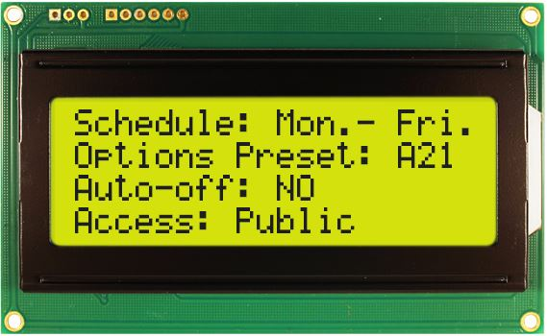
Figure 1: New heaven display NHD-0420D3Z-FL-GBW-V3

Within this document the display content is related to by a table. Below represents the display seen from left to right and up to down as a matrix of 4x20.
/ | 1 | 2 | 3 | 4 | 5 | 6 | 7 | 8 | 9 | 10 | 11 | 12 | 13 | 14 | 15 | 16 | 17 | 18 | 19 | 20
1
2
3
4

As example, the table below represents the same display content as in Figure 1.
/ | 1 | 2 | 3 | 4 | 5 | 6 | 7 | 8 | 9 | 10 | 11 | 12 | 13 | 14 | 15 | 16 | 17 | 18 | 19 | 20
1 | S | c | h | e | d | u | l | e | : |  | M | o | n | . | - |  | F | r | i | .
2 | O | p | t | i | o | n | s |  | P | r | e | s | e | t | : |  | A | 2 | 1
3 | A | u | t | o | - | o | f | f | : |  | N | O
4 | A | c | c | e | s | s | : |  | P | u | b | l | i | c

Keypad
The system contains a keypad which represents the only possibility for the user to interact with the several functions of the system.
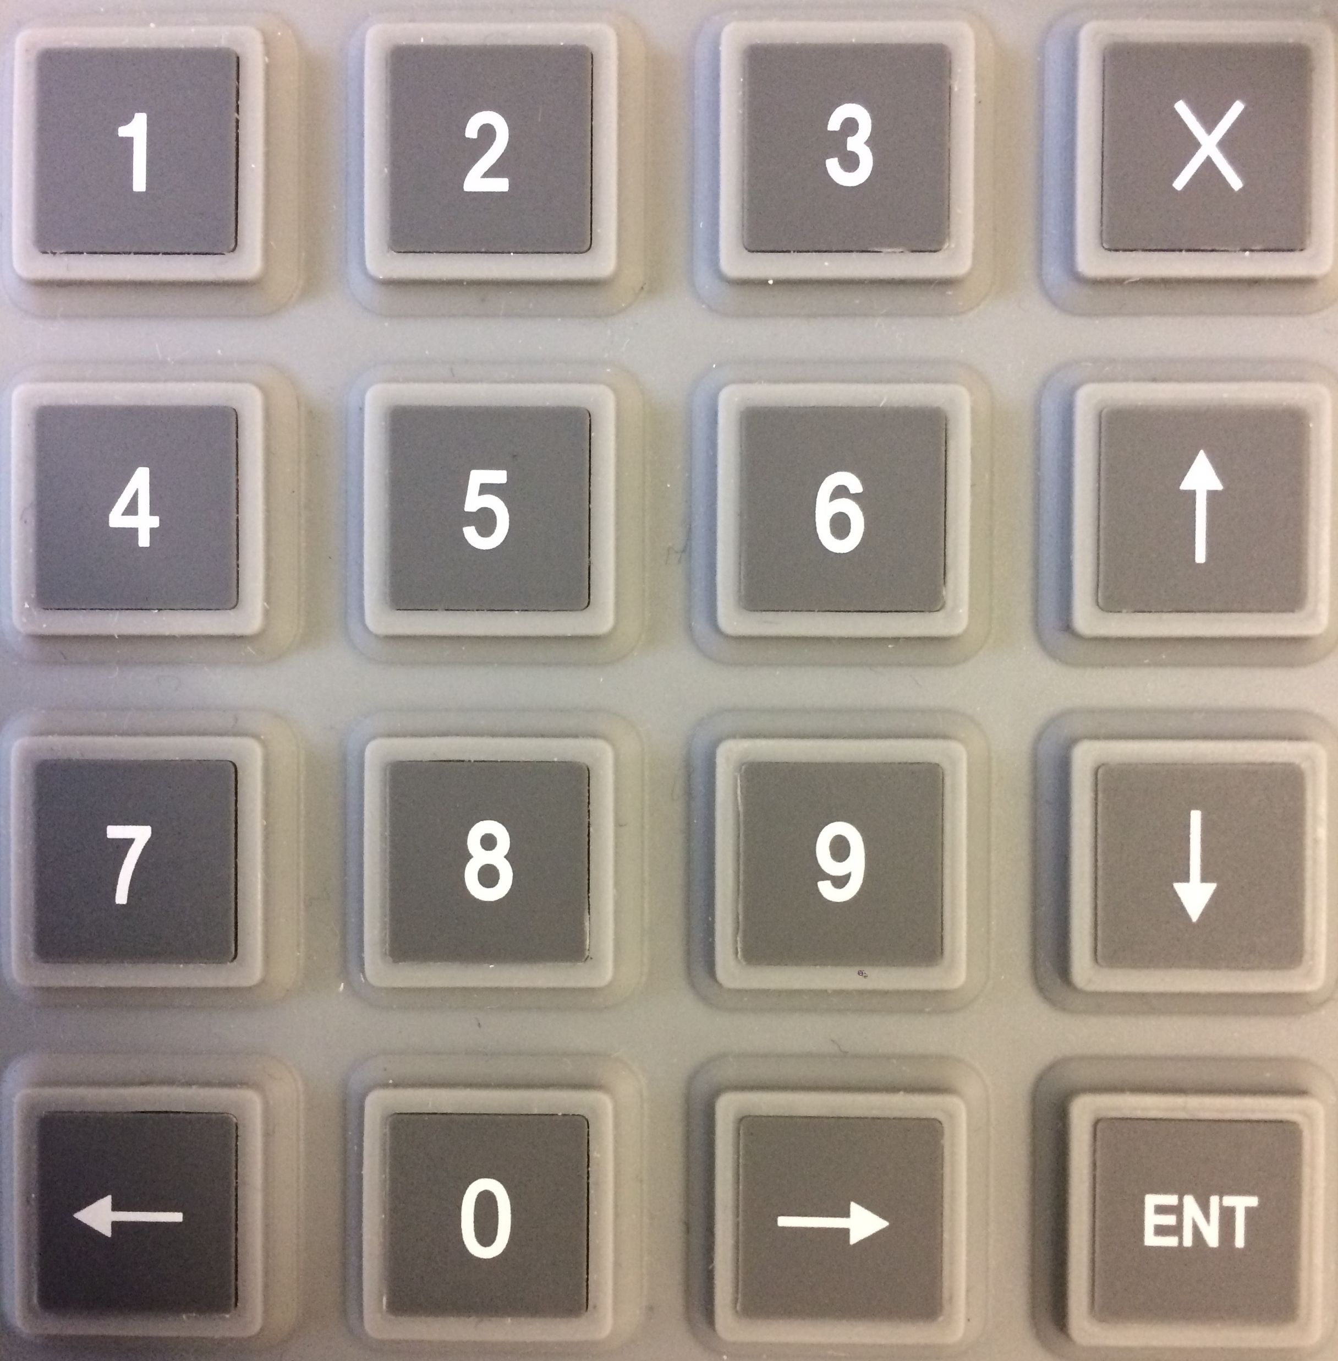
Figure 2: 16-key keypad

The keypad consists of a matrix of four by four keys, making it 16 keys totally. They are labelled as follows:
0-9 | Numeric keys 0 - 9
← | Arrow left
↑ | Arrow up
→ | Arrow right
↓ | Arrow down
ENT | Enter
X | Escape

Service manual

Selection cursor
As soon as a menu with selectable items appears on the display there must be a cursor/selector to differ between the currently highlighted menu item and other items.
The cursor is character: >
The cursor is always in first position of the current row, followed by a blank (space character).
For example, the cursor active in third row with random text behind looks like:
/ | 1 | 2 | 3 | 4
1 | R | a | n | d
2 |  |  | 1 | .
3 | > |  | 2 | .
4 |  |  | 3 | .

